**Ethanol Vapor Sensor**

**Final Report 2019**



EE129: A, B, C

Faculty Advisor: Peter Weiss

Members:

Maelia Uy-Gomez

Bridgette Blotz

David Durkin

John Lupu

Jorge Alegria

James Doan

Jacob Crowley

Rev 4.1



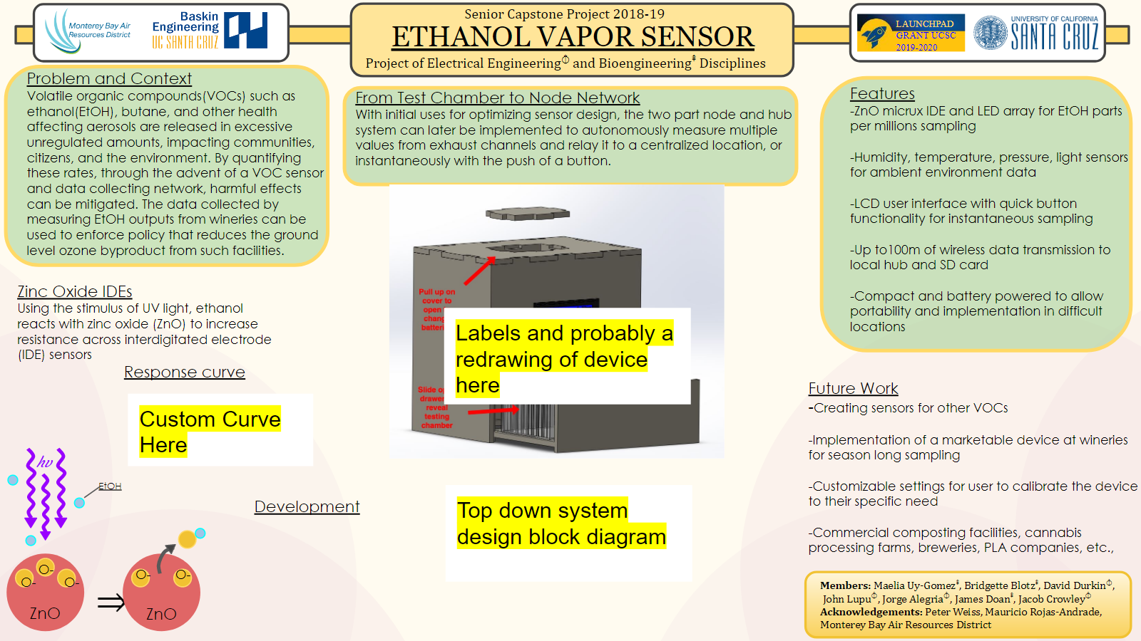

Table of Contents

**Abstract** **3**

**Chapter 1 - Addressing the Issue** **4**

1.1 Problem Statement 4

1.2 Background and Feasibility 4

**Chapter 2 - Project Overview** **8**

2.1 Design Considerations 8

2.2 Personnel Considerations 11

**Chapter 3 – Sensors** **14**

3.1 Environmental Sensors 14

3.2 Zinc Oxide Sensor 18

3.2.1 Testing and Validation 19

3.3 Conclusions 41

**Chapter 4 - Power** **42**

4.1 Design Considerations 42

4.2 Testing and Validation 42

4.3 Future Work 69

4.4 Conclusions 72

**Chapter 5 - RF** **73**

5.1 Design Considerations 73

5.2 Testing and Validation 76

5.4 Conclusions 81

**Chapter 6 - Mechanical** **83**

6.1 Design Considerations 83

6.2 Testing and Validation 87

6.3 Conclusions 92

**Chapter 7 - User Interface** **93**

7.1 Design Considerations 93

7.2 Testing and Validation 94

7.3 Conclusions 95

**Chapter 8 - Implementation and Integration** **97**

8.1 State Machine Integration 97

**Chapter 9 - Conclusion** **101**

**Chapter 10 - Future Work** **103**

**Acknowledgements** **105**

**References** **106**

**Appendix A: Datasheets and Parts** **108**

**+9V Input capacitor** **109**

**+9V board Schottky diode** **109**

**Appendix B: Schematics and PCBs** **110**

**Appendix C: Code** **118**

**Appendix D: Standard Operating Procedures (SOPs)** **119**

**https://drive.google.com/drive/u/2/folders/1QkMCOOotaUtPmWmZkfym_NjDR1eUNJwT** **119**

**Appendix E: Mechanical Specifications** **120**

**Appendix F: Testing Results** **122**

# Abstract

Large-scale winery ethanol vapor pollution causes significant health and environmental issues because it is largely unregulated due to a lack of credibly cost-effective measurement devices/systems. An engineering design was fabricated to address this problem for large-scale wineries, utilizing a research prototype zinc oxide (ZnO) air quality sensor (still in active development) to quantify ethanol concentrations. The device was designed to communicate ZnO and environmental sensor data wirelessly from an ethanol source (node) to a hub that stores the data on a microSD card. The goal for this device was fulfilled by streamlining ZnO sensor testing and recording, laying the foundation for further development upon implementation into wineries.

# 

# Chapter 1 - Addressing the Issue

## 

## 1.1 Problem Statement

Volatile organic compounds (VOCs) are chemicals that evaporate at room temperature, such as common household cleaning products, and are a known health hazard despite their widespread use. On a larger scale, VOCs are emitted by wineries, breweries, and composting sites, which can cause a variety of health issues in surrounding communities. Ethanol (EtOH) in particular can react with ultraviolet (UV) light from the sun to produce ground-level ozone. While ozone is an important atmospheric compound, at ground-level, it is known to cause several types of respiratory problems and diseases along with air pollution in the form of smog. In an effort to regulate EtOH emission levels by wineries, the government has required the implementation of ethanol scrubbers in the exhaust pipes of fermentation tanks used in the process of making wine. However, there has been pushback by wineries because these devices are costly and their effectiveness has not been proven.

## 1.2 Background and Feasibility

During the wine fermentation process, the natural sugar from the grape juice reacts with yeast on the skin of the grape[1] to form alcohol (EtOH) and carbon dioxide (CO2) gas[2]. The fermentation process can have many stages, depending on the amount of natural sugars and nutrients still available[3]. Ethanol, along with other VOCs, could be emitted at varying rates throughout all stages of the fermentation process. The emission rate of EtOH peaks shortly after the pressing of the grapes, which is usually done in mid-August up until the end of the harvest in the fall months (Williams, 1983). According to Richard Stedman, an air pollution control officer in three counties including Monterey, the typical output of ethanol by small wineries accumulates to just less than 10 tons of ethanol per year. However, industrial wineries emit roughly 100 tons of VOCs per year, and some plan to expand their capacity to twice to three times what stands now. The state of California currently limits VOC emission from wineries at 25 tons per year, or about 165 lbs a day. Anything beyond this limit requires an ethanol scrubber, such as the one made by the company, NoMoVo, to be installed at multiple locations within a winery to reduce ethanol emissions. With the lack of data regarding the credibility of these devices, correlated with the lack of regulation, wineries have not followed suit with installing the scrubbers. The complacency and ignorance of wineries, coupled with the expanding industry, comes the increase in emissions and a rapid growth of the problems already seen from harmful VOCs (Stedman, 2019).

Current methods and technologies for sensing VOC emissions are typically nonspecific for sensing gases of interest, and are cumbersome to operate due to poorly designed interfaces. An example of a commercially used technology for monitoring air quality is the PurpleAir sensor, an “Internet of Things (IOT)” air quality sensor that detects particulates (PurpleAir, 2019). While this device detects particulate material, it does not discriminate between various sizes or types of VOCs. The Environmental Protection Agency (EPA) has a list of federally designated methods for measuring key air pollutant, with in-depth references and equivalent ways pollutants can be monitored (EPA, 2018). However, these “suggested” federal reference monitors are typically difficult to operate because they are large, clumsy sensors which are not easily navigable. Because the nature of attaining the data needed to quantify these issues is unclear and inconsistent, regulations have been disregarded.

The rise of greenhouse gas emissions demands more versatile monitoring of pollutants that is not possible with the outdated systems currently in use. Stedman conveyed the issue with conventional measurement systems, stating that sensor *device* systems are on the rise, meaning our product would be a pioneer in the field. The advantage to sensor style systems is that they are cheap, portable, and have the ability to require little to no technical knowledge to operate. Standard systems are large, machines that require training to use and specialized mechanics to repair. A flaw with sensors is that they are more unreliable in the quantification of particulates than their full-system counterparts, however, the difference in data reliability does not eliminate the market for a more user-friendly, versatile, and cost-effective option.

In recent years, Zinc Oxide (ZnO) nanoparticles have been on the rise as a feasible way to detect the presence of ethanol gas. The main basis for our research has been based on the Zheng, Yao, Wang, et al. (2015) work on light-controlling ethanol gas sensor based on ZnO nanoparticles for wearable devices. An initial proof of concept for sensor fabrication uses Polyethylene terephthalate (PET) layered with Indium Tin Oxide (ITO) on a single surface of a piece of glass, etched down the middle to create a barrier for the deposit of zinc powder. The etched channel creates a separation on the conductive layer of the glass, effectively described as an open-circuit. The conductive layer is about 1 micron thick and separated using a cutting tools, such as a glass cutter or knife. The ZnO deposited on the channel creates a bridge between the two conductive layers and effectively closes the circuit with a known measurable resistance that is tunable with the presence of EtOH and UV light. The presence of the UV LED light allows valence electrons to move to the conduction band, which generates more free electrons. With the presence of EtOH, an exchange between the free electrons from the ZnO strip and EtOH electrons results in an increase of current and a decrease in resistance between the two channels. (Hullavarad and Hullavarad, 2010). **Figure 1.1** depicts this method.

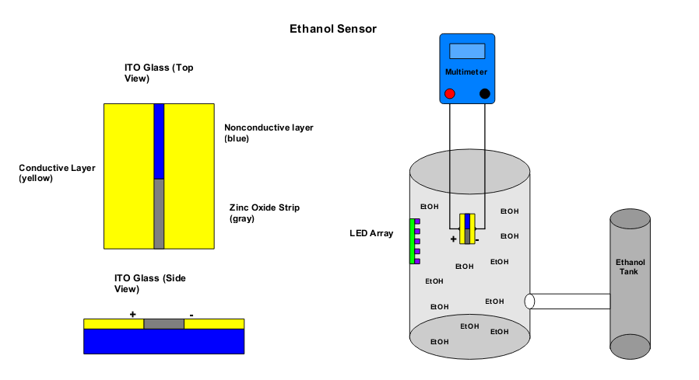

***Figure 1.1*** *- The proof of concept set-up obtained (Left) ITO glass and the etched strip creates separation between the conductive layers. (Right) Sampling chamber depicting measurement of conductive layers with the presence of EtOH and UV LED using a multimeter.*

With these things considered, Peter Weiss, the faculty sponsor for our project, saw a rising need for a device that would combat the issues surrounding VOC emissions. His expertise and interest in chemistry, atmospheric science, and environmental studies drew him to finding a solution, seeing a possible implementation of using ZnO technology to detect EtOH from wineries. He began work with Mauricio Rojas-Andrade, a postdoctoral candidate at the University of California, Irvine, who was responsible for designing, fabricating, and optimizing ZnO sensors, over the summer of 2018. Together they prototyped a glass-jar chamber to measure the resistance response of a ZnO channel on ITO glass, under UV lighting. Having this concept established, Weiss approached us to form a team to design and test a device that would take the glass-jar testing chamber a step further to create a more marketable and user friendly version that could meet the rising need for sensing and data collection in wineries.

Weiss wanted a team to determine the optimal design and operating conditions for the ethanol sensor, integrate that sensor into an ambient air sampling unit, and deploy a prototype at fermentation and aging facilities. This pioneering sensor he had in mind would be taking first-of-its-kind measurements of ethanol gas concentration in exhaust from these facilities. Breaking these tasks down, much of his work is dependent upon the advent of a credible, replicable, and reliable ZnO sensor, which would be developed by the team behind the project. Making sensitive electrochemical measurements, identifying detection limits and possible interferences, and mitigating these boundaries and errors are some of the steps in establishing such a sensor, already having proof of concept in place. Following this, construction of an air chamber with ports for sample injection, performing controlled lab experiments, and bombarding the device to see effects from water vapor, temperature, and changing air compositions would take place to validate design. Lastly, would come implementation, with the device taking measurements of emissions, but also pre- and post- data from wineries where an ethanol scrubber was in place. Doing so would give credibility to the ethanol scrubber, removing the excuse from wineries and vineyards that valid proof of the effect of the scrubber existed. Following the success of these three major steps would come replication, patenting, and commercialization. With all this done, a manuscript detailing the work, design, and application could be drafted to quantify emissions and shine a light on the issues with EtOH.

As one can plainly see, this tentative plan did not solely deal in the realm of simply chemistry, or required just electrical engineers. A proposed device like Weiss’ would require the expertise and workforce of members from many fields of study. It requires chemists, electrical engineers, mechanical engineers, advocates for environmental policy, test engineers, mathematicians, and members with a combination of skills and practices. This multifaceted project requires the effort of a team that can work across fields and specializations, to integrate and mesh many different aspects of a singular device, to achieve what is desired by our client. Hence our engineering team came together to work toward this common goal.

# 

# Chapter 2 - Project Overview

## 2.1 Design Considerations

Our response to the challenge of monitoring ethanol vapor pollution produced by large industrial wineries is to design an instrument capable of measuring the concentration of ethanol vapor accurately and consistently, and to assist regulatory agencies in accrediting scrubbers that help limit air pollution. It was crucial that our product was designed to be adaptable to different environments and easy to operate to accommodate all types of scrubber systems, all types of users, and to simplify future maintenance. We summarized these considerations into a design that would be portable, reliable, and robust.

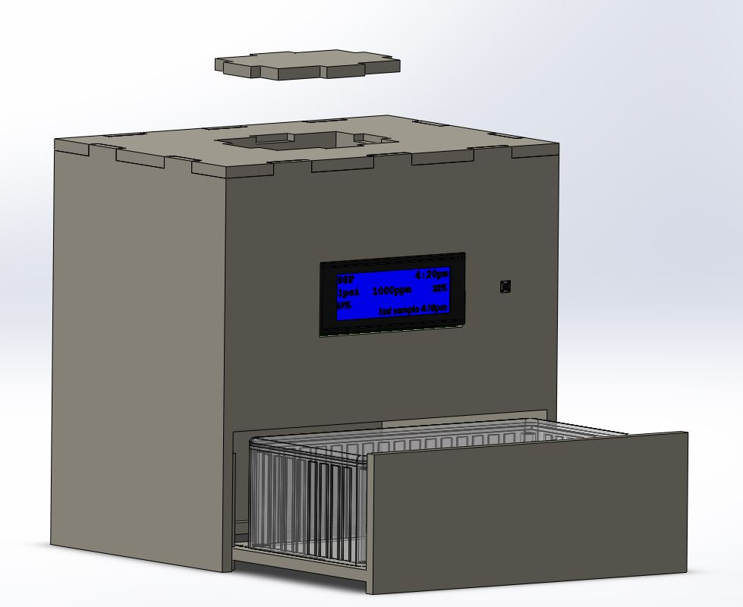

*Figure 2.1a - Sketch of the Design*

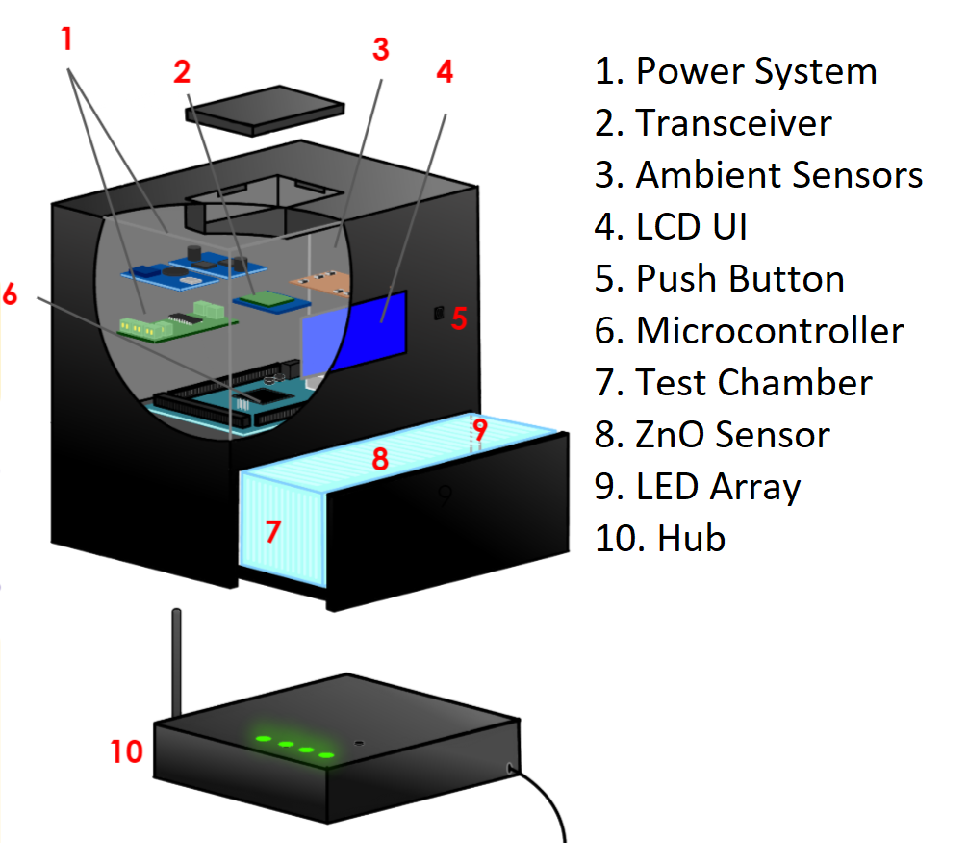

*Figure 2.1b - The second and final revision of the device layout*

With only general specifications given to us by our client, there was freedom in our design to be based on the conditions that we found our instrument would have to endure. Thus the layout of our final design was decided based on the many trade-offs we discovered, that we weighed individually. These trade-offs were most notably: portability, ruggedness, display, and total cost (See **Table 2.1**).

|  |  |  |
| --- | --- | --- |
| **Table 2.1** - Design Trade-Offs | | |
| **Trade-off Options** | | **Comments** |
| Battery Powered | Plug-in | While a plug-in device would make power demands simpler, it would drastically decrease the portability and flexibility of positioning the device. To accomodate large scale wineries, having highly flexible portability and positioning of the device would facilitate multiple node connections, which is why we chose a battery powered system for our design. |
| LCD Text-only Display | Graphing Capability on Node | An LCD display allows users to quantify data easily, while a graph requires more careful observation and more complex hardware and software. The user can easily identify problems and troubleshoot issues ranging from general maintenance to internal issues as easily with a text-only screen as opposed to one with graphing capabilities. |
| Local Storage | Transmit Data | Having local storage on the device would decrease the complexity of the hardware and decrease the power consumption, while having wireless transmission would make it easier for the user to control multiple devices at once, making the product easier to use on a large scale operation. The additional complexity of hardware to transmit data wirelessly greatly facilitates the large scale design parameter specified by our client. |
| Low Cost | High Cost | We wanted the cost of the whole device to be as cheap as possible for the buyer while still being constructed of quality materials that are still resilient to both high and low temperatures, ethanol vapors, and constant water exposure. Given that the cost was mostly a factor for the mechanical housing, this trade-off is conducted in the mechanical section. |

Before starting this project, there were some underlying assumptions that dictated the scope and timeline of the projects deliverables.

For one, we understood that the ZnO sensor had been already created and was ready to be implemented into the device. We thought the hardest part of creating the ZnO sensor had been done and it was our job to further optimize the sensor in Peter Weiss’s lab. We ultimately discovered that there were multiple delays in receiving the correct materials needed for optimizing the ZnO sensor. These materials would take months to order and attain, as many of them were being shipped from other countries, thus delaying our work of testing the ZnO nanoparticle solution that will be laid onto the IDE.

We were under the impression in the Fall of 2018, that we already had some potential winery clients willing to let us on-site to test our finished device. This unfortunately, fell out of place under circumstances that were out of our own control. This would have saved the team time and effort in trying to seek out a client who would be willing to let us put this device on their post-scrubber system. This additional task takes focus away from optimizing and perfecting our design under various extraneous circumstances, meaning additional time will be allocated for this.

We were under the impression at the beginning of the Winter quarter that we would be collaborating with Mauricio to perfect the sensor. Knowing this, we took the initiative to design the housing for the sensor so that once the ZnO sensor was optimized, its current versus voltage characteristic curve when reacting to ethanol could be quantitatively deduced. We assumed that Mauricio found a relationship between the resistance of the sensor and the concentration of ethanol in the chamber such that our sensor can easily be wired to our device and work nominally. With Mauricio attending graduate school at UC Irvine, his proximity to us has posed as a hindrance to our goals of perfecting the ZnO sensor.

## 2.2 Personnel Considerations

The team divided the labor into five subteams for Winter Quarter design: Sensors, Power, Mechanical, Radio Frequency (RF), and User Interface (UI). These subteams were constructed based on individual strengths, relevant coursework, or previous major-related experience. In Spring Quarter, technical roles from Winter Quarter had reduced tasks and emphasis, as focus changed to completing the final stages of our project. However, team members were still responsible for completing sufficient work and documentation of work in their specified area of labor. Although subteams achieved preliminary results individually, collaboration among subteams was imperative to integrate all individual aspects into a cohesive design. The breakdown of member roles and subteam division for is shown in **Table 2.2**.

|  |  |
| --- | --- |
| **Table 2.2 -** Member Roles and Subteam Division | |
| **Member** | **Major/Expertise** |
| Peter Weiss | Faculty Sponsor |
| David Durkin | Electrical Engineering  *Radio Frequency (Winter), Admin/Documentation (Spring)* |
| Jacob Crowley | Electrical Engineering  *Sensors* *(Winter)*, *Integration (Spring)* |
| Bridgette Blotz | Bioengineering - Assistive Technology (Motor)  *Mechanical (Winter), Admin/Documentation (Spring)* |
| James Doan | Bioengineering - Bioelectronics  *Sensors* *(Winter),* *ZnO Sensor (Spring)* |
| John Lupu | Electrical Engineering  *Power / Sensors (Winter)*, *Integration (Spring)* |
| Maelia Uy-Gomez | Bioengineering - Bioelectronics  *User Interface / Sensors (Winter)*, *ZnO Sensor (Spring)* |
| Jorge Alegria | Electrical Engineering  *Sensors (Winter)*, *Integration (Spring)* |

*Sensors (Primary Focus in Winter)*

The Sensors subteam focused on the design, testing, and optimization of the different sensors implemented in the device. It was critical to optimize the sensing ability of the device to ensure the greatest balance between effectiveness, longevity, and ruggedness of the device. In order to accomplish this, different parameters needed to be defined for the device to find the best operating conditions of the instrument. The team was able to design and build the ZnO-EtOH sensor, as well as test and implement environmental sensors to monitor chamber humidity, pressure, temperature, and light intensity.

*Power (Primary Focus in Winter)*

The Power subteam implemented an energy generation and storage system, as well as a method for effective power distribution amongst the various parts of the design. The engineer assigned to this role designed an accurate power budget considering the worst-case scenarios for supply voltage and current draw, as well as form factor, heat, regulation for noise, energy consumption, power-on/off transient behavior, diode choices, analog-digital isolation, and efficiency.

*Radio Frequency (Primary Focus in Winter)*

The RF subteam managed all wireless communication between devices, and took on the printed circuit board design to connect all elements in the project. Using wireless communication, this role required RF design and implementation, which entailed research and testing our communication system between devices. This communication allowed for the transmitting of data between our central hub and any nodes implemented on site in different fermentation tanks.

*Mechanical (Primary Focus in Winter)*

The Mechanical subteam designed the housing of the sampling chamber and external hub which holds the Arduino Mega microcontroller, battery pack, valves, radio frequency components, microSD card breakout board, LCD, UV LED, and all sensors. Special considerations for the design took into account condensation control, air circulation, heat exposure, and pressure regulation. Design began with Computer Aided Design (CAD) and research of materials for construction. The mechanical team constructed a marketable version of the CAD drawings.

*User Interface (Primary Focus in Winter)*

The UI subteam implemented the front- and back-end design using the Arduino microcontroller. The script written by the UI team takes in sensor data from all the nodes and transmits it to the user on the LCD screen at the central hub, and the data is stored locally on a microSD card. The UI team focused on the need to transmit data through high frequency ranges, and ensuring data was not distorted in any way when being relayed back to the user. The main priority of the UI design was functionality and and easy-to-use interface.

*Administration/Documentation (Primary Focus in Spring)*

The Administration/Documentation subteam primarily focused on documenting the projects progress, compiling data and testing results into clearly formatted reports, drafting a user manual, leading and organizing meetings on presentation preparation, and revising the final report as needed.

*Integration (Primary Focus in Spring)*

This subteam focused on integrating the design into a ready to use prototype for onsite testing at wineries. The Integration subteam had to work closely with the Mechanical subteam in order to successfully assemble and organize the electrical components into the mechanical housing structure.

*ZnO Sensor Production (Primary Focus in Spring)*

The ZnO Sensor Production subteam worked on the ZnO sensor, including testing and validation of the design. This team worked in close contact with Peter Weiss and Mauricio Rojas-Andrade to produce the promised deliverables of response curves, optimal design, SOPs, and instructions and file for replicability.

# Chapter 3 – Sensors

## 3.1 Environmental Sensors

The goal of the sensors subteam was to utilize environmental pressure, humidity, light intensity, and temperature sensors to measure conditions inside the ethanol chamber. Monitoring the consistency of ambient values helps preserve the quality of the data from the ZnO sensor. Focus was given to further the development of the ZnO sensor that would relate channel resistivity to ethanol concentration in parts per million. This tasked proved to be beyond the scope of the team’s expertise, and our list of deliverables was adjusted to reflect this change (See **Future Work)**. Nonetheless, we were still able to contribute to the development of the ZnO sensor in part, without the pressure of requiring a completely functional product by the end of the school year. The sensors are placed such that their leads and metal components are stored in dry airspace and their sensing portions exposed in the ethanol chamber. The ZnO sensor is designed to take measurements on a predetermined interval that can be specified by the user.

Humidity Sensor

The humidity sensor monitors the humidity level inside the chamber in order to prevent condensation. This measurement is useful for the device in the sense that it informs the user when the condensation within the device is too high to function (above 90% humidity). Furthermore, once the valve feature has been developed, this sensor will be able to trigger an operation to begin flushing or draining the chamber of the condensed water vapor. Since temperatures can be expected to exceed 100 ℉ in most exhaust pipes, a sensor resistant to high temperatures was necessary. The HIH-4030 was chosen for this reason. The sensor samples in 500 ms intervals, but is only needed for discrete data points, as with most of the sensors. Regarding other operating conditions, the datasheet states that this sensor must be shielded from bright light in order to maintain accurate results. This posed a problem because a UV LED is needed in the chamber, but this issue was resolved by placing the sensor behind and away from UV LED. While, there is still refracted and reflected light, it is nominal. More information regarding the placement of sensors can be found further on in the report under **Mechanical Design Considerations**.

The datasheet specifications for the HIH-4030 can be seen below in **Table 3.1**.

|  |  |  |  |  |
| --- | --- | --- | --- | --- |
| **Table 3.1** - HIH-4030 Humidity Sensor Datasheet Specifications | | | | |
|  | Min. | Typical | Max. | Units |
| Voltage | 4 | - | 5.8 | [V] |
| Current | - | 200 | 500 |  |
| Temperature | -40 | - | 185 | [Fahrenheit] |
| Humidity | 0 | - | 100 | [% RH] |
| Accuracy | -3.5 | - | +3.5 | [% RH] |

**Equation 3.1.1: $RH=(V_{OUT}-0.958)/0.0307$**

**Equation 3.1.1** above displays the transfer function from the datasheet but it only applies to an ambient temperature of 25 degrees Celsius. Since our device is expected to operate at different temperature ranges, the temperature sensor was used to calibrate this formula. The datasheet includes three different graphs for the following temperatures: 0, 25, and 70 degrees Celsius. The maximum voltage for these three graphs is 3.9 Volts and this value decreases by 0.0062 Volts for every one degree Celsius increase in temperature. This decay in maximum voltage is only applicable if the temperature is over zero degrees Celsius, however it is very unlikely that testing will be performed below this zero degrees. Since the voltage depends on the temperature, the temperature sensor can provide feedback to properly calibrate the humidity readings. The schematic for this sensor including the temperature sensor can be seen in **Appendix B**.

The code for this sensor and the following sensors can be found in the **Appendix** **C**. The resulting humidity output for this sensor has a $±3\%$ error as expected due to the datasheet. This is acceptable due to the mechanical design which prevents the effects of water building up in the chamber due as a result of condensation. More information regarding this design can be found in the Mechanical subsection.

Pressure Sensor

In addition to providing pressure information for calibration of the ZnO sensor, the purpose of the pressure sensor was to detect if the valves are opening and closing properly during respective air-in and air-out states. The MPX5500DP pressure sensor from NXP was selected due to the pressure range at which it operates, its sampling rate, and its ability to operate at high temperatures. Having a minimum sampling rate of one millisecond means that it is very responsive to change, which is extremely useful for our application since this is a safety feature that ensures proper pressure to prevent chamber leakage or component damage when air is being let in.

**Table 3.2** lists the operating ranges and other characteristics for the MPX5500DP.

|  |  |  |  |  |
| --- | --- | --- | --- | --- |
| **Table 3.2** - MPX5500DP Operating Ranges and Conditions | | | | |
|  | Min. | Typical | Max. | units |
| Pressure | 0 (0) | - | 500 (72.5) | kPa (PSI) |
| Temperature | -40 (-40) | - | 125 (257) | Celsius (Fahrenheit) |
| Accuracy | - |  | - |  |

After consulting with the local beer brewery, Humble Sea Brewery, we became aware that the pressure can reach up to 15 psi in the valves therefore a pressure sensor that can operate over this range was required. Though this wasn’t our intended audience (like a large-scale winery), it was still an ethanol fermentation facility, which we believed would be close enough to guide this portion of our design. It is then important to note, that if the 15 psi threshold is surpassed while using an updated version of the state machine, this feature will not function as intended and must be updated. The MPX can withstand the 15 psi threshold and responds to increase of airflow during testing, which was done with an air pump and a flowmeter. We did not have the opportunity to test the sensor’s resilience at pressures higher than 3 psi. The pin configuration for this sensor can be seen in **Appendix B**.

This circuit was recommended by the manufacturers for power decoupling purposes. The input voltage was connected to the 5V pin on the Arduino and the output voltage was connected to an analog pin. The output voltage was used to calculate the pressure by using the transfer function provided in **Equation 3.1**. This transfer function can be seen in the **Equation 3.1** below and for further information, refer to the datasheet in the appendix.

**Equation 3.1: $V_{OUT}=V_{IN}*((0.0018*P) +0.04)$**

The relation between voltage and the analog to digital converter reading can be seen in **Equation 3.2.**

**Equation 3.2: $(V_{OUT}/V_{IN})=(1023/ADC)$**

Replacing $(V_{OUT}/V_{in})$ from Equation 3.1 and then solving in this equation in terms of pressure, the transfer implemented can be seen below in **Equation 3.3**.

**Equation 3.3: $P=((1023/ADC)-0.04)*(1/0.0018)$**

The code for this sensor can be found in the appendix.

Temperature Sensor

The temperature sensor was implemented using the 3950 NTC 10k Precision Epoxy Thermistor. The resistance of a thermistor varies with respect to the applied temperature, which can then be calculated by measuring the voltage across the thermistor. In the case of this thermistor, NTC (negative temperature coefficient) means that the resistance decreases as the temperature increases and 10k refers to the resistance at room temperature.

The datasheet for the Adafruit thermistor did not specify specific operating parameters. The resistance across the thermistor was recorded using a voltage divider instead of a Wheatstone bridge since the resistance of the thermistor did not have a wide range. The schematic for this sensor can be seen in **Appendix B**.

After rearranging the voltage divider formula in terms of thermistor resistance, the transfer function can be seen below. **Equation 3.3** was plugged into **Equation 3.4** to obtain a transfer function in terms of the analog-to-digital conversion value.

**Equation 3.4: $R_{T}=(R*1023-ADC))/(ADC)$**

As the surrounding temperature increases, the resistance across the resistor decreases and the resistance increases as the temperature decreases. Once the resistance was calculated, the temperature was obtained using the Steinhart-Hart equation. The Steinhart-Hart equation is a mathematical formula that relates temperature to resistance and the modified version from the datasheet can be seen in **Equation 3.5**. In this equation, $T_{O}$ represents room temperature (298.15 K), B represents the thermistor coefficient (3950), and $R_{O}$ represents the thermistor resistance at room temperature $(10kΩ).$

**Equation 3.5: $(1/T)=(1/T_{O}) +(1/B)*ln(R/R_{O})$**

The **equation 3.5** results in a temperature in Kelvins therefore a conversion to either Celsius or Fahrenheit is required. The unit currently displayed is Fahrenheit due to our clients preference. The resulting temperature calculated by this sensor had a $±4$ degrees Fahrenheit error but this is acceptable because even with this error, the user will still be able to determine if the temperature within the chamber is exceeding a desired range. Also, it is a value that our client wished to have displayed and knowing the temperature inside of the housing unit is useful to prevent overheating of some of the more temperature sensitive components.

Light Intensity Sensor

In order to detect whether the UV LEDs are working properly, a light intensity sensor was implemented. The CdS photoresistor from Adafruit was selected due to its ability to operate under UV light exposure. The resistance of the photoresistor decreases as the light intensity increases, acting similarly to that of the thermistor. Since this photoresistor acts a potentiometer, the sampling rate of the sensor was not an issue. Also, the CdS photoresistor typically requires less than 1 mA of current therefore the impact on the battery life was not drastic. More information regarding battery life can be found further on in the **Power** chapter.

The unknown resistance across the light intensity sensor was recorded using a voltage divider circuit similar to the temperature sensor. The schematic for this can be seen in **Appendix B**.

After rearranging the voltage divider equation in terms of the resistance across the photoresistor, the resulting ADC to photoresistor resistance transfer function can be seen in **Equation 3.6**.

**Equation 3.6: $R_{L}=R * ((1023/ADC)-1)$**

For this sensor, as the light intensity increased, the voltage across the photoresistor increased and the resistance for the photoresistor decreased and vice versa. If the resistance of the photoresistor is known, the intensity of the light incident on this sensor can be determined by mapping out the resistance values under different lighting situations. In the housing unit, the light intensity sensor is to be two centimeters away from the UV LEDs therefore the testing that took place was performed at this proper distance. The light intensity responded accordingly to the 450 nm wavelength of the UV LED and the recorded resistance for the photoresistor when the UV LED is turned on was in the range of 190 to 200 Ohms. Therefore, if the resistance of the photoresistor is not in this expected range when the UV LED is supposed to be turned on, then this indicates a UV LED error and the user is notified to prevent unreliable data from being recorded.

## 3.2 Zinc Oxide Sensor

Potential applications of zinc oxide as a sensing mechanism and its reactive semiconductor properties have been studied and well documented in multiple scientific papers. The unique chemical properties of zinc oxide nanoparticles make them ideal candidates for sensing the presence of ethanol vapor.

Zinc oxide was chosen as our substrate for its ability to accurately measure impurities in air, its low cost, and safety. The nanoparticles are fairly cheap, and only very small amounts are needed at a time to produce the stock suspensions and sensors themselves. In addition, zinc oxide is biologically safer than other sensing chemicals used which makes the production process much easier and hassle-free without having protocols in place to ensure safe practice. Chemical safely refers to the potential hazards that a particular chemical agent poses to biologic systems or the environment. Chemical safely is a essential consideration because metal oxide semiconductors are typical non-organic compounds that do not degrade naturally in the environment they are exposed to. All these features were important in considering the final product because our goal is to make our device easy to use and relatively affordable while staying environmentally conscious. Our decision was also based on the material’s ultraviolet sensing properties due to its direct wide bandgap. Zinc oxide offers easier preparation and reproducibility than other UV light-sensing chemical structures due to its larger surface area.

|  |  |  |  |  |  |
| --- | --- | --- | --- | --- | --- |
| **Table 3.3** - Tradeoff summary between sensing methods and metal oxide semiconductors | | | | | |
|  | SnO2 | WO3 | In2O3 | Fe2O3 | ZnO |
| Cost for nanoparticles | $68/25g  For 55nm | 52/25g  For 60nm | 168/25g  For 20-70nm | $45/25g  For 20-40nm | $39/25g  For 35-45nm |
| Chemical Safety | Irritant | Irritant | Health Hazard | INC | Environmental Hazard |
| Band gap | 3.4eV | 2.2eV | 2.7eV | 2.2eV | 3.37eV |

*Prices and specifications retrieved from National Center for Biotechnology Information and US Research Nanomaterials.*

When ZnO is exposed to oxygen in the air, the oxygen molecules are adsorbed onto the surface of the ZnO particles. Each adsorbed oxygen molecule holds onto an electron from the conduction band (band of electrons orbitals that electrons can jump up into conduction band from the valence band when excited). This reduces the number of electrons available for conduction near the surface. Therefore, oxygen reduces the conductivity of the device, resulting in higher resistivity. The presence of the UV LED allows valence electrons to move to the conduction band where more free electrons are generated. The number of free electrons increases the current flow and decreases the resistance in the semiconductor (Hullavarad and Hullavarad, 2010).

## 3.2.1 Testing and Validation

We began testing and validating the proof-of-concept zinc oxide nanoparticles on indium tin oxide (ITO) glass given to us by our advisor, UCSC Chemistry Department Associate Professor Peter Weiss, and his postdoctoral researcher, Mauricio Rojas-Andrade. The tests ran on zinc oxide and ITO glass as its doping medium for the inorganic compound were purely for initial verification purposes and had not yet gone through substantial trials when the team joined the project. Because this project was in such early stages, our goal was to create a functional and reproducible zinc oxide sensor capable of detecting ethanol vapor and translating resistivity to parts per million values, in addition to the implementation of all the environmental sensors. As mentioned previously, this goal shifted when the team recognized that the sensor fabrication process was much more chemistry-intensive than we realized, thus beyond the scope of our expertise. With this in mind, we wanted to continue to push the sensor development as far as we were capable of with the background knowledge of team members and the research available.

The team started where Peter and Mauricio left off, following the testing procedure they had developed on the ZnO nanoparticles drop-casted on ITO glass. The original procedure involved physically creating a channel across the conductive coating of the ITO glass. ZnO nanoparticles were then carefully deposited along the channel and “sealed” with hydrochloric acid (HCl). After countless trial and errors with the ITO glass throughout the first half of Winter Quarter, the team realized that producing a reliable sensor with the procedure they had been following would not work, because the HCl was dissolving the conductive coating on the ITO glass. The sensors team attempted to combat this degradation of the conductive layer by wrapping the ITO was acid proof tape. However, some of the acid would still leak into the outer surface of the glass compromising the conductivity of the glass surface. Then smaller quantities of HCL was used to prevent leakage onto the glass but these micro droplets would slide off the surface of the Zinc Oxide powder and wouldn’t keep all the powder sealed onto the glass. It was at this moment when the team realized this part of the project was beyond our skill set, and we re-evaluated the reality of our deliverables. Luckily, around the time of this realization, Peter introduced the team to the Micrux Interdigitated Electrodes (IDEs), pictured in **Figure 3.1**. The IDEs are a glass substrate with gold electrode pads and an SU-8 coating. To create a connection between the two electrodes, you deposit your material in the electrochemical cell (the round section) where “fingers” of gold electrode plates are in an interlocked pattern. Despite the challenges faced throughout the beginning of the sensor fabrication, we continued on with the new sensors to develop the fabrication and testing protocol.

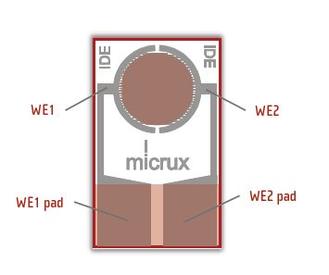

***Figure 3.5 -*** *Micrux Interdigitated Electrode is used as our platform for the Zinc Oxide nanoparticles. The working electrode (WE) pads are used to make contact with the positive and negative terminals of the multimeter. Image taken from* [*https://www.micruxfluidic.com/en/electrochemical-solutions/thin-film-electrochemical-sensors/interdigitated-electrodes-ide/*](https://www.micruxfluidic.com/en/electrochemical-solutions/thin-film-electrochemical-sensors/interdigitated-electrodes-ide/)

*LED Array*

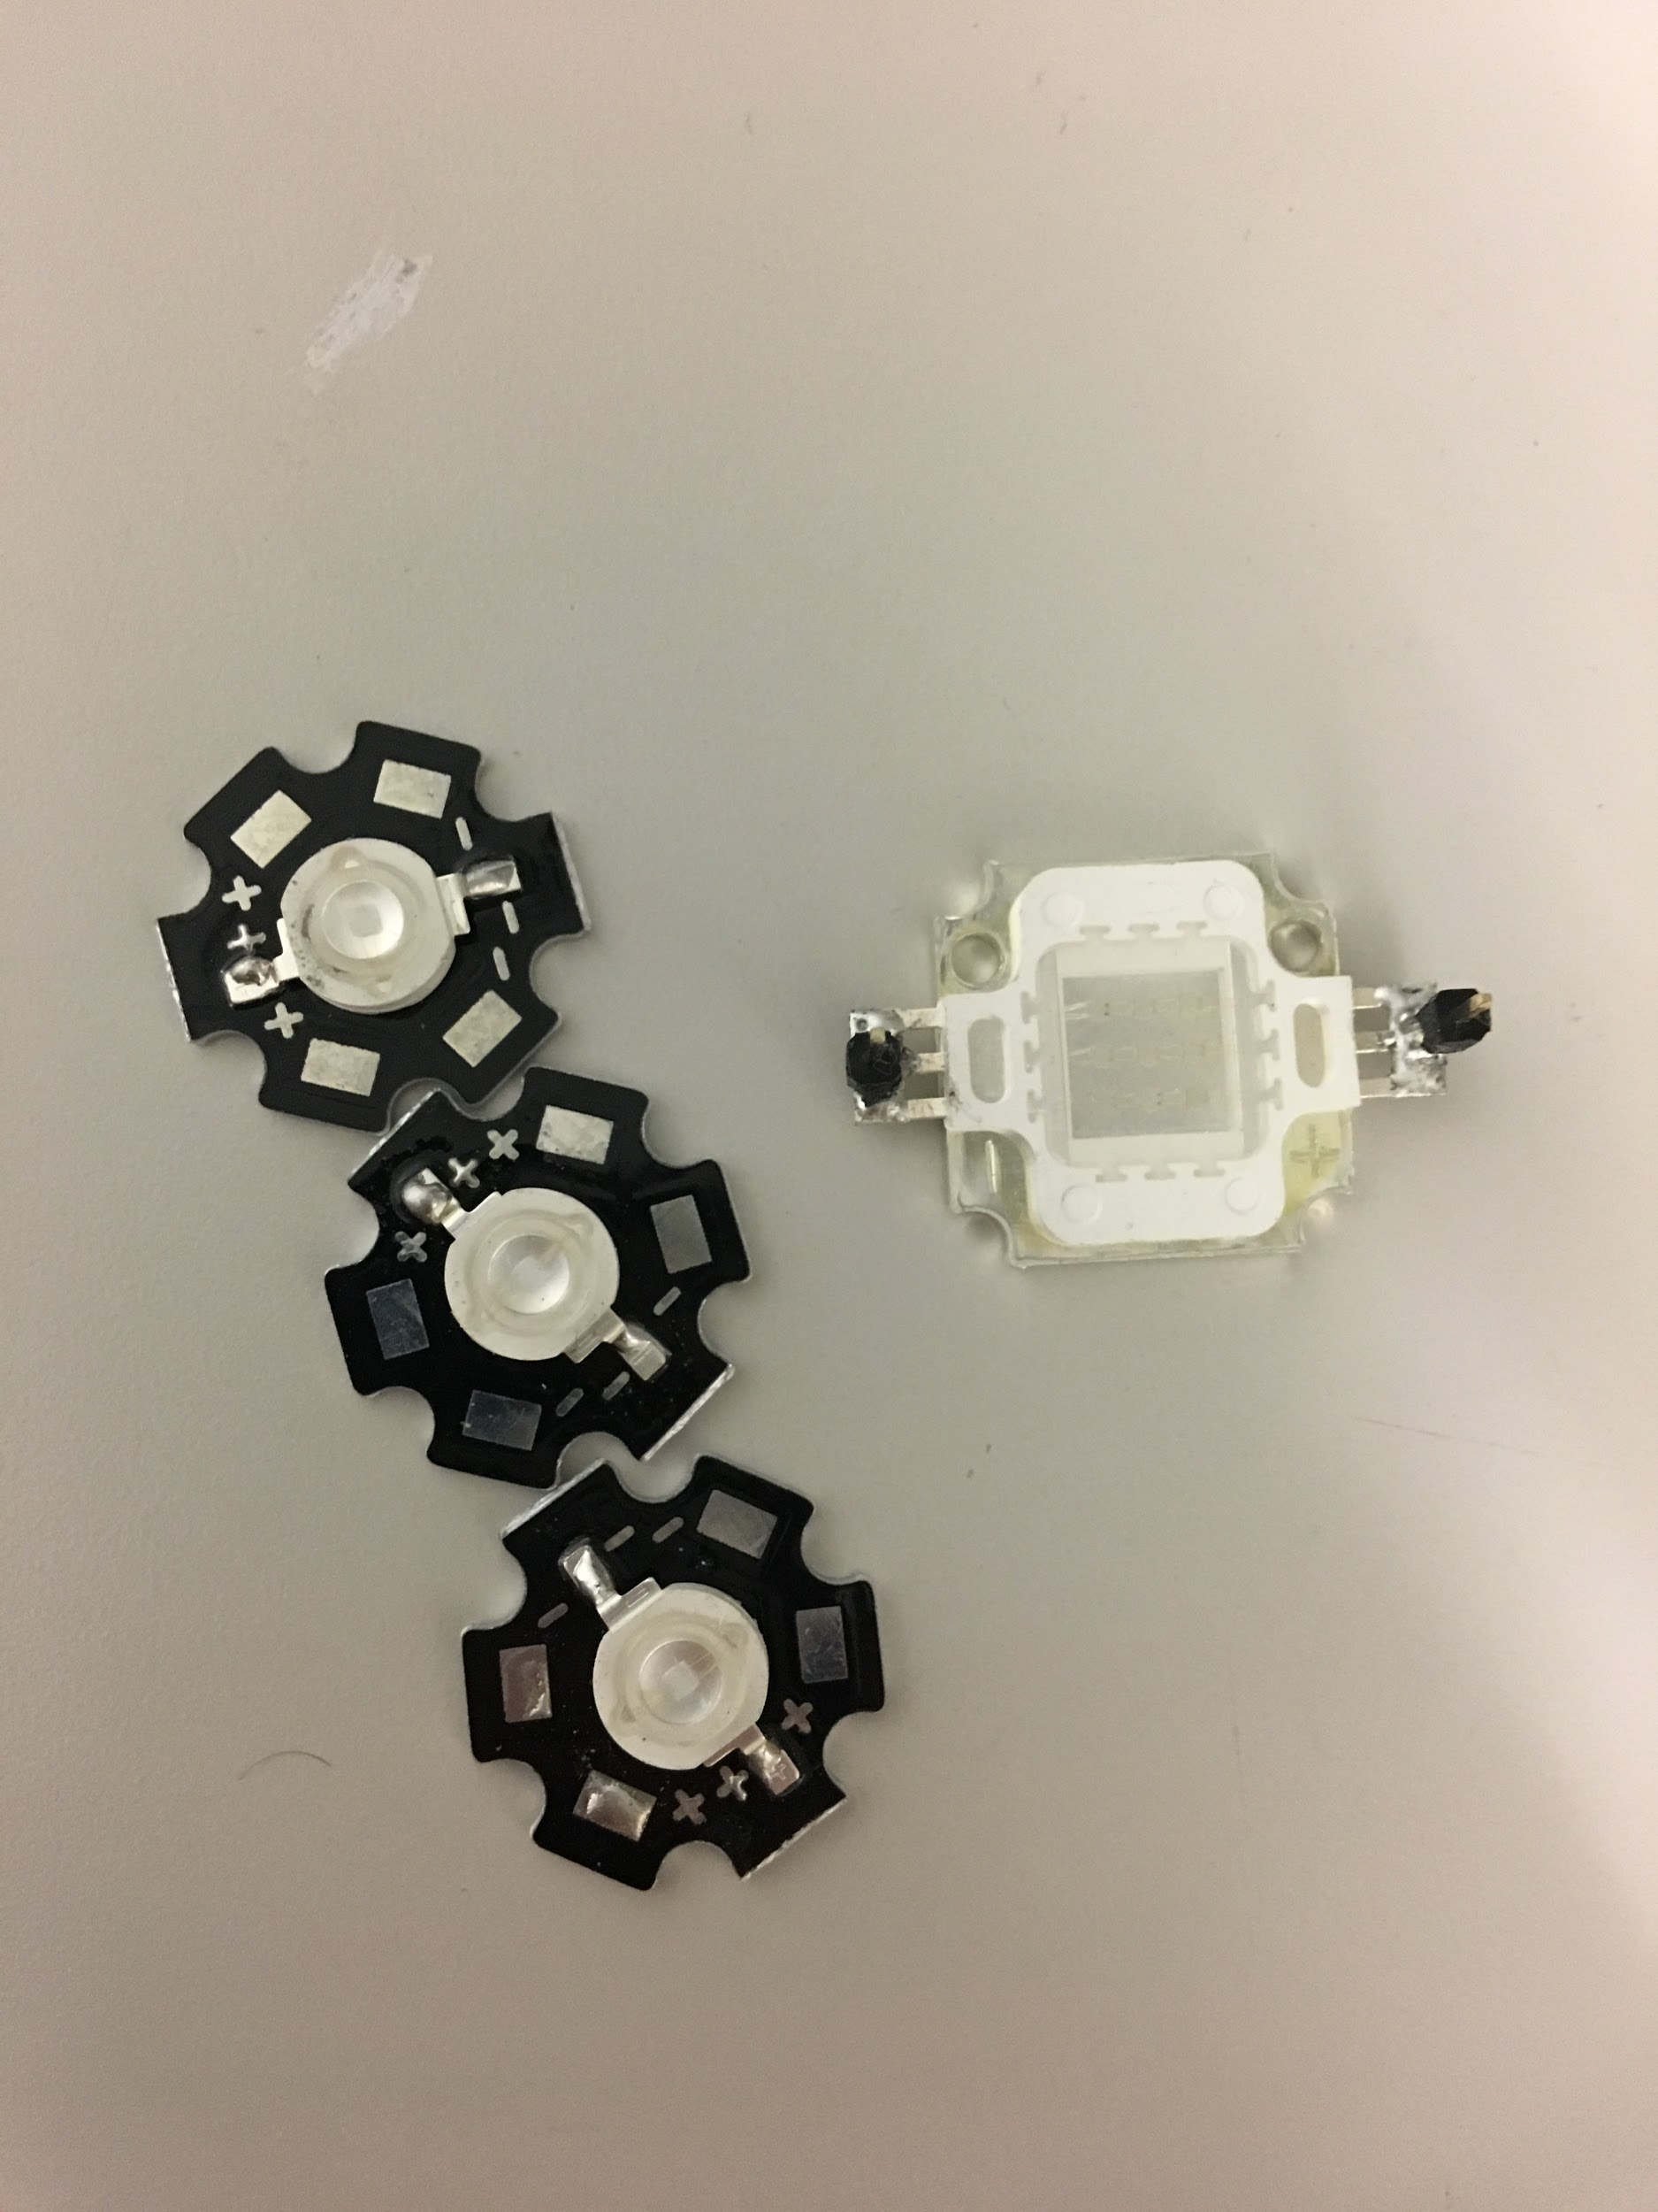

***Figure 3.6:*** *Chanzon LED array and LED bulbs.*

In order to test the Zinc Oxide sensor, we need a source of UV light to excite the electrons of the ZnO. The Zinc Oxide reacts in at wavelength of 365nm. A light source with enough power to excite the ZnO is needed. For initial testing, we used a UV LED flashlight which proved to work well in regards to what we needed to see to prove a reaction was occurring. For final chamber testing we used 3W LED bulbs for testing the ethanol sensors. We originally tried using a 10W LED array, but ran into multiple problems including the array flickering on and off and individual bulbs burning out, even when supplied a low voltage and current. We considered a heat sink, but the time spent engineering a solution coupled with its high voltage rating (9-11V) made the array a less desirable option for our final product.

This LED bulb only needs between 3.3-3.8V and 700mA of current to operate as opposed to the LED array which needs 9-12V. The LED bulbs can be power from a 3.3V power from the Arduino which is intended to be used in the final design. We place two of these bulbs in series in order to supply an sufficient amount of UV exposure to illicit a response. We tested the sensors response to UV light alone to ensure the sensor would in fact respond to the UV light, and we took measurements at different distances to see the effect light intensity had on the sensing capacity. **Figures 3.9-3.11**  show the sensor response from a single sensor at different distances from the UV LED bulb, while **Figure 3.10** shows the average resistance drop. From these tests, we could conclude that the resistance drop decreases as the UV light is placed farther away from the sensor. The angle at which the UV LED is hitting the sensor also has an effect on the response of sensor itself which has been tested. The response to the UV simulus is greatest when the sensor is placed directly in front of the sensor.

*Measurement Instrumentation*

Data collection from the IDE was done using a bluetooth digital multimeter (DMM) in order to get real time data from the Zinc Oxide sensors that were fabricated. Resistance values were measured anywhere between 100Ω - 60MΩ in response to exposure to ethanol gas and UV light. The sampling rate at which the resistance is measured is one value every second. The data collect is transmitted wirelessly via Bluetooth to a mobile application provided by the manufacturer of the multimeter. An important note when using the bluetooth DMM is that your phone will not record messages if your phone is locked. You are able to use other apps, but the phone must remain unlocked to take continuous measurements. This is the cause for the random jumps in resistance values found in the testing graphs. The following circuit diagram shows the setup of our testing apparatus. There are often strange peaks in our data, due to a response from the multimeter to a change in magnitude. 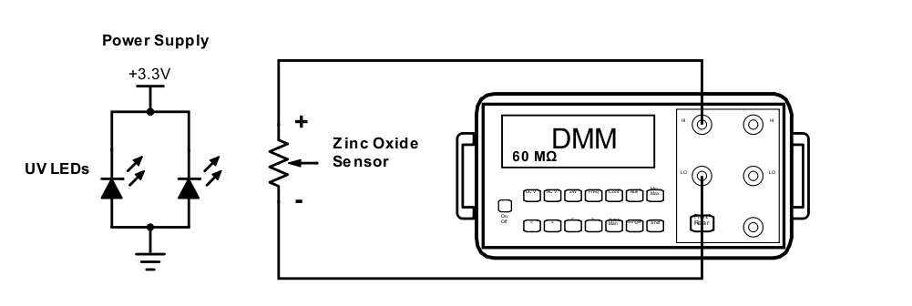

***Figure 3.7*** *Digital Multimeter from SainSmart was used to measure the resistance of the Zinc Oxide sensor. The resistance limit that the DVM can measure is up to is 60MΩ.*

*Flow Rate and PPM Calculations*

Determining the parts per million (ppm) concentration of ethanol vapor requires knowing the volume of ethanol in the chamber and the flow rate at which ethanol is filling the chamber. A flow meter is used between the ethanol tank and the chamber to measure the flow rate of the ethanol standard. A mass flow sensor (flow meter) has positive and negative leads that have a potential voltage difference between 0-5V. The voltage range corresponds to the a flow rate range between 0 to 2L/m.

((Voltage of flow meter (V))/5)*2 = flow rate

After measuring the flow rate and volume of the chamber we can find the ppm concentration. The volume of the test chamber is 1165mL which was determined using the dimensions of the chamber. However, since we measured our chamber with a ruler, the significance of the measuring instrumentation is around 2 significant figures. The ethanol gas in the tank has a ppm concentration of 223ppm.

$1mg/mL = 1000$ ppm

((Conc. EtOH in tank) * (flow rate))/(Vol. Of Chamber) = (Conc. of EtOH in chamber)

$(0.223mg/ml *flow rate)/1165mL$ = Conc. of EtOH in ppm

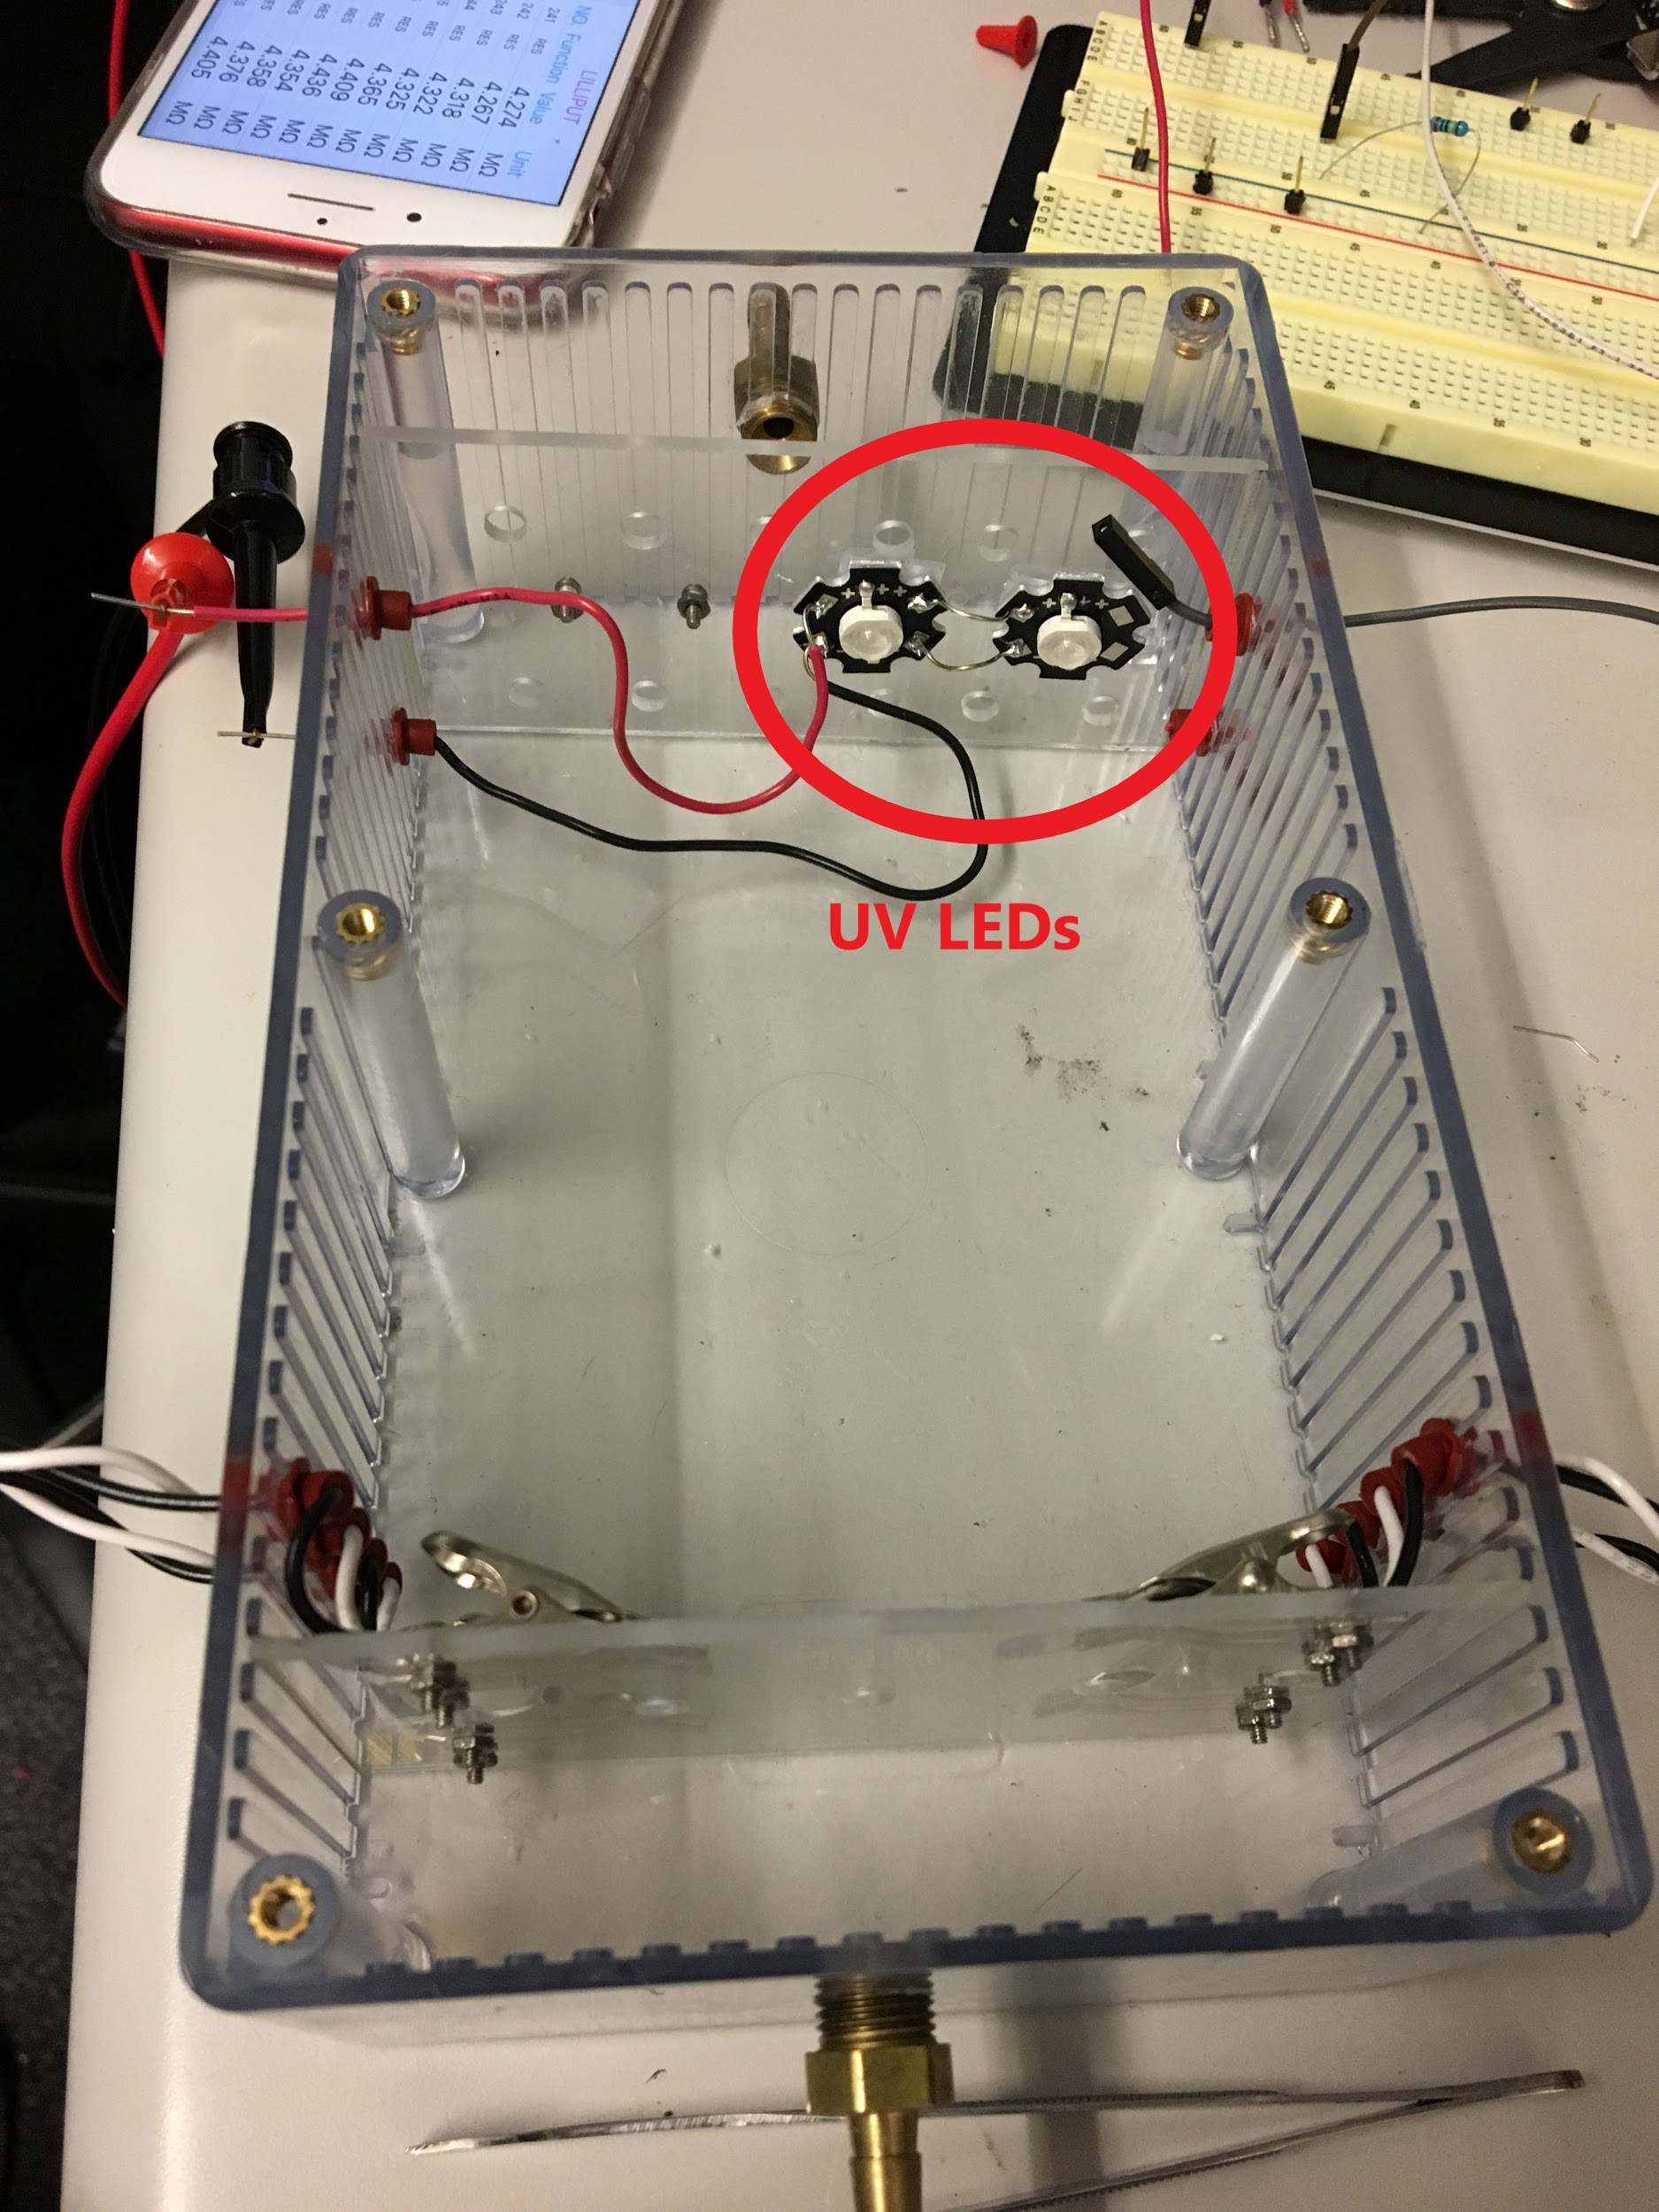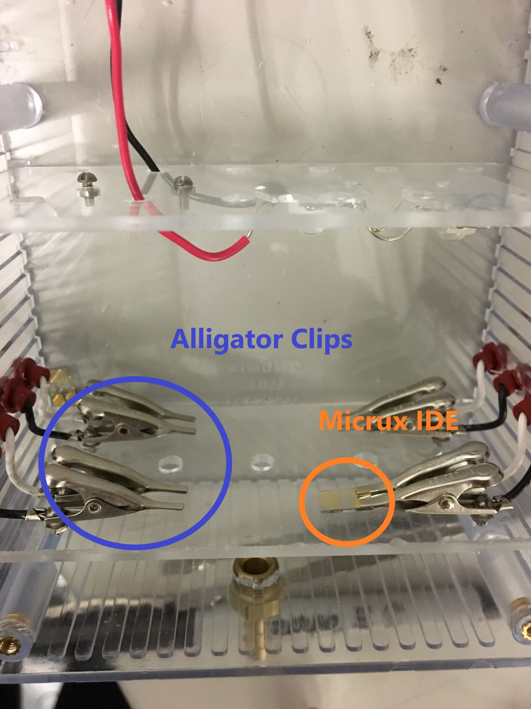

***Figure 3.8*** *- The final test chamber used for measurements during the Spring Quarter*

During the spring, the team was able to further the progress made in the winter. It was during this quarter we received the parts we would use in the final design, such as an LED array and driver, as well as a “real” test chamber, as opposed to a jar with a drilled hole in the lid. The sensor requires an airtight chamber in order to prevent leakage of ethanol gas. The test chamber seen in **Figure 3.8** was designed by our advisor with the help of the mechanical subteam, and manufactured by Joe Cox at the Machine Shop on campus. It is made out of Lexan, a type of plastic, with holes for wiring with rubber grommets and a removable lid that can be screwed on, all to ensure the airtight chamber required for testing. The testing apparatus includes an inlet where the ethanol can flow into the chamber and an outlet that is used to flush out the gas. The chamber used contains 4 pairs of power and ground alligator clips screwed onto a plastic slide in the chamber. These clips hold the sensors in place and are connected to wires that allow us to simultaneously measure the response of each individual sensor, should that be required later on. There are also two 3W UV LEDs connected in parallel and attached to another plate, with power lines running out of the chamber. A power supply is used to drive the LEDs with an input voltage range of 3.4-3.8V and a current limit of 700mA. The slides that the sensors and UV LEDs are mounted onto can be removable and the distance between the two can be adjusted thanks to the slots along the inside of the chamber. The full fabrication and testing procedure can be found in the SOP in **Appendix D**.

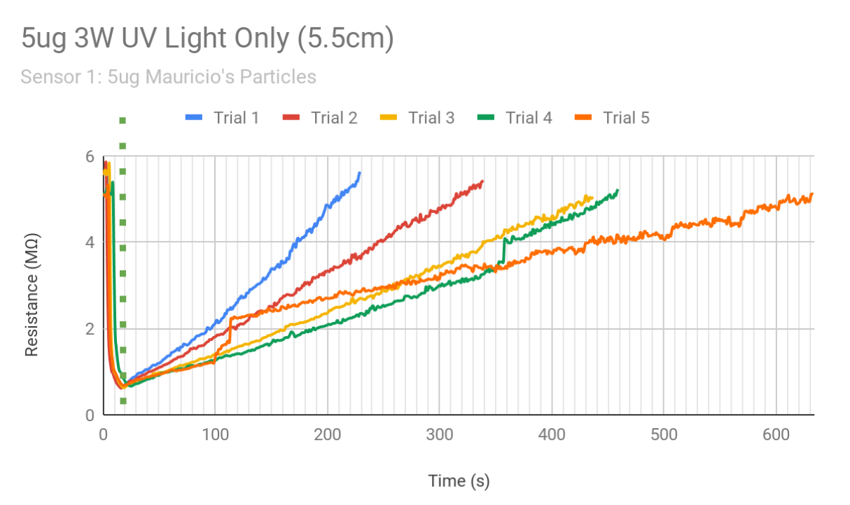

***Figure 3.9*** *5𝜇g sensor response to 3W UV 5.5cm away. The dotted line*

*marks the point the UV light was turned off.*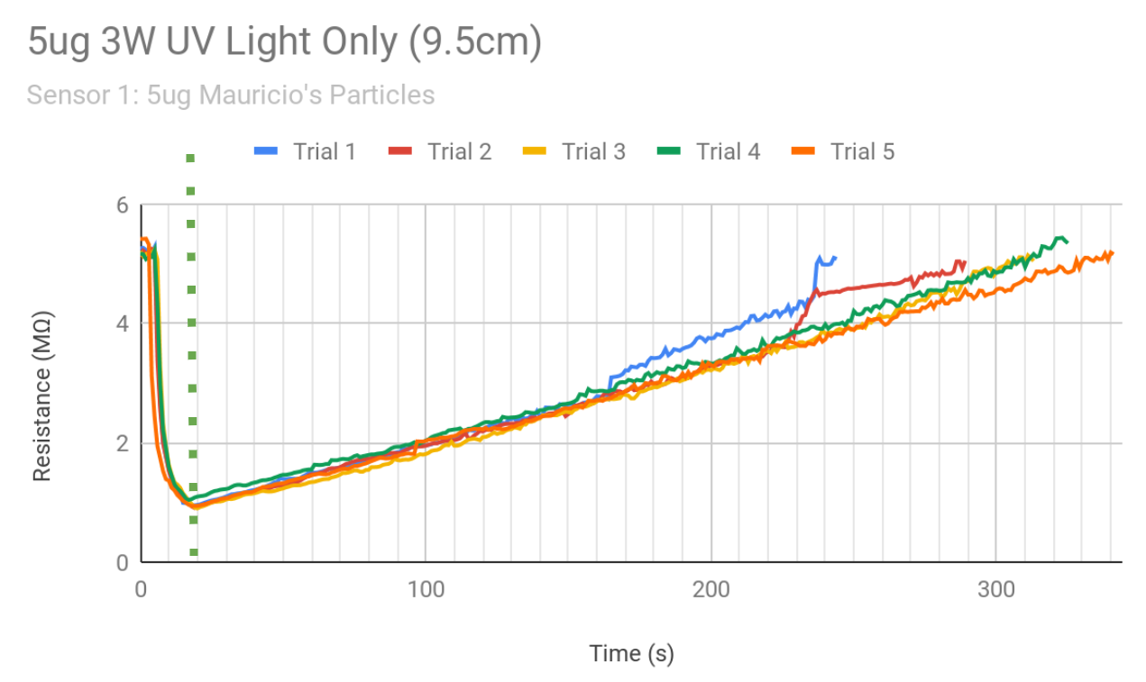

***Figure 3.10*** *5𝜇g sensor response to 3W UV 9.5cm away. The dotted line*

*marks the point the UV light was turned off.*

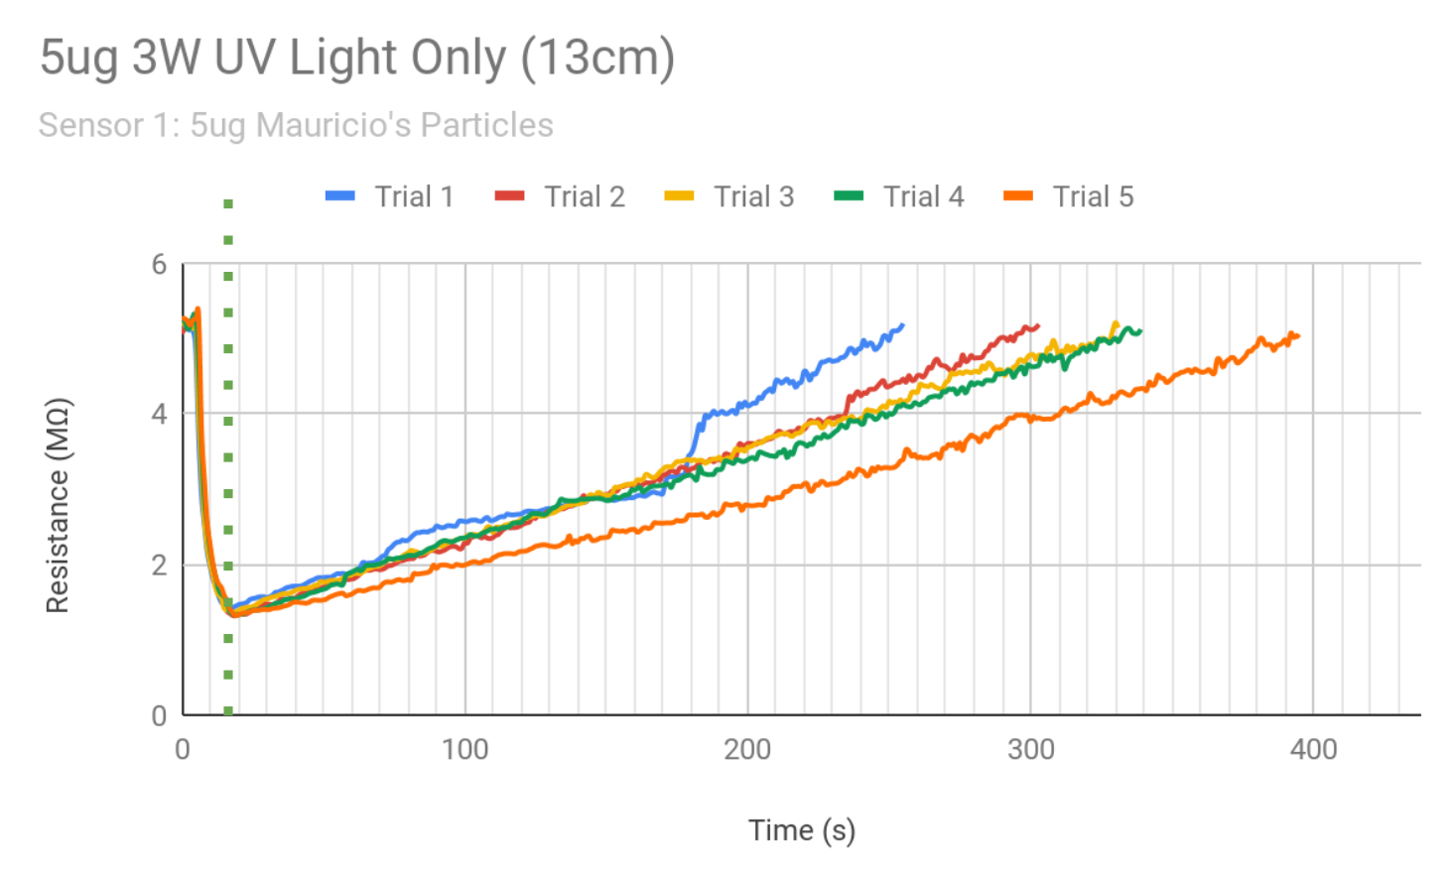

***Figure 3.11*** *5𝜇g sensor response to 3W UV 13cm away. The dotted line*

*marks the point the UV light was turned off.*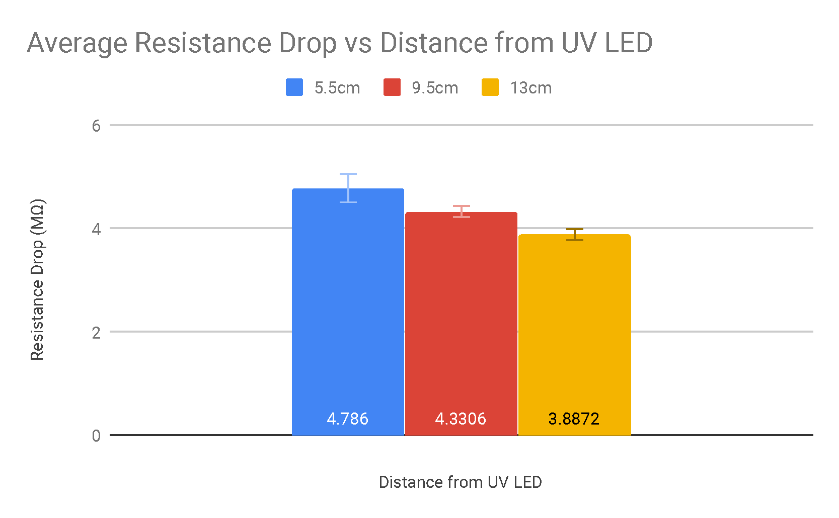

***Figure 3.12*** *Average resistance drop (over 5 trials) on the same sensor across different distances between the UV LEDs and the ZnO IDE sensor*

In our UV test graphs, we also found the slopes of the recovery periods, though degradation between trials seems apparent as each trial is run. The slopes of each trial for each distance, and their corresponding R value for linear regression is listed in **Table 3.4**. For graphs with a value jump, explained in Measurement Instrumentation, are listed with a line break for each part of the curve. A linear regression fits most, but not all cases. In the trials that a linear regression was not the best fit, a quadratic was. The average slope is around 0.02.

|  |  |  |  |  |  |  |
| --- | --- | --- | --- | --- | --- | --- |
| **Table 3.4** Slopes and R value for linear regression for all UV Light Only trials | | | | | | |
|  | **5.5cm** | | **9.5cm** | | **13cm** | |
| m | R | m | R | m | R |
| **Trial 1** | 0.0232 | 0.988 | 0.0128  0.0182 | 0.996  0.988 | 0.0112  0.0177 | 0.942  0.981 |
| **Trial 2** | 0.0148 | 0.999 | 0.0133  8.79x10-3 | 0.989  0.901 | 0.0134 | 0.995 |
| **Trial 3** | 0.0106 | 0.996 | 0.0142 | 0.993 | 0.0119 | 0.998 |
| **Trial 4** | 8.5x10-3  0.0116 | 0.988  0.98 | 0.0138 | 0.996 | 0.0115 | 0.997 |
| **Trial 5** | 7.22x10-3  5.28x10-3 | 0.735  0.993 | 0.0131 | 0.998 | 9.76x10-3 | 0.991 |

Testing and Validation

After validating a sensors’ response to UV light alone, we tested a response to EtOH. Some important notes to **Figure 3.13** are: 1) This is the same sensor used in our UV light only trials (**Figures 3.9-3.11**) and 2) We are using Mauricio’s nanoparticles that he fabricated on his own at UC Irvine. The slopes for the response are listed in **Table 3.5**, for comparison to the response in the UV only trials. We ran these tests slightly different than our final testing protocol, which will be described later, and can be found in our Standard Operating Procedure, **Appendix D**. For these runs, we flushed 70ppm of EtOH into the testing chamber before measurements were taken, and then the UV light was turned on. For time purposes, we maintained a baseline resistance of ~5MΩ and let the sensor drop to ~0.2MΩ before turning off the UV light, for consistency. The average resistance drop in 10s with EtOH in the chamber was 4.93kΩ, only a 0.2kΩ difference. This was cause for concern, because this change is not significant enough in relation to the range of resistance of the sensor (in the high megaohm range).

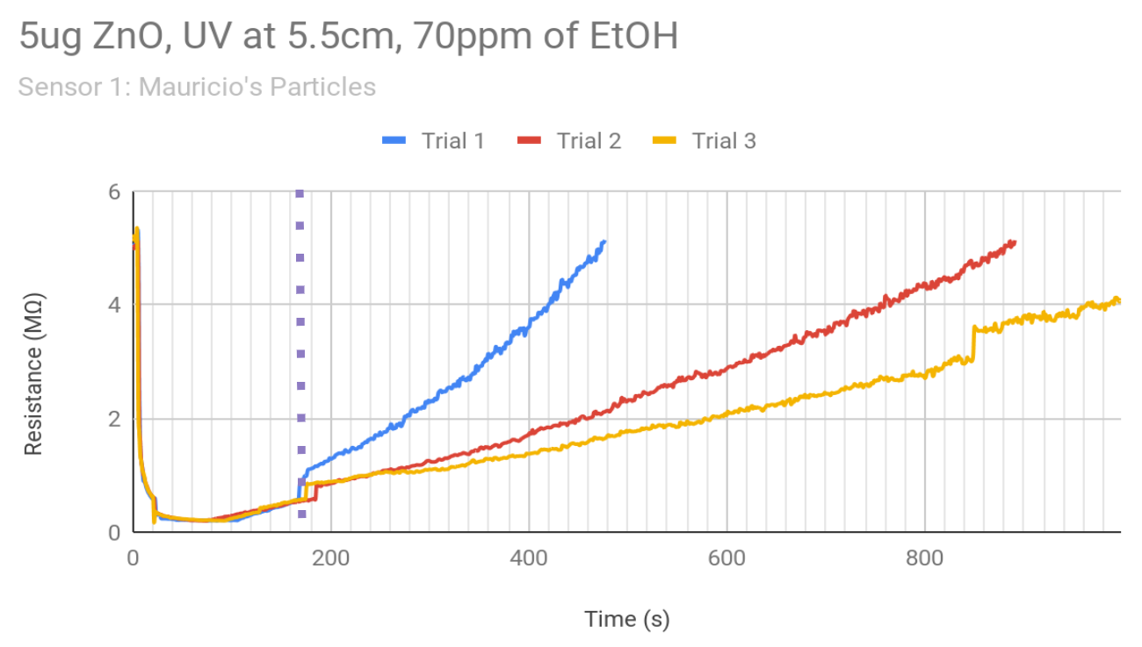

**Figure 3.13** Full test run to validate a response to EtOH

|  |  |  |
| --- | --- | --- |
| **Table 3.5** Slopes and R values of a linear regression for the full test trials | | |
|  | **Slope** | **R** |
| **Trial 1** | 0.0129 | 0.987 |
| **Trial 2** | 5.88x10-3 | 0.99 |
| **Trial 3** | 3.42x10-3  4.34x10-3 | 0.99  0.975 |

The results of the full run prompted us to reanalyze our testing procedure. This is when we decided to change our protocol and test different nanoparticles. We turned the UV light on and let the resistance hit a constant minimum value. At 50s, after the sensor has bottomed out with UV alone, we flushed in EtOH for different time lengths, depending on the concentration of ethanol desired. The EtOH settled for 10s before flushing it out, and then after another 10s, the UV light was turned off and the sensor was left to recover fully. We went back to testing commercially available nanoparticles on the chance that the particle’s Mauricio sent were causing the issues. We tested two different sensors, prepared identically and in parallel. Each had 25𝜇g of 10-30nm ZnO nanospheres, and was tested at around 80, 150, and 200ppm of EtOH in the chamber. The resistance response curves for all trials can be seen in **Figure 3.14**. There is a direct correlation to the difference between the UV light baseline resistance to the baseline resistance in the presence of EtOH. We compared these resistance drops in **Figures 3.15** and **3.16**.

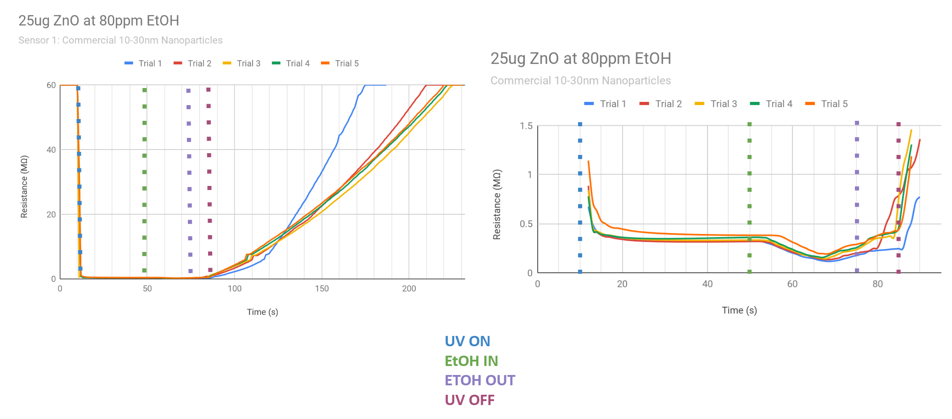

1. Sensor 1 at 80ppm EtOH

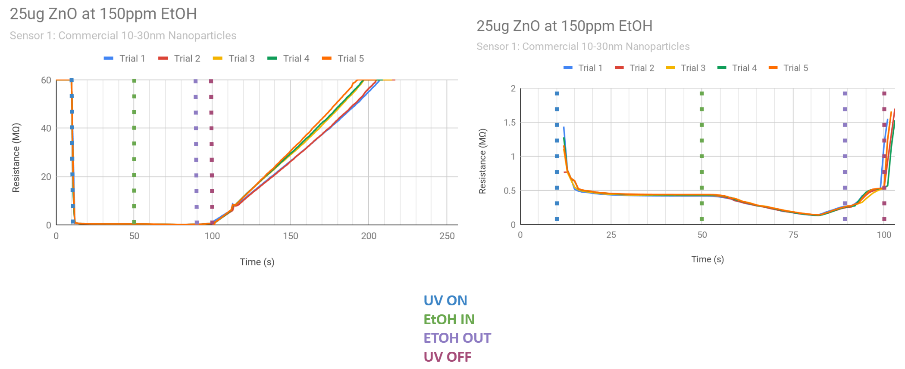

**(b)** Sensor 1 at 150ppm EtOH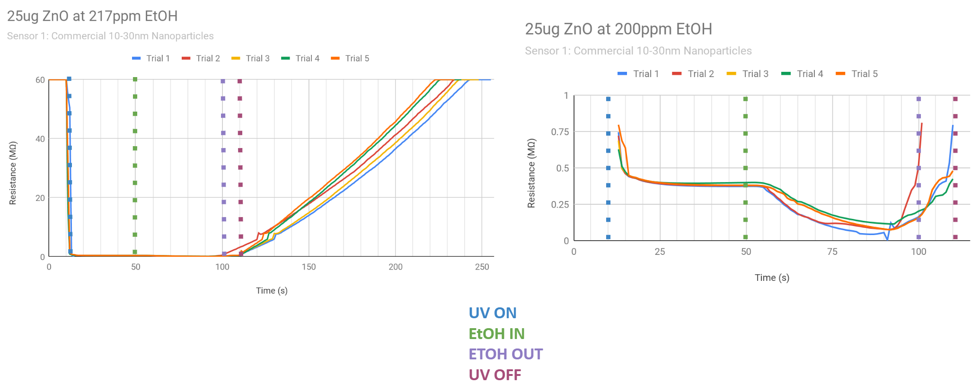

**(c)** Sensor 1 at 200 ppm EtOH

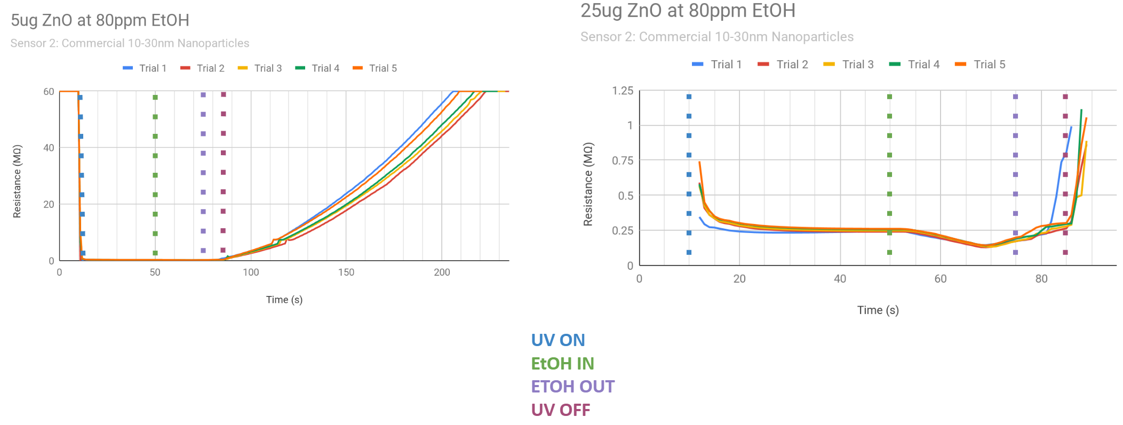

**(d)** Sensor 2 at 80ppm EtOH

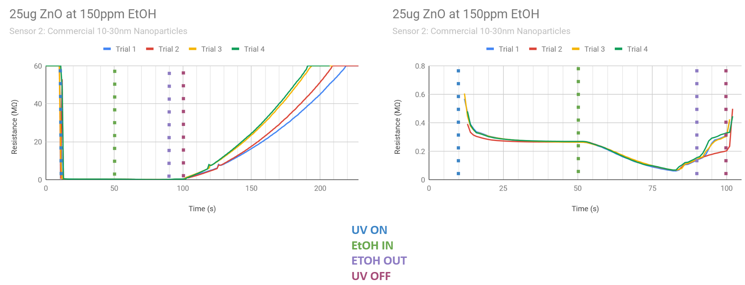

**(e)** Sensor 2 at 150ppm EtOH

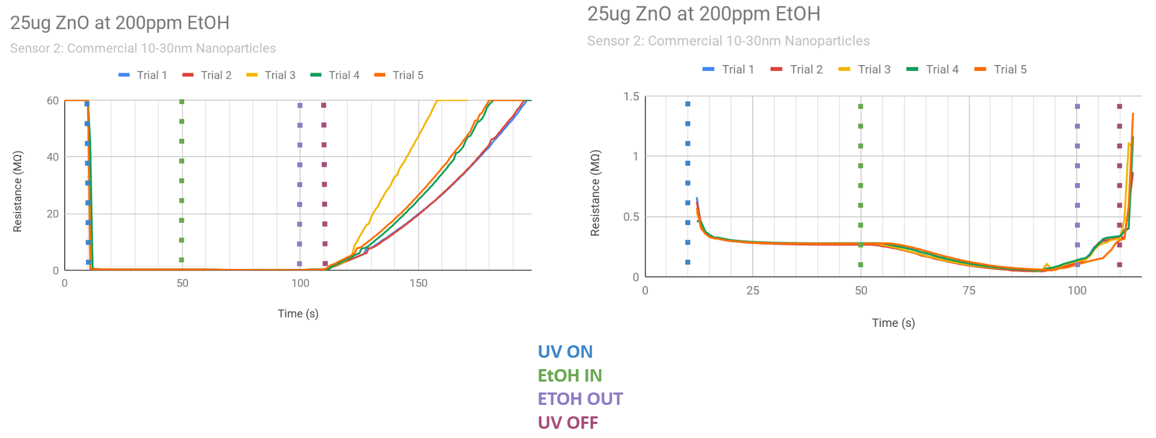

**(f)** Sensor 2 at 200ppm EtOH

**Figure 3.14** Response curves of two sensors at different concentrations of EtOH

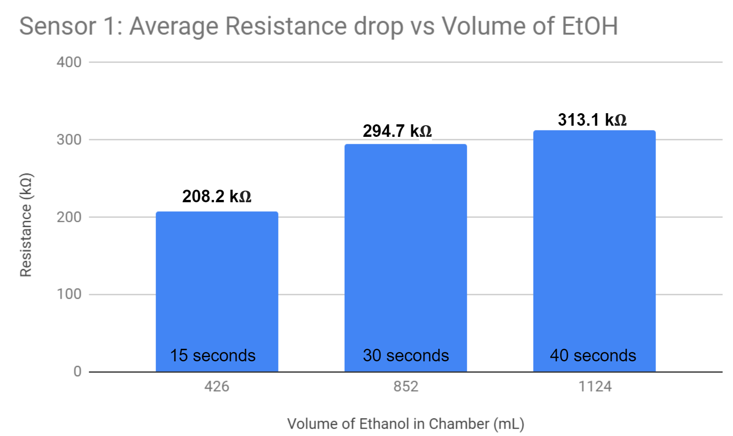

**Figure 3.15** Average resistance drop for Sensor 1 at various EtOH concentrations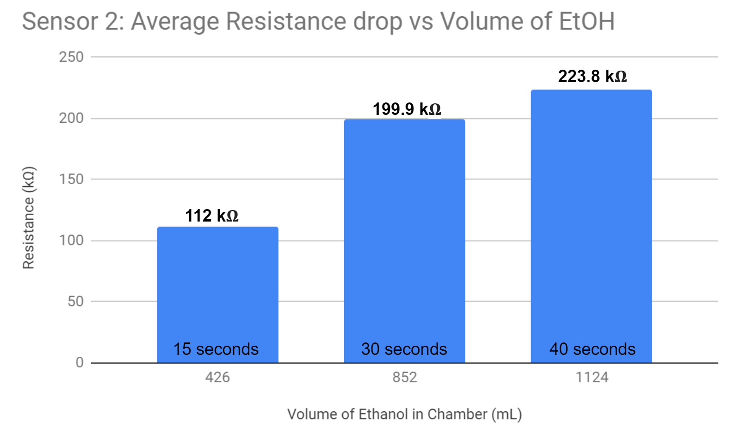

**Figure 3.16** Average resistance drop for Sensor 2 at various EtOH concentrations

We also wanted to see how the recovery varied, and if we still saw an extreme sensor degradation. The slopes and R values for linear regression are listed in **Table 3.5**. Like the UV trials, a polynomial fit when linear regression was not the best option.

|  |  |  |  |  |  |  |
| --- | --- | --- | --- | --- | --- | --- |
| **Table 3.5** Slopes and R value for linear regression for full runs with the new protocol | | | | | | |
|  | **Sensor 1** | | | | | |
| **80ppm** | | **150ppm** | | **200ppm** | |
| m | R | m | R | m | R |
| **Trial 1** | 0.742 | 0.962 | 0.544 | 0.999 | 0.454 | 0.993 |
| **Trial 2** | 0.487 | 0.982 | 0.554 | 0.997 | 0.45 | 0.994 |
| **Trial 3** | 0.432 | 0.986 | 0.578 | 0.992 | 0.473 | 0.994 |
| **Trial 4** | 0.439 | 0.991 | 0.601 | 0.996 | 0.513 | 0.997 |
| **Trial 5** | 0.444 | 0.992 | 0.63 | 0.996 | 0.516 | 0.997 |
|  | **Sensor 2** | | | | | |
| **80ppm** | | **150ppm** | | **200ppm** | |
| m | R | m | R | m | R |
| **Trial 1** | 0.508 | 0.981 | 0.514 | 0.979 | 0.711 | 0.986 |
| **Trial 2** | 0.453 | 0.974 | 0.554 | 0.98 | 0.721 | 0.984 |
| **Trial 3** | 0.459 | 0.98 | 0.645 | 0.984 | 1.23 | 0.975 |
| **Trial 4** | 0.47 | 0.978 | 0.655 | 0.985 | 0.809 | 0.976 |
| **Trial 5** | 0.497 | 0.982 | - | - | 0.833 | 0.984 |

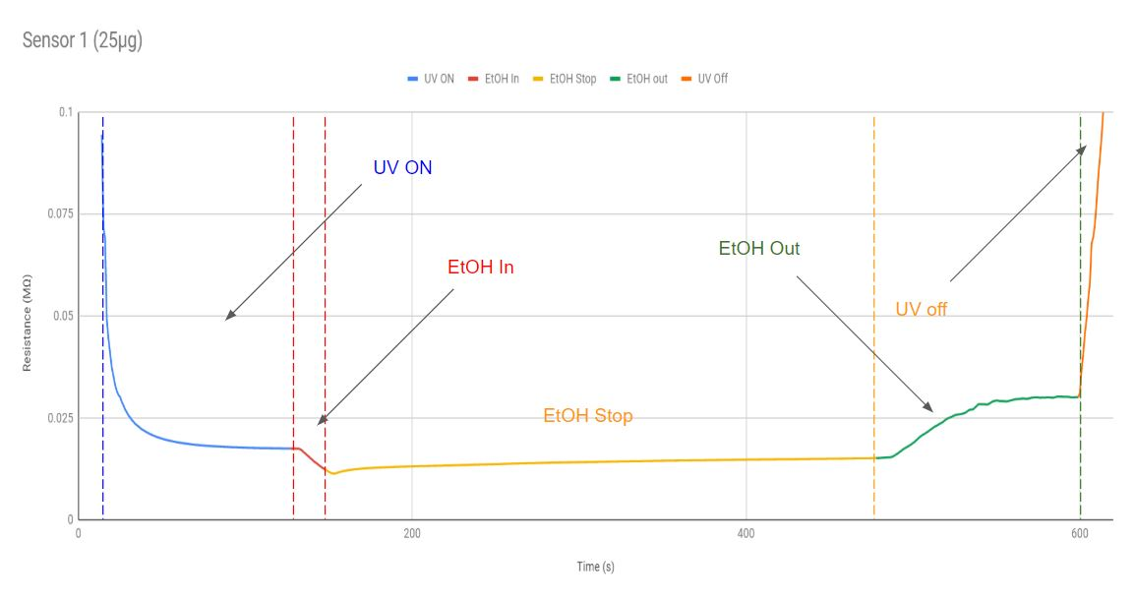

**Figure 3.17:** Test run to show degradation of IDE and response to concentration of ethanol left in the chamber for a longer duration of time..

The **Figure 3.17** above is the 5μL concentration of commercial standard Zinc Oxide nanoparticles that were drop casted on the IDE from a 10mg/mL suspension. The total amount of Zinc Oxide used is 25μg. The trial above shows how ethanol changes in response to ethanol vapor present and the UV light influencing the change in resistance. The sensor was placed 3.8cm away from the UV LED which was power by the power supply in BE 310. The response curve above is broken down in the following 4 graphs below.

The first section of **Figure 3.17** represents when the UV light is turned on from 12s to 127s. The resistance of the IDE starts at above 60MΩ which is greater than the terminal resistance the Bluetooth Multimeter can measure. The UV light causes the sensor to respond so that it reaches a baseline resistance of 17.68kΩ. This same sensor was tested two days ago and had a baseline average resistance of about 200kΩ shown in **Figure** 3.15 for sensor 1**.** The resistance is much lower than the resistance that has been tested before which suggests that the sensor doesn’t behave in a repeatable process. This could be due to the sensor being exposed to air of the method of drop casting that has been used to coat the IDEs. The curve from the UV shows that the response is almost immediate and a power series trendline was used to fit the response.

Section 2 of the graph shows when the UV light is still on and ethanol vapor is fed into the chamber. An average of the baseline resistance starting from t=97 to t=127 was taken to determine where the sensor stops responding to the UV light stimulus. At this point, ethanol is fed into the chamber for total of 30 seconds with a flow rate of 0.217mg/mL. This translates to approximately 300ppm of ethanol in the chamber. The ethanol is kept in the chamber for the duration from t=127s to t=478s. The minimum resistance observe was about 11.48kΩ which is a change of 6.2kΩ. This shows that the sensor is much less responsive than it was a few days ago when it had a 200 plus difference between the previous sensor’s numerous trials. After filling the chamber, I allowed it to rest with the ethanol still in the chamber. There was a gradually increase in resistance from the response to ethanol but I propose this is due to the fact that our chamber is not vacuum sealed and can result in some leakage. The resistance it reached up to with the ethanol was about 15.06 taken as an average from t=420 to t=470. This is where the resistance stayed around the same value.

Section 3 is the section where ethanol vapor was let out of the chamber. As the ethanol is removed from the chamber, there is an immediate jump in the resistance change. At this point, the UV LED is still on, but the ethanol is flushed out. This graph follows a similar fit to a polynomial function with a slope of 1.65e10x^2+1.01x-525. This graph reached a different of around 14.84 from the chamber with ethanol to the chamber flushed out. Section 4 shows when the UV light is finally turned off at t=599s. This results in a large spike in resistance jumping from 30kΩ to 60MΩ in about 60 seconds.

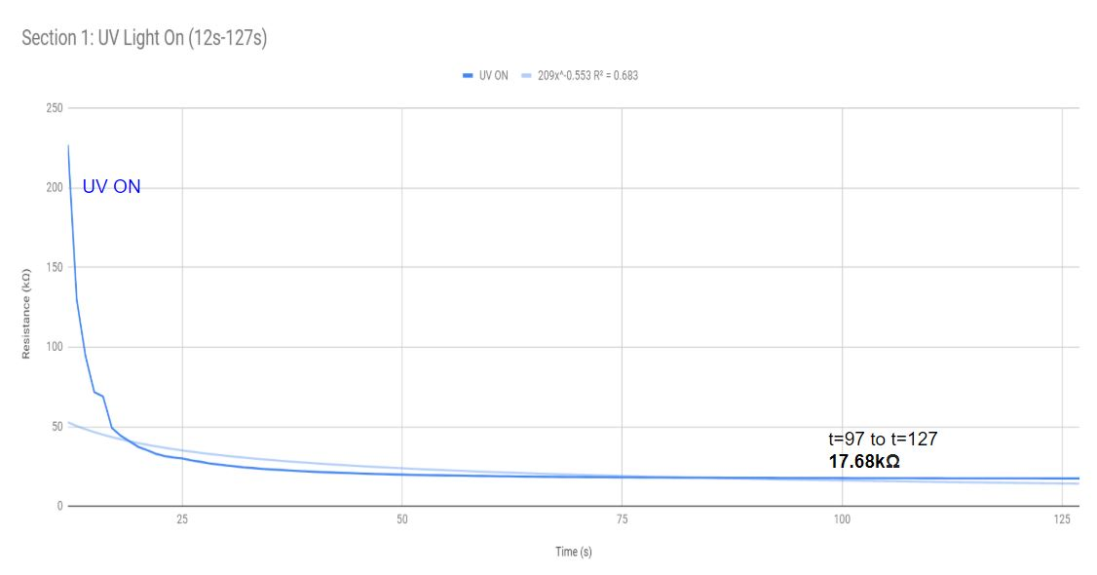

**Figure 3.14a**

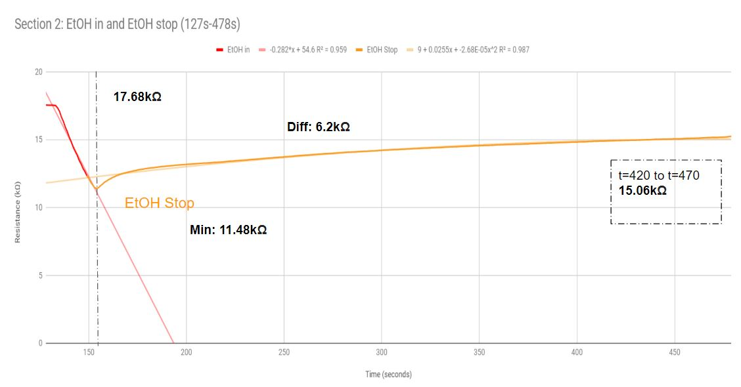

**Figure 3.14b**

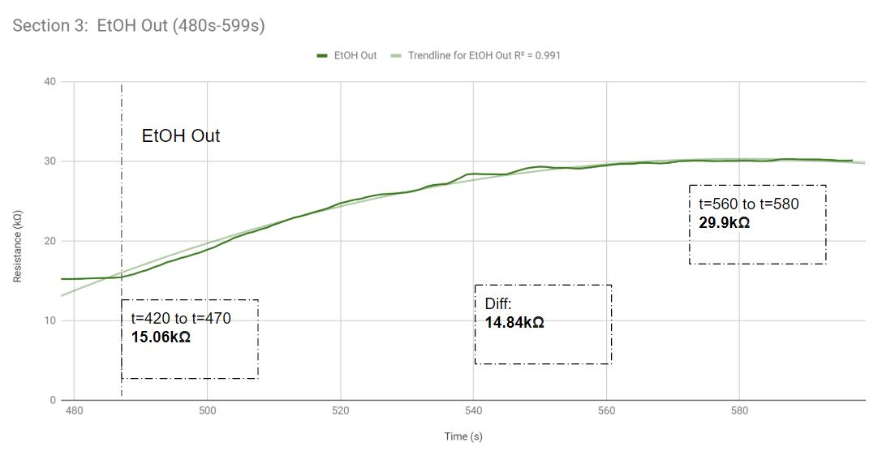

**Figure 3.14c**

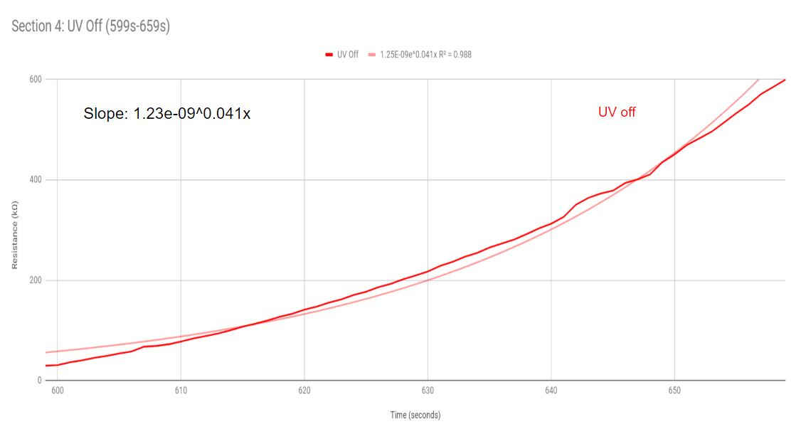

**Figure 3.14d**

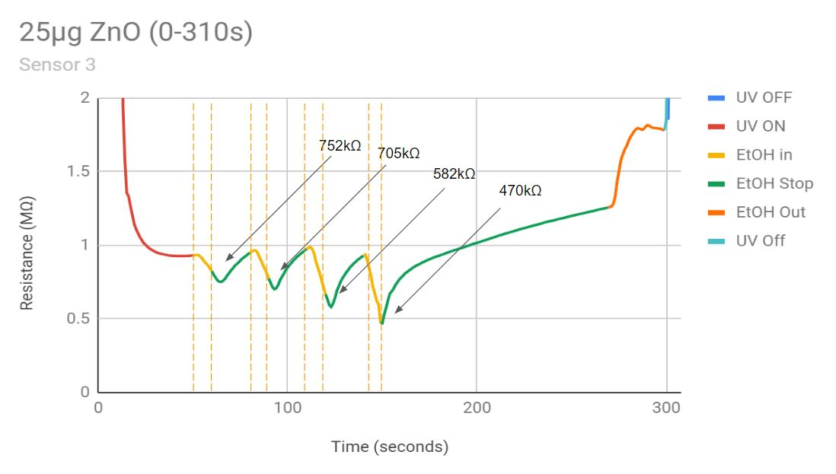

**Figure 3.18:** Response curve showing the reaction to multiple 10 second intervals of ethanol fed into the chamber. The following sections show what occurs at each stage of the test.

The figure above shows the response to ethanol for a 25μg sensor. The resistance of this sensor is notably different in terms of characteristics associated with similar sensors tested before. I tested this sensor from a new IDE with Zinc Oxide. I kept the conditions at 3.8cm with the UV LED powered by the power supply at 3.3V. The following sections show a close up of the image above. The UV light was turned on resulting in a decrease in resistance from overload to about 930kΩ shown in **Figure3.18a.** I took an average of the lowest baseline resistance from t=30 to t=35 because this was where I observe the least variation in resistance values. Ethanol was released at time 50s and then allows to rest in the chamber for 20 seconds. So five 30 second session where 10 seconds ethanol was filled in the chamber and 20 seconds of no ethanol was performed back to back. Since the ethanol wasn’t flushed out, you can see that there is a larger and larger resistance drop occurring. This is because more ethanol is likely accumulating within the chamber since it isn’t being flushed out. Finally at time 270s, ethanol is flushed out by opening the top of the chamber. There is an immediate increase in slope shown in the orange section. Overall, you can see that there is a significant response to ethanol throughout the intervals of testing. This suggests that the chamber needs a more proper way of flushing out samples so that old samples don’t taper with new data collected.

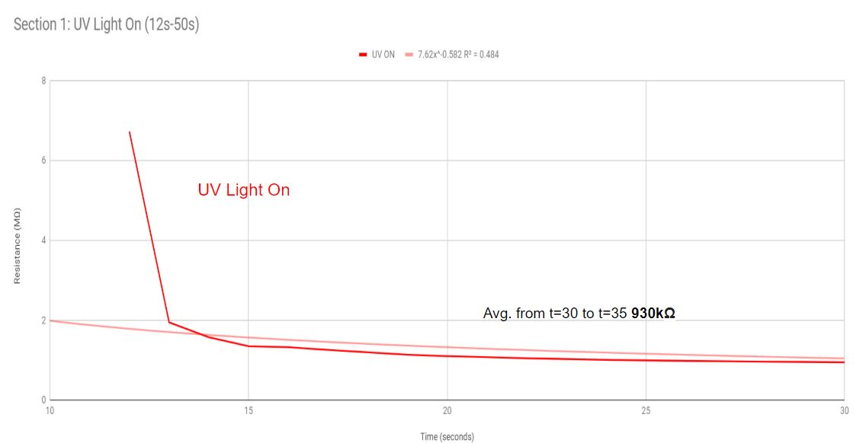

**Figure 3.15a**

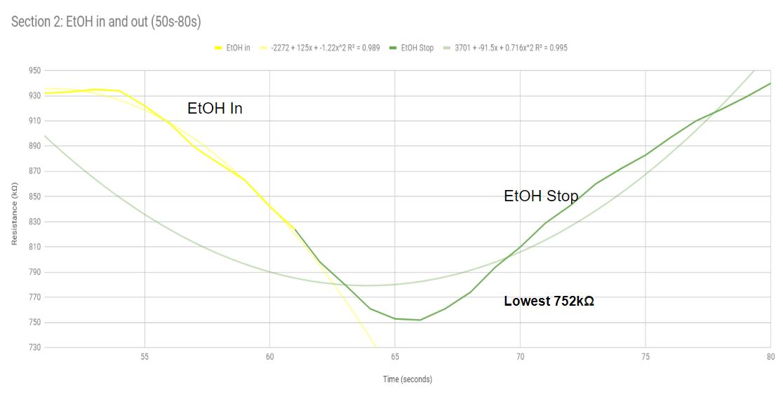

**Figure 3.15b**

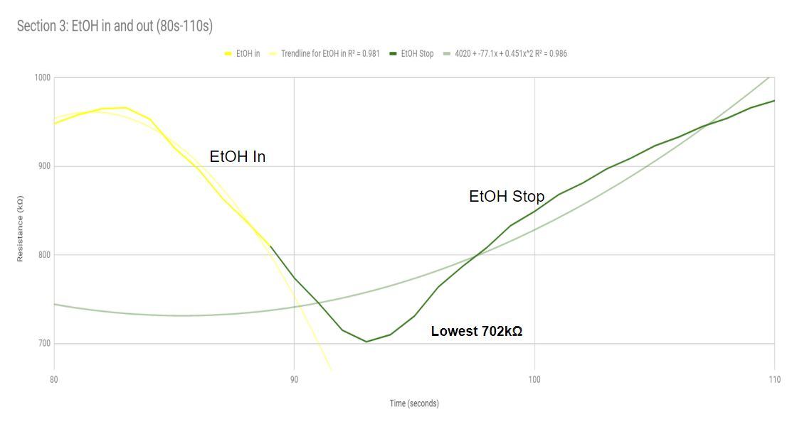

**Figure 3.15c**

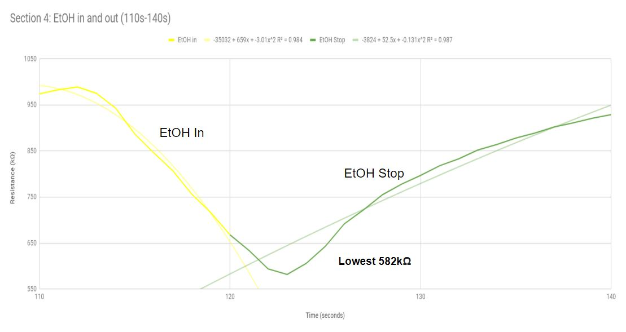

**Figure 3.15d**

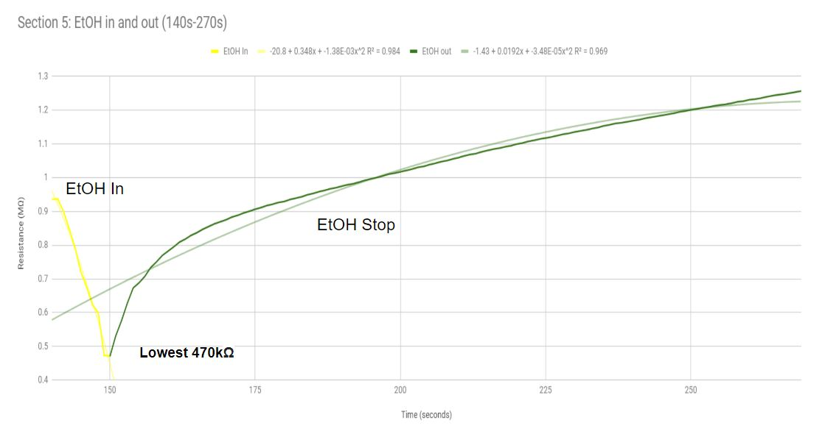

**Figure 3.15e**

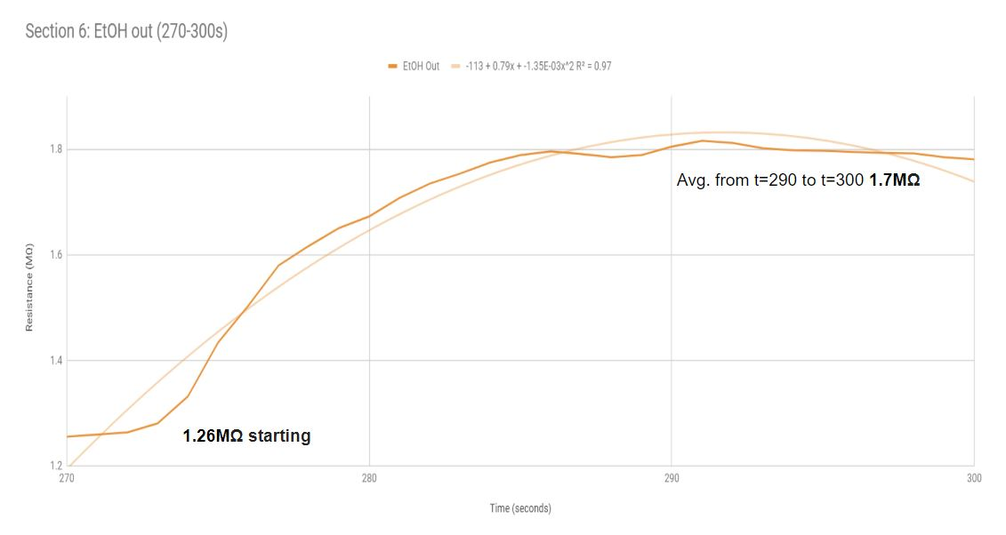

**Figure 3.15f**

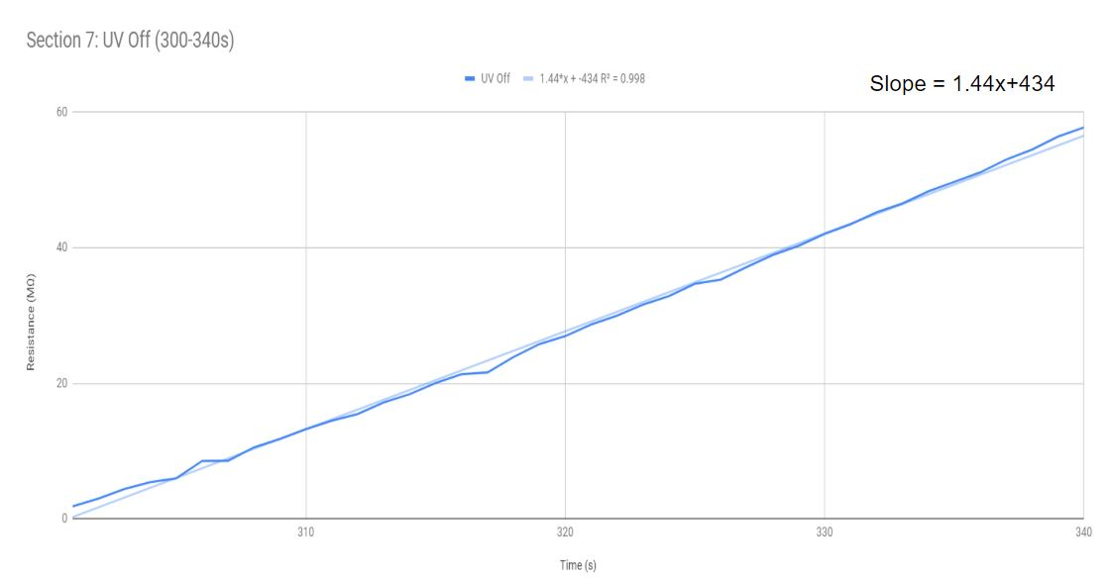

**Figure 3.15g**

## 3.3 Conclusions

The zinc oxide sensor is still in development, but has made strides since making incisions on ITO glass when we first began. The current design does not include components for the zinc oxide sensor -- the design of this component was heavily delayed and unable to make it into the final design. The integration of the ZnO measurement strategy will need to be included on a different PCB. For more detail, see **Future Work**.

The current sensor is also very sensitive in that the zinc oxide nanostructures can easily be wiped off the electrodes surface. We recognized that the sensor needed to be placed in a controlled environment in which measurements can be tested without water condensation affecting the sensing capabilities of the ZnO. The design specifications for a housing that would protect our sensor from external factors are further explained in the **Mechanical** chapter. Ideally, the sampling chamber the IDE rests in will need to be downsized in order to ensure even mix of ethanol throughout the chamber. Intricately placed fans in the chamber is a suggestion into the future testing of the chamber. These fans would need to account for the physics of air circulation within the chamber as well as venting out the sampled ethanol.

The response we have observed corroborate the properties and expectations the Zinc Oxide sensor is capable of. When exposed to UV light, the nanoparticles will exchange electrons between the oxygen atoms resulting in a current flow. Noticeable resistance drop occurs with this change in current. Larger concentration of Zinc Oxide drop casted into the IDE yields much greater sensitivity to UV light and ethanol vapor, however, oversaturation of Zinc Oxide makes readings unreliable because Zinc nanoparticles begin pile over one another resulting surface particles getting more UV exposure.

# Chapter 4 - Power

## 4.1 Design Considerations

While many sensors exist in helping detect the concentration of ethanol, they lack the portability to be powered autonomously without relying on power from an external source. When designing the power system for this device, we had the best interest of our client, Peter Weiss, as well as the wineries that would potentially use this device in the future, in mind.

Our idea of a perfect power system for this device is one such that the client will not need to monitor and maintain it constantly. Having the device be battery powered over a confined “plug-in” setup remedies this concern. This allows for the device to be portable so that it could easily move from one fermentation room to another. The power system is relatively compact and light to fit a certain form factor that makes the device seem un-noticeable when attached to the exhaust pipes from fermentation tanks. Finally, the batteries’ capacity is easy to track on the user interface and the batteries are easy to replace or recharge.

Luckily, this system is not a power intensive one. This helps us downsize the batteries, making the device even more portable. The battery configuration must follow the form factor of being less than 10 cubic inches in volume. As far as what battery we used, we wanted to be open ended and allow the client to be able to power this system with batteries that can be found at their local store rather than needing to order special ones online.

## 4.2 Testing and Validation

The challenge with integrating all different electrical components in this power system is sizing a battery that has a high enough voltage to power each component while having enough capacity to supply the needed supply currents. A properly designed power budget is the best way to size our battery system to ensure effective power distribution across all analog and digital devices.

The final version of our system level power budget (per node) can be seen in **Figure 4.1**.

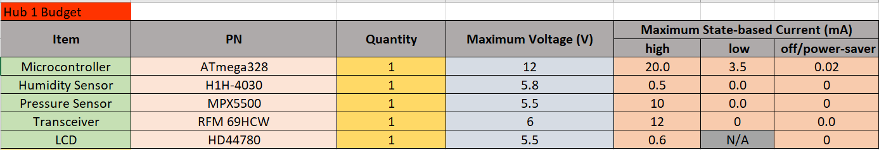

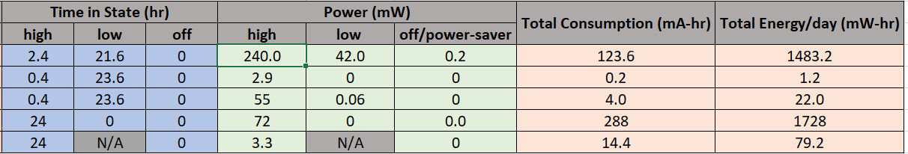



***Figure 4.1*** *- Finalized System Power Budget*

Each electronic IC, sensor, microcontroller has its respective part number (provided from the manufacturer), quantity needed, maximum operating voltage, and maximum current draw for the high, low, and power-saver states. These three states mentioned can be better described in **Table 4.1**.

|  |  |
| --- | --- |
| **Table 4.1** - Description of each current state | |
| State | Description |
| High | The device is operating at its specified voltage and all internal circuitry is working to produce its desirable output. |
| Low | The device is drawing enough current to keep its internal circuitry active but the device is not outputting anything. |
| Off/Power-Saver | The device is turned off and not drawing any current. (This is most common with the sensors however the Arduino will go into power-saver mode which draw little current.) |

Note how the power budget has the **maximum** voltage and current values. These take into account the worst case scenarios. All of these maximum input voltage and maximum state based current values were determined by the electrical characteristics from each device’s datasheet. These datasheets can be viewed in **Appendix B**. Our goal was, of course, not to operate these devices under these conditions. They however needed to be accounted for the power budget to perform the worst-case power analysis.

To the right of the maximum current draw in each state is the amount of time each device would be in the high, low, and off/power-saver states. This was the most important factor of the entire power budget. Having every device on and powered by the battery at once would be impractical and will lead to a higher needed capacity. The solution we came up with was to incorporate a state machine and call the needed devices such as the sensors or microcontroller in the state that needs them. A device operating for 5 to 10 seconds in its high-state, then immediately going back to sleep saves a great deal of current draw and battery life. The microcontroller is predictably on more often than, let’s say, the humidity sensor. **Table 4.2** lists every device and how long it will be in the high state for each respective time interval. As stated previously: *Our device takes a sample once every ten minutes interval during a 24-hour day.* In other words our design takes a sample *six times per hour*. This can change with the clients’ request.

|  |  |  |  |
| --- | --- | --- | --- |
| **Table 4.2** - Duty Cycles for each current drawing device (**HOURLY)** | | | |
| **\*\*\*NOTE: These times are for every 10 minutes intervals\*\*\*** | | | |
| Device | Time in high state (s) | Time in low state (s) | Time in off/power-saver state (s) |
| Arduino Mega | 60 | 540 | 0 |
| Humidity Sensor | 10 | 590 | N/A |
| Pressure Sensor | 10 | 590 | N/A |
| Radio Transceiver | 10 | 590 | N/A |
| LCD | 120 | N/A | 480 |

We can find the total power consumption in each state knowing the current draw and maximum input voltage of each component. We use a derivation of Ohm’s Law to find the power seen in columns to the right of “Time in State.” **Equation 4.1** and **Equation 4.2** show this method.

**Equation 4.1**: Pin state = VmaxIin state [mW]

**Equation 4.2**: Total Power Consumption = (Phigh + Plow + Poff) [mW]

The next column contains the total current consumption each for each device. This is the most important specification in this document because the sum of the total consumption helps us size our battery to power the system. All batteries come with a capacity specification and we need to pick our battery configuration based off the maximum consumption of our system. We can determine the consumption in mA $⋅$ hr by using **Equation 4.3**.

**Equation 4.3**: Current Consumption = (Ihighthigh) + (Ilowtlow) + (Isavertsaver) [mA $⋅$ hr]

where *I* is the current draw (in mA) and *t* is the time (in hours) in state.

Finally, the total energy per day can be seen in the next column to the right and is calculated similarly to how we calculated current consumption, see **Equation 4.4**.

**Equation 4.4**: Total Daily Energy Consumption = Q $⋅$ [(VmaxChigh) + (VmaxClow) + (VmaxCsaver)] [mW $⋅$ hr]

where *Q* is the quantity of the component, *Vmax* is the maximum operating voltage, and *C* is the current consumption in a state.

The sum of these calculations show the **total daily consumption** is approximately **430 mA $⋅$ hr**. The maximum power consumption is approximately **415 mW** and the maximum daily energy consumption is **3314 mW $⋅$ hr**.

The fermentation cycle for wine last approximately *two weeks* therefore we aimed to design the power system so that the client may change out the replaceable batteries everytime there is a new fermentation cycle. Alkaline D batteries contain a typical capacity of **12000 - 18000 mA $⋅$ hr**. If we were to use these batteries with our calculated daily consumption from the power budget, the device should last between **20-30 days** before the batteries fully discharge. This number will change due to power losses in the power converters we implement.

Although we recommend Alkaline D, we left it up to the user to decide what types of battery chemistry they want to use for this system and we’ll go more in depth on the protection circuitry used in case the client picks a battery with a higher than nominal discharge voltage.

Dtype alkaline batteries produce a nominal voltage of 1.5V. They are not rechargeable when compared to other battery chemistries. They do have a slower discharge rate when compared to other types such as nickel metal hydride (NiMH).

NiMH and Alkaline have significant differing properties that facilitated our decision for which batteries would be ideal. NiMH keep their voltage and charge at a constant level before dropping drastically while Alkaline batteries have a much more steady decline in voltage and charge. Thus, Alkaline batteries also have greater nominal capacity than NiMH.

The high level block diagram of this design can be seen in **Figure 4.3**. A more detailed look of this image can also be seen in **Appendix B**.

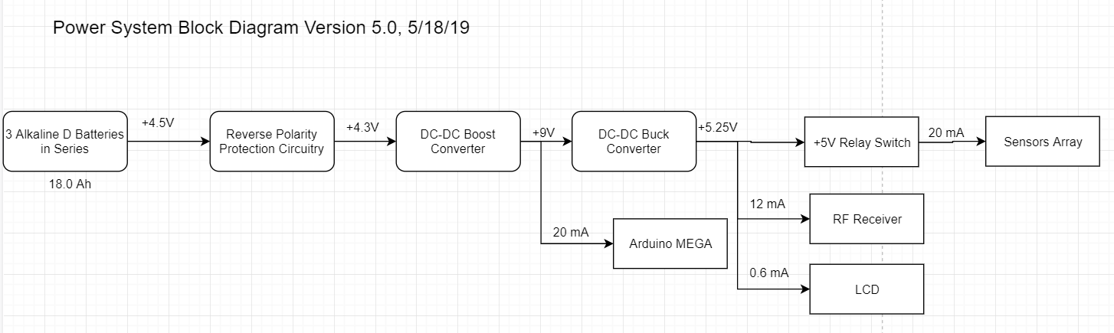

***Figure 4.2*** *- System level block diagram of our entire power system*

The 4.5V series of D batteries will power 4 main loads. One load will need its input voltage stepped up to +9V while the other three of these loads will be stepped back down to +5.25V.

Step down switching regulators were chosen to be used for this system, despite the Arduino having its own on board +5V and +3.3V output reference voltage pins. We ultimately decided to create our own +9V and +5V power rails to power everything to prepare for the possibility that the Arduino microcontroller malfunctions and cannot power the sensors, radio, or LCD. We can never be too safe when taking precautions in designing this system. The Arduino Mega will thus be driven by +9V through its *Vin* pin.

The +5V switching regulator draws less current from the power supply however, it is responsible for powering more loads than the +9V regulator therefore, this rail is the most important and needs a steady +5V output. The downside of using switching regulators, which we’ll discuss in the next subsection, is the unsteady ripple of the output voltage. The input voltage tolerances for some of the sensors on the +5V rail, as seen in Appendix A, vary as little at 200 mV. Knowing this, the 5V converter needs to be designed as having an output voltage less than **250 mV** and a load current up to **50 mA** **maximum**.

The few times the client will need to interact with the system is either to check the concentration of ethanol inside the chamber, *or to change the batteries out*. We cannot rely on the notion the client has the technical background to put the correct batteries in or even in the case the correct way. This led us to create a simple design used to protect the internal circuitry of our system in the event of one of these anomalies.

This simple protection circuit consists of a fuse, diode, and toggle switch all in series. The entire schematic can be found in **Appendix B.**

In series with the series D cells is a standard through hole (THT) fuse rated for a maximum current of **2.0 A**. The reason why we picked this current rating is because this is both the **maximum rectified output current** of the diode and the **maximum input current** of the +9V DC-DC Boost Converter.

A 1N5858 Schottky diode is in series after the fuse for reverse battery protection. The diode becomes forward biased and current flows normally through the battery’s load (the DC-DC converters). If the battery gets installed backwards, the diode becomes reverse-biased and no current will flow. This method can protect against any type of battery from Alkaline to Lithium-Ion. A major disadvantage of using this protection method is the forward voltage drop across the diode that will decrease the battery life. This drop lowers the efficiency of the power circuitry after the diode. To minimize this decrease in efficiency, I picked a 1N5818 Schottky diode with a very low forward voltage drop.

The 1N5818 has a very low voltage drop which can be seen in the figure below:

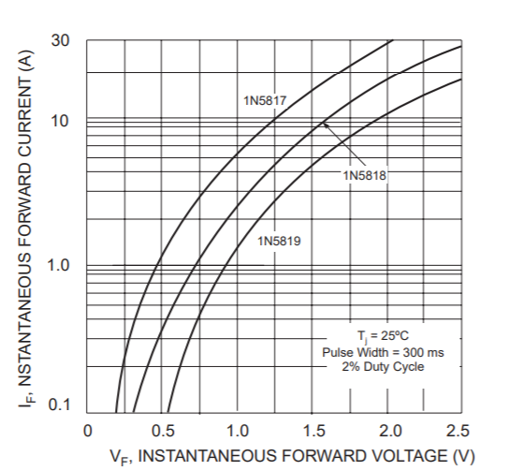

***Figure 4.3*** *- Forward current versus forward voltage plot from 1N5818 datasheet*[4]

Knowing the voltage rails required for powering the components, we have to choose between using standard LM series linear regulators, or switching buck regulators. Linear regulators are great for powering low power devices and luckily, this project is contains many. Linear regulators are particularly useful when the difference between the input and output voltage is very small. Despite their simplicity and low cost, linear regulators are highly inefficient.

Another option would be switching regulators, which are much more efficient, very compact, and available in many modular chips. We will not be using linear regulators for this project due to their high inefficiency.

Conceptually, a linear regulator operates like a variable resistor. All of the load current must pass through the series transistor resulting in high power losses due to heat. All power losses are given by **Equation 4.5** and the efficiency of a linear regulator is found by **Equation 4.6**.

**Equation 4.5**: Ploss = (Vin - Vo)Io

**Equation 4.6**: ɳ = $\frac{P_{out}}{P_{out}+P_{loss}}$ = $\frac{V_{o}⋅I_{o}}{V_{o}⋅I_{o}+ (V_{in}- V_{o})⋅I_{o}}$ = $\frac{V_{o}}{V_{in}}$

Looking at the LM7805 datasheet, the minimum input voltage is typically 7V for a stable 5V output. Plugging these number into equation 4.6 yields an efficiency of only **71%**. The remaining 29% gets wasted and generates heat in the regulator. The regulators must thus have the thermal capabilities to handle the worst case maximum Vin.

All power supply regulators are powered by a series of batteries that are up to the client to purchase and use in the device. The danger with this is that the client may choose cheap batteries with unstable discharge voltages greater than their nominal values. An overvoltage episode into a linear regulator may generate excess heat in the chamber where all the electronic circuits are contained, possibly damaging other circuits. While this could be avoided by simply attaching a heat sink to each regulator, this will compromise the portability of the design by making the electronics storage area unnecessarily larger.

Switching regulators fulfill the power supply requirements needed for this project due to their low power consumption, small size, and high reliability within a large input voltage range. These types of regulators rapidly switch a series element (typically a FET) on and off. Switching regulators store input energy temporarily and release it at a lower or high voltage level. The regulators duty cycle determines the amount of voltage is transferred to the load.

These are more efficient modes of power supplies because the FET switches from either on to off, dissipating nearly no energy. Switching regulators have the versatility to step-up or step-down the value of its input voltage and can be used in both isolated and non-isolating applications. The downside with switching regulators is that their output voltage is noisy and has ripples similarly see in **Figure 4.4**. Another disadvantage switching regulators have when compared to linear regulators is that they are more complicated to create.

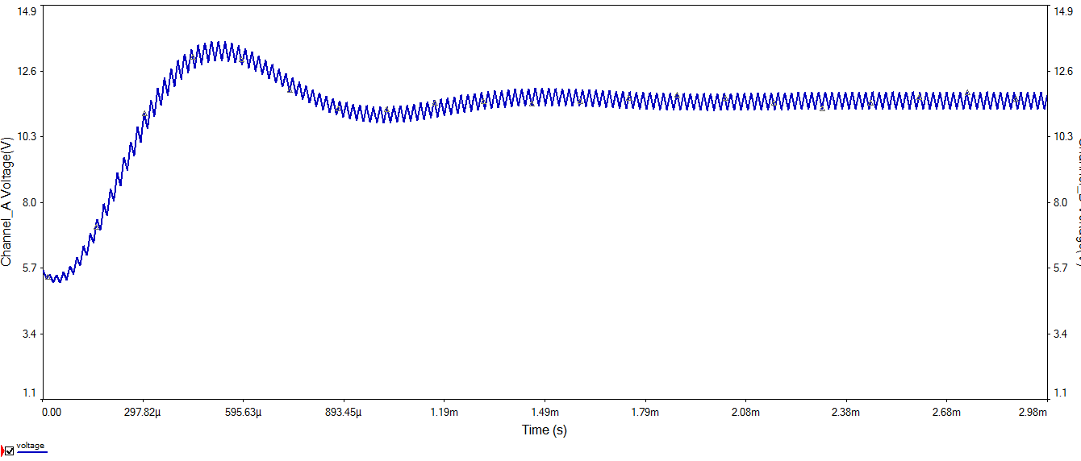

***Figure 4.4*** *- Output voltage waveform of switching buck regulator[5]*

We can, however, control the magnitude of the voltage ripple by choosing our external components properly. This will be covered in greater detail in the next section. **Table 4.3** summarizes the tradeoffs between linear and switching regulators.

|  |  |  |
| --- | --- | --- |
| **Table 4.3** - Tradeoff summary between linear and switching regulators | | |
| Category | Linear | Switching |
| Design Capabilities | Buck | Buck, Boost, Buck-Boost |
| Efficiency | Low to Medium | High |
| Complexity | Low | Medium |
| Dimensions | Small to Medium | Medium to High (due to external components) |
| Cost | Low | High (due to external components) |
| Noise | Small | High |
| Input Voltage Range | Small | High |

The basic model of a buck converter can be seen in **Figure 4.5**.

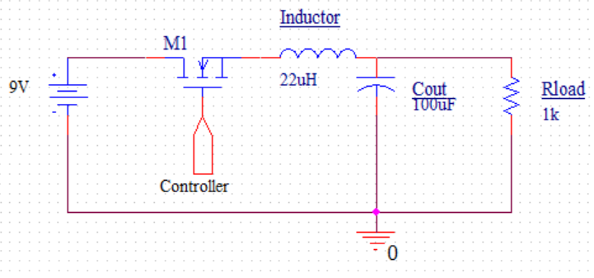

***Figure 4.5*** *- Buck converter model*

A buck converter can take an input voltage directly from a battery source. Its circuit consists of a transistor to act as a basic switch. As the switch is closed, current flows through the inductor which opposes a change in current and stores energy in the form of a magnetic field. This energy eventually gets released once the transistor is switched off. The energy then flows back through the load.

Even when the switch is closed, the load gets supplied with current once the maximum energy inside the inductor gets stored. Current gets stored as charge in the load capacitor when the switch is on. During this on period, there will be large voltage on the cathode of the catch diode. Since the diode is reverse biased, it does not conduct.

Once the switch is off, the current stored in the inductor flows back through the circuit. The back-emf caused by the releasing energy from the inductor causes current to flow through the load and the diode. The remaining charge stored in the load capacitor keeps current flowing despite the inductor releasing all of its energy. This occurs until the switch is on again and the cycle repeats. The resulting output voltage waveform is similar to the one seen in **Figure 4.4** previously.

Our project needs two different power rails for +5V and +9V meaning we’ll need two different types of switching regulators. Our +5V regulator will be a buck converter while the +9V one will be a boost converter. We chose the LM2575HVN and the TPS6140 switching IC’s for both the 5V and 9V operations respectively. These circuits needed to be designed, tested, then laid out on a PCB for integration.

The LM2575HVN from Texas Instruments is a simple step down voltage regulator. This chip has an adjustable output voltage range from 1.23V to as high as 37V and is rated for up to 1A load currents. It also has a very wide input voltage range from 4.75V to 40V. This integrated circuit is also highly efficient with ratings ranging as high as **88%**.

This chip simplifies the design of our switching power supply by having all of the switching capabilities of a buck converter isolated to one IC. It can also be shut off via an external ON/OFF pin in an emergency scenario. This chip can also operate in a wide temperature range from -40 degrees Celsius to 125 degree Celsius. The high efficiency of the LM2575 chip requires no heat sink, optimizing the space the printed circuit board will take.The simplified schematic of the LM2575 from its datasheet can be seen in **Figure 4.6**.

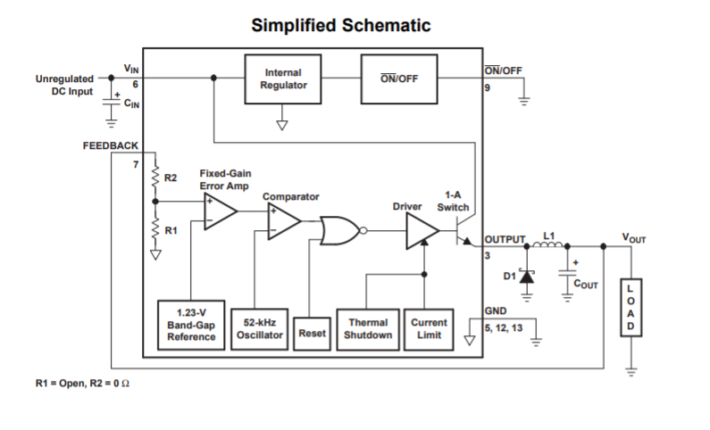

***Figure 4.6*** *- Simplified Schematic of LM2575 IC[6]*

The LM2575 comes in two packages: a 5-pin TO-220 package and a 16-pin DIP package. We chose the DIP package since it has a simpler layout than the TO-220 package, which will occupy less space inside of the housing. The extra unused pins in this package can provide thermal relief via the copper ground plan on the power rails PCB. The IC package can be seen in **Appendix A** along with the 5V buck converter schematic with all external components. Six separate components needed to be picked for a proper design of these circuits: a diode, inductor, input capacitor, output capacitor, two feedback resistors.

The feedback pin (pin 7) must be connected between two programming resistors who’s ratio controls the value of the output voltage, as in **Equation 4.7**.

**Equation 4.7**: Vout = Vref(1+ $\frac{R_{2}}{R_{1}}$)

The value of Vref is always going to be 1.23V according to the datasheet. Assuming we picked R1 to be 1 kΩ and we want an output voltage of 5V, the equation above can be rearranged to find the value of R2, as seen in **Equation 4.8**.

**Equation 4.8**: R2 = R1(- 1) ; R2 = 1k(- 1) = 3.065k = 3.0 kΩ

The choice of the inductor is key to a properly designed switching power supply. A crucial detail in this design is deciding whether this circuit will operate in continuous (where current constantly flows through the inductor) or discontinuous (where the inductor current goes to zero during a switching cycle) mode. Continuous mode is often preferred because it offers more output power at lower currents and lower output ripple voltage. One disadvantage of continuous current mode is that a large inductor is required for smaller loads.

The LM2575 can operate in both continuous and discontinuous mode perfectly fine. With light loads less than 200 mA, TI assures that it is perfectly acceptable for this regulator to enter discontinuous mode.

The datasheet on TI gives an easy to follow set of directions on how to pick the correct inductor for this operation. First, we calculate the “set” volts-second across our inductor, as shown in **Equation 4.9**.

**Equation 4.9:** E $×$ T = (Vin-Vout)(Vout/Vin){1000/fosc (in kHz)} [V $×$ µs]

For this chip, the oscillating frequency stays at a constant 52 kHz. The volts-seconds for the 5V output voltage will be:

E $×$ T = (9.0V - 5.25V) $×$ (5.25V/9.0V) $×$ {1000/52k (in kHz)} = **42 [V $×$ µs]**

Use **Figure 4.7** from the datasheet to find the intersection between the values above and the maximum load currents. For the 5V rail, the maximum load current is **50 mA**

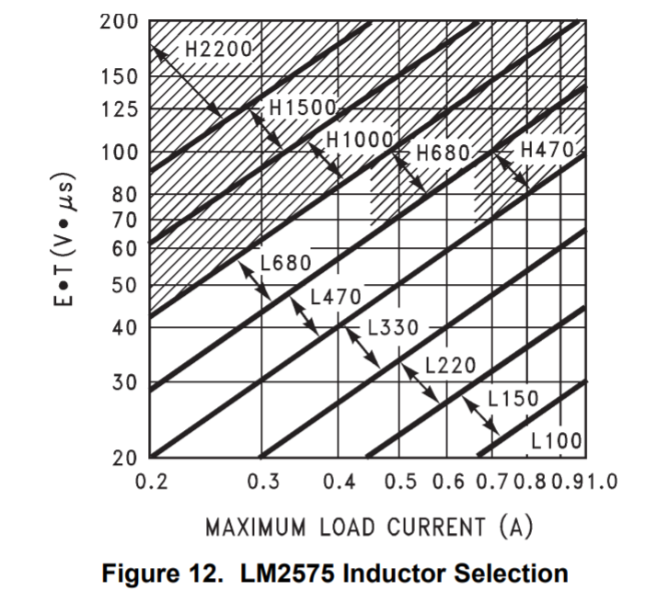

***Figure 4.7*** *- Inductor selection guide[7]*

Linearly extrapolating the trends of this chart yields us an acceptable inductor value of **2.2 mH**.

The inductor should never carry more than its rated current or the inductor will begin to saturate and act like a long coiled up wire, or a very low value resistor. An inductor rated as low as 2A will suffice. Knowing these characteristics, we found the inductor we would be using on Digikey and proceeded to order it.

An output capacitor is required for both stability and to control the output voltage ripple which needs to be *less than 150 mV* to prevent overpowering the sensors. The datasheets recommends ultra low-ESR aluminum electrolytic capacitors for this application. The larger the value of Cout, the less the output voltage ripple will be.

The LM2575 control loop has a two-pole two-zero frequency response. The dominant pole-zero pair is established by Cout and L1. Cout must be as in **Equation 4.10** to assure a stable ripple voltage at the output.

**Equation 4.10**: Cout 7758 $⋅$  $\frac{V_{in(max)}}{V_{out}⋅L_{1}(uH)}$ (µF)

The output capacitor voltage rating should be about 1% of the desired Vout for a stable output voltage ripple. We were able to calculate the appropriate output capacitance for the 5V rail by using the equation above which was **40 uF**. A 40 uF capacitor is not commonly supplied by electronic distributors so we had to settle for a **47 uF** output capacitor. We chose aluminum electrolytic capacitors due to their low ESR values. Their voltage rating should be at least 1.5 times the output voltage, which is about at least **7.5** **V** to cover both rails. Luckily, the output capacitor we chose had a 25V rating.

The diode selected should have a current rating of 20% greater than the maximum load current. For a 50 mA maximum load current, the current rating for the diode must be at least **60 mA**. A Schottky diode is a fast switching rectifier typically rated the lowest 20V and 1.0A for a 1N5817. We thus chose the 1N5818 Schottky diode for this design with a forward current rating up to 1.0 A and a reverse voltage rating up to 40V. The higher reverse voltage rating of the diode helps protect the switch from high transient voltage events.

The datasheets suggests any aluminum electrolytic or tantalum capacitor with a low ESR value is enough to bypass any AC noise coming from the battery. The typical range is anywhere from 47 µF to 330 µF therefore a **100 µF** aluminum electrolytic capacitor would suffice.

All components must be placed as close as possible to avoid the possibility of unwanted noise. The PCB’s for these schematics designed using good engineering layout techniques can be seen in **Appendix B**.

Another +9VDC-DC step up converter needed to be designed for this system to power our Arduino Mega microcontroller. The Arduino has four possible powering inputs as we can see in **Figure 4.8**.

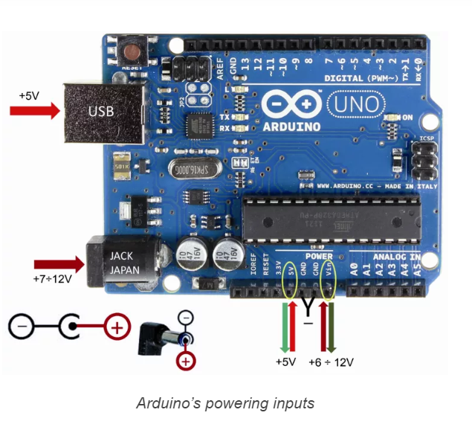

***Figure 4.8*** *- The four ways to power an Arduino (Note: The powering methods are the same in the UNO seen above and the MEGA)[8]*

The USB sockets need *exactly* 5 V to power the entire microcontroller and this can come from a computer or any other power supply. We did not plan on having any USB power system on this device as it would make the system less autonomous. We used the “Vin” port on the microcontroller to power the board. The fundamentals circuitry about how this pin powers everything is described below.

Refer to **Figure 4.9** from the arduino schematic.

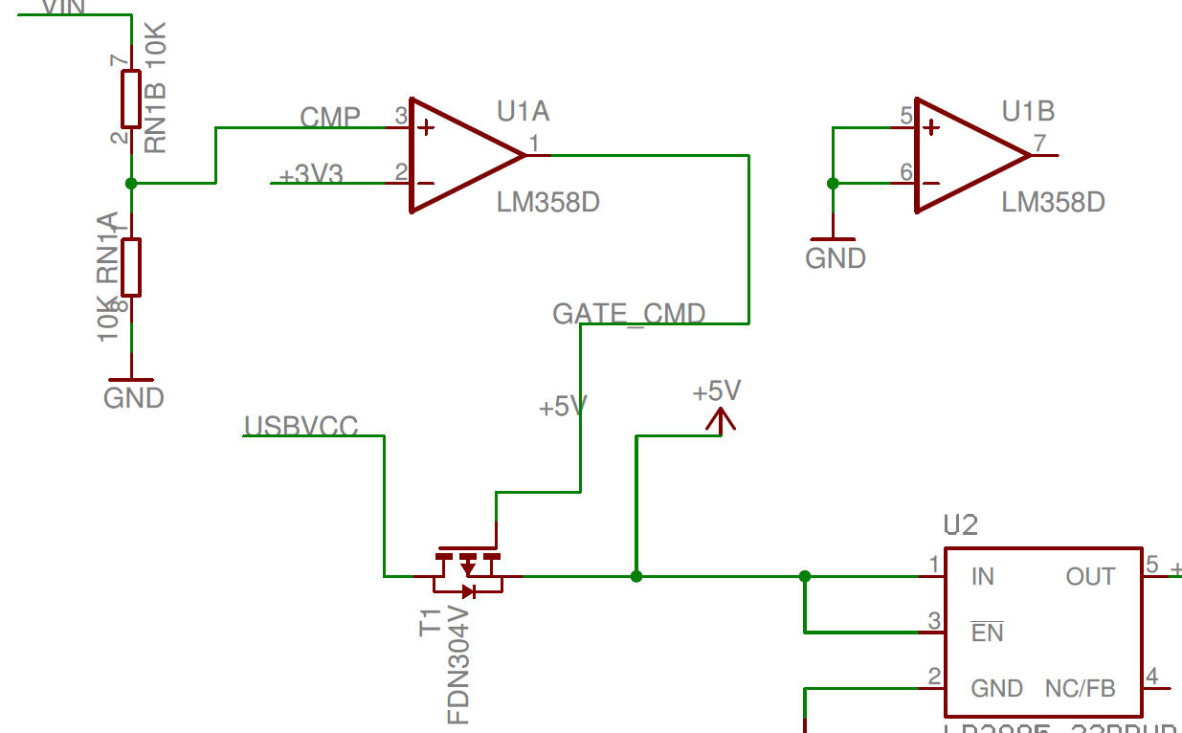

***Figure 4.9****- Arduino internal power system[9]*

The comparator takes in voltages from both the inverting (-) and noninverting (+) pins. The output is driven to -V if the inverting input is greater than the noninverting input.

The output of the comparator is driven into a p-channel MOSFET acting as a switch. Depending on the output of the previous voltage divider, the comparator decides whether the 5-V comes from the comparator or the USB.

The comparator is given two inputs from Vin and 3.3V from the onboard regulator. The power running through the “Vin" socket will go through a voltage divider seen above. The voltage divider divides this Vin in exactly half of its original value. For example, if we were to power the Arduino with just 6V, the Vin at the comparator will be only 3V and the Arduino will just be powered by the on board regulator. To assure that the power is supplied through the Vin pin, **Vin must be at least 6.6-V.** If Vin into the comparator is greater than 3.3V, it is driven to 5V and the P-MOSFET turns on the allow current to flow from whatever power supply is connected to the Arduino. *To assure we always power the Arduino from our power supply, we decided a Vin value of +9V would be sufficient.*

The boost converter IC from the breakout board we ordered is the TPS6104 Low-Power DC-DC Boost Converter. This board has already been laid out and was ready for testing when ordered however, we still needed to understand the functionality and verify the legitimacy of the switching IC and each external component on the board.

This layout is designed to be a high-frequency boost converter dedicated for small to medium loads. This chip is ideal to generate voltages up to 28V but, it can also be used to generate standard 3.3-V, 5V, 9V or 12V power conversions. It has a wide input voltage range from 1.8-V to 6-V, making it extremely versatile and has an internal switching current in between 250-mA and 400-mA. Its internal switching frequency can be as fast as 1-MHz. This chip has a very small 28-μA typical no-load quiescent current and a 1-μA Shutdown current and comes in the compact SOT23-5 surface mount package which is seen in **Figure 4.10**.

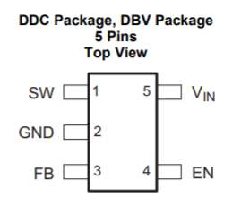

***Figure 4.10*** *- Pinout of TPS614x series SOT23-5 package[10]*

Tying the “EN” pin to ground forces this IC to shutdown. This device will need to be on at all times and will thus be tied to the input input voltage going into the package. The “FB” pin is the feedback pin of the device that operates similarly to the “FB” pin on the LM2575 IC. This pin is connected to the external voltage divider which programs our desired output voltage of +9V. The “GND” pin gets tied to ground. The “Vin” pin is the supply voltage in pin. Finally, the “SW” pin stands for “switch” gets connected to the external inductor and Schottky diode needed for the boost converter which is connected to the drain of the IC’s internal power MOSFET.

This highly efficient IC with its datasheet rating as high as **93%** makes it a suitable device for the design specifications of our power system. The efficiency versus the load current at different output voltages from the datasheet can be seen in **Figure 4.11**.

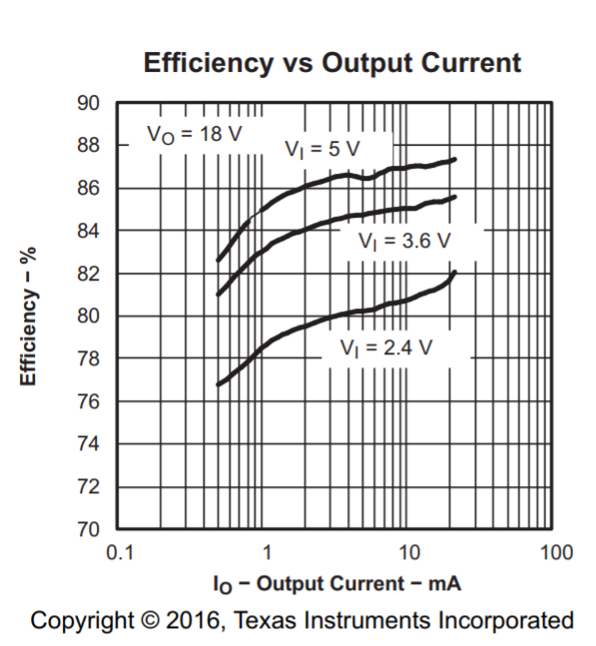

***Figure 4.11*** *- Efficiency versus load current of TPS614x IC[11]*

The higher the load current, the greater the efficiency of this IC. If we refer to our power budget seen in **figure 4.1**, the “high” state current draw of the ATMega328 chip is **20-mA**. This load with the addition of the loads coming from the +5.25V board would yield an efficiency of around **88% to 90%**.

The typical application circuit for this chip is seen in **Figure 4.12**.

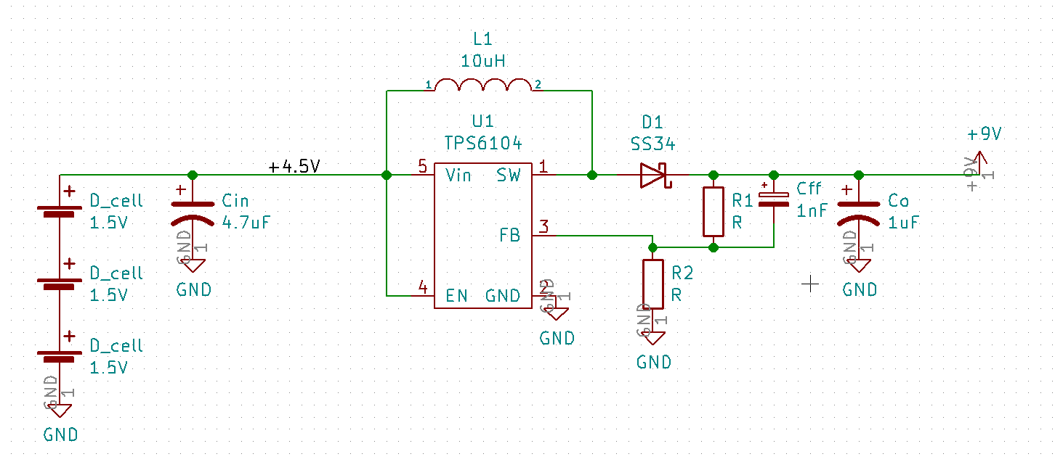

***Figure 4.12*** *- Typical Application of TPS6104x IC in KiCAD™*

The value of the inductor, load current, input and output voltages determines the switching frequency of the chip. The inductance is very important as it prevents the output current from going to zero and forcing the circuit into **discontinuous mode**. The datasheet provided by TI recommends inductor values between 2.2-μH and 47-μH for the best possible results. The maximum inductor value is determined by the maximum on time of the P-channel MOSFET switch, which the datasheet reveals to be *6 μs*.

The choice of inductor determines whether the maximum switching frequency at the converter maximum load current is not exceeded. The maximum switching frequency of the MOSFET can be seen in **Equation 4.11**.

**Equation 4.11**: fs(max) =

Here, “IP” represents the peak current inside of the switch. The MOSFET switch turns on until the inductor reaches its current limit of 400 mA. There exists an internal propagation delay of 100 ns meaning the actual current exceeds the limit by a very small amount. The peak current can be calculated by **Equation 4.12**.

**Equation 4.12**: Ipeak = 400 mA + $\frac{V_{IN}}{L}$ $×$ 100 ns

Take the on board inductor value of **22-μH**. The peak current value with the propagation delay would be:

Ipeak = 400 mA + $\frac{4.5 V}{22 μH}$ $×$ 100 ns

= 400 mA + 0.020 = **400.02 mA**

Thus, the maximum switching frequency is:

fs(max) =

=

= **0.26 MHz**

TI assures us that if this above calculated value does not exceed the maximum switching frequency (1-MHz) of the inductor, the inductance value is safe and we can use **Equation 4.13** from the datasheet to calculate the switching frequency with all loads

**Equation 4.13**: fs(Iload) =

The nominal load current is about **20-mA** and “Vd,” or the switch rectifier diode forward voltage drop is **0.3-V**.

= $\frac{2 × 43.1 mA× (9 V - 4.5 V - 0.3 V)}{{400.02 mA}^{2} × 22 μH}$

= **102.8-kHz**

This value will be the switching frequency of the boost converter under the maximum load conditions assuming a 22-μH inductor and fresh batteries.

The output voltage is determined by the value of the resistive divider (R1 and R2) that goes into the FB pin seen inthe application schematic. **Equation 4.14** belowis the output voltage of the converter as given by the datasheet.

**Equation 4.14**: Vout = 1.233-V $×$ (1+ $\frac{R_{1}}{R_{2}})$

Setting R2 to **2.4-kΩ** and rearranging for R1 gets:

R1 = R2(- 1)

= 2.4 kΩ (- 1)

= **15.1-kΩ**

This board conveniently comes with a potentiometer ranging from 1-kΩ to 100-kΩ so that we can change the frequency, and subsequently, the output voltage of this board. This potentiometer gives us the freedom of our boost converter outputting a voltage anywhere between **1.7-V to 52.6-V**.

**Figure 4.17** shows a feedforward capacitor: Cff in parallel with R1. The datasheet recommends this capacitor to provide enough overdrive for the error comparator inside the chip. If the board did not come with feedforward capacitor, the output voltage would experience higher ripples which otherwise results in a less-stable output. Lower switching frequencies require larger feedforward capacitors. **Equation 4.15** from the datasheet helps determine the sufficient value for the feedforward capacitor:

**Equation 4.15**: CFF = = = **2.05-nF**

A **10-nF** capacitor on the board remedies any issues that may arise

The datasheet recommends either low ESR electrolytic or tantalum output capacitors for the value of “Co” seen in **Figure 4.18**. A 47-μF tantalum capacitor with a 25-V voltage rating on the board can be found in **Appendix A**:

The datasheet provides **Equation 4.16** for the output voltage ripple with this capacitor:

**Equation 4.16**: ΔVout =

=

**ΔVout = 88.43-mV**

An output voltage ripple of approximately **88.43-mV** would not cause any issues as that would makes the absolute maximum output voltage of this converter **9.09-V**. Both the Arduino MEGA and LM2575 IC can take voltages up to **12-V and 47-V** respectively.

An input capacitor is necessary any low-frequency AC noise that may otherwise come from the power supply into the chip. The datasheet recommends a 4.7-μF low ESR ceramic input capacitor for this filtering. The input capacitor on the DC-DC converter board is a 4.7-μF SMD 0805 ceramic capacitor which is seen in **Appendix A**.

The best diode for this application is a Schottky diode due to its ultra-fast rise times and low forward voltage drop. The diode that went on the board is a SS34-E3/57T SMD Schottky Diode from Vishay which can be seen in **Appendix A**. This diode has a **current rating of 3.0-A and a reverse voltage rating up to 40-V**.

Part of the success of this project is implementing an effective method in conserving the battery life. This will provide the most effective and efficient method of power distribution in this system. Upon doing more research, we found the best way of accomplishing this goal was to design a relay or switching system that can effectively “open” and “close” power to any load. This integrated switch would new a very low voltage drop across itself and must be able to be controlled by the Arduino.

Our load options which we can turn off dwindle down to the radio, LCD, and sensors. We cannot shutdown the radio at any time because it always needs to be initialized, waiting for a signal from the hub. For more information on the operation of the radio, “RF” section of this report. The LCD already draws as little as 0.5-mA of current when on and 0.2-mA of current when on standby mode. The LCD will also always need to be on the let the user know which state the microcontroller is on at the moment. This leaves us with the sensor array which draws a current of approximately **12-mA** (according to the power budget). With a duty cycle of only 1.7% daily, it makes no sense to constantly power these sensors when they don’t need to take measurement. Hence, we will implement the a switch/relay here.

We originally went with the **TPS22918** power switch IC from TI due to its adjustable rise and fall times, low on-resistance, and its ease of use for implementation. The IC can be seen in **Figure 4.13**.

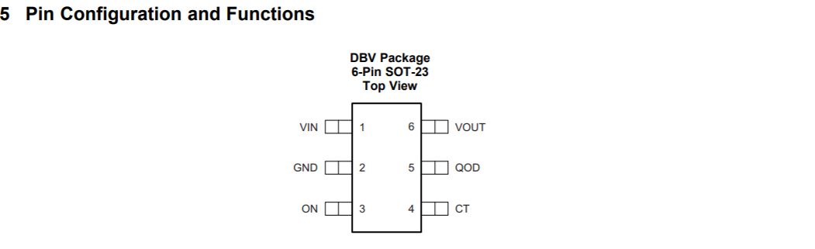

***Figure 4.13*** *- TPS22918 pins[12]*

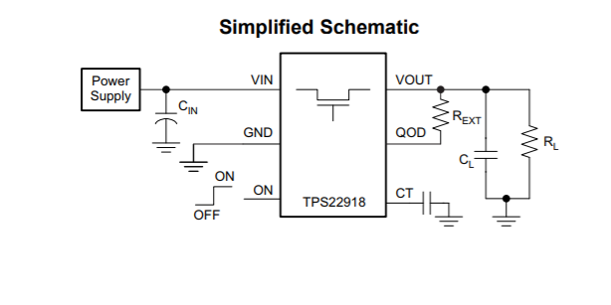

***Figure 4.14*** *- Schematic for TPS22918 circuit[13]*

Referring to **Figure 4.14**, the “power supply” would come from the 5V rail. The ‘ON’ pin would be controlled by a digital pin on the Arduino Mega. The state machine would be programmed to turn this pin off when exiting each state. An input capacitor of at least **1 µF** is needed, according to the datasheet.

The Quick Output Discharge or QOD pin controls the amount of excess charge that gets released upon closing the switch. The can be regulated by an extension resistor (Rext) between the QOD pin and Vout. The extension resistor added with the internal resistance of the chip (53 mΩ) lowers the discharge rate after the switch closes again after a period of time. This is used to protect any circuitry the chip may be driving from a quick discharge event. Most of the circuitry being driven can handle the minimal excess discharge so there was no need to pick an extension resistor value We planned to rely on the internal resistance of the pin to regulate the discharge therefore, we shorted this pin to output.

The load capacitor, according to the datasheet, must be at least 1/10th the value of the input capacitor therefore at least **100 nF** will suffice. Finally, CT is used to alter the rise and fall times of the switch. Since this is not a high-speed application, the rise and fall times are not a concern and we can short CT to ground.

Some struggles with effectively integrating this switch IC into the design halted us moving forward with this method and we needed to change our method of switching power on and off at the sensors load.

The solution was a 5V relay switch breakout board which can be seen in **Figure 4.15**.

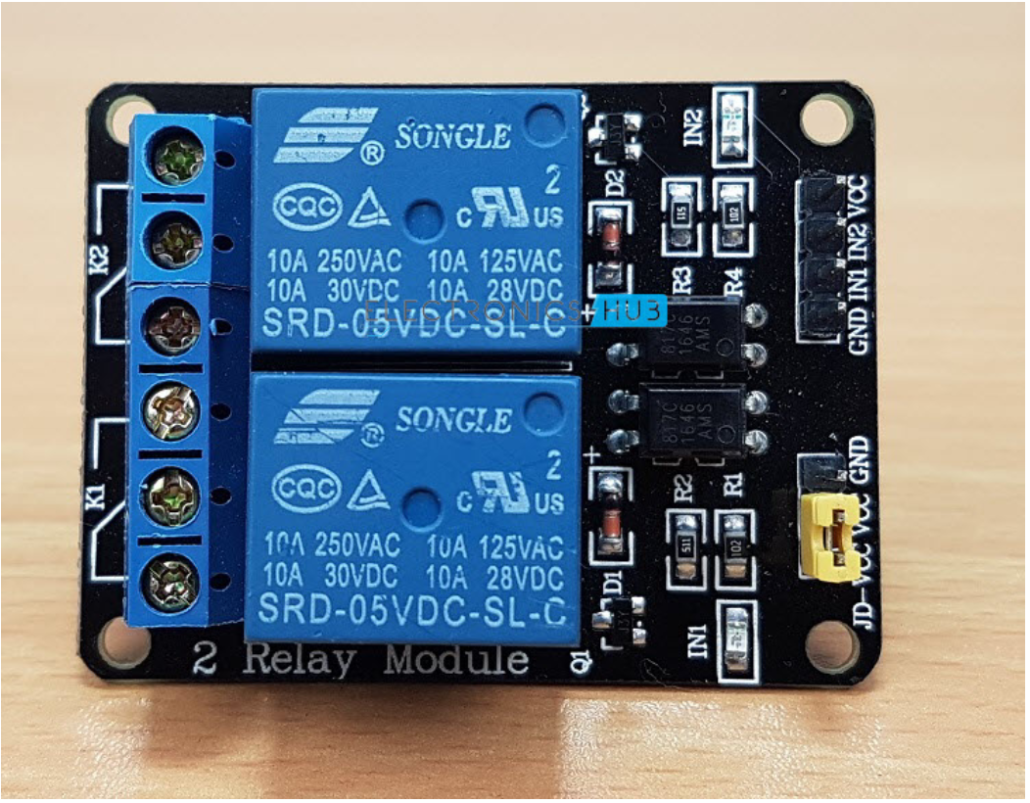

***Figure 4.15*** *- 5V relay switch module*

This device seamlessly integrates with the Arduino board and can be powered via the 5V port of the Arduino itself, which isn’t currently in use. The 5V output from the Arduino is not powerful enough to drive the loads therefore it will only be used to power the relay.

This two terminal relay seen in **figure 4.15** above has 3 pins per switch for a total of 6 output pins total. Each switch contains a NC, C, and NO output pin which connects to the device we want to control. These pins represent the normally closed, common, and normally open pins respectively. This board also has a Vcc pin that is powered from the Arduino, a GND pin, and a signal pin that will come from a digital pin of the Arduino.

Inside of the relay contains a 120-240V switch that’s connected to an electromagnet. This electromagnet is activated when a low voltage signal pulls a contact to open or close the switch.

The two electrical contacts (NO and NC) will be used depending on the application we are using the relay for. Furthermore, it depends on whether we want the 5V signal to turn the switch on or off. In the normally open configuration, when the relay receives a HIGH signal from the Arduino, the switch will close and current will flow from the common terminal to the NO terminal. Subsequently, a LOW signal will open the switch again.

Conversely, in the normally closed configuration a HIGH signal will open the switch while a LOW signal will close the switch allowing the current to flow. For our application, we can use either the NO and NC configurations. We just need to make sure the state machine logic follows the hardware configuration.

To isolate the Arduino from the relay circuitry, we can power the relays with an external 5V. This would protect the circuitry of the Arduino microcontroller and assure no damages occur possibly harming the entire board. Testing this method with our design worked great and we were able to see the current draw from the power supply decrease when the power to all sensors was cut off.

All methods of battery conservation may delay the decay of our batteries but, the client still needs an indication about when the batteries are low. Our solution is a low battery state implemented into the state machine. The state machine enters a low battery state whenever the capacity of the batteries is **less than 10%**. We used the following method to detect the percentage of capacity left on the batteries.

We know the nominal voltage of each cell is 1.5V. 3 cells in series provides a nominal voltage of 4.5V. Conversely, the discharge voltage of Alkaline cells is 0.9V or 2.7V for 3 in series. This 4.5V from the batteries drives a voltage divider (seen below).

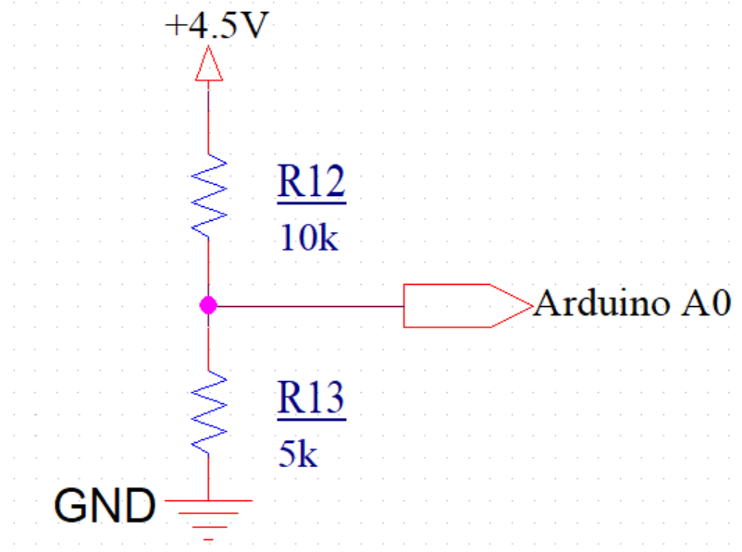

***Figure 4.16*** *- Voltage divider low battery state detection*

Pin J7 feeds into the Arduino MEGA’s Analog A0 pin. The maximum and minimum voltage feeding into this pin was calculated by using the known nominal and discharge voltage. By plugging in the discharge and nominal voltage for $V_{in}$ into **equation 4.17**, the theoretical voltage across the $5kΩ$ was recorded to be in the range of 0.9 to 1.5 Volts.

**Equation 4.17:** Vx = Vin() = Vx = Vin()

**Equation 4.18:** Vx = Vin()

**Equation 4.18** represents the software formula used to calculate the voltage across the $5kΩ$ resistor where ADC is the result of the analog-to-digital conversion. The Arduino uses a 5 Volt reference to convert analog signals to digital signals that range from 0 to 1023. In our case, our analog signals range from 0.9 to 1.5 Volts which corresponds to an ADC range of 184 (0.9 Volts) to 307 (1.5 Volts). Essentially, 0% and 100% battery correlates to 0.9 and 1.5 Volts, respectively. These digital signals were mapped to a percentage using **equation 4.19**.

**Equation 4.19: $\frac{(V_{x}-0.9)}{Max Voltage}⋅100\%$**

In the **equation 4.19**, 0.9 Volts represents the offset to change the operating range of 0.9 Volts to 1.5 Volts to 0 to 0.6 Volts. This offset was included to make the voltage range mapping to a percentage simpler. The max voltage variable is represented by 0.6 Volts which is the 1.5 Volts minus the offset.

Therefore, if Vx is 4.5V, the battery percentage would be 100%. If Vx is 2.7V, the battery percentage would be 0%.

Say the client puts in batteries with lower or higher than nominal voltage than alkaline cells. We clearly state in our user manual we recommend Alkaline cells for the longest lasting functionality. Future work may be done in such that the state machine can go into a “wrong battery” state and refuse to function until the correct batteries are placed.

Implementation of the power system in our device would not be possible without proper testing. The original idea was to have a **5.00V** rail to power all devices on this rail. We received the following results when testing with this configuration.

Plugging in the 5V regulator into the Arduino to power it, the current draw from the supply increased from 7 mA to **47 mA**. (We of course learned later that the Arduino needed at least 7-12VDC to work nominally) All 4 sensors that Jorge picked were also able to be powered solely by the regulator as well as the LCD display. Luckily, the sensors and display were not power intensive and when powering all 5 devices, the current draw increased to about **15 mA** total.

Once everything was powered on one rail, there was an interesting feature on the LCD. The values displayed on the LCD were nothing near what we were seeing before, when just operating from the power supply. The temperature and humidity were way off the expected values and the sensors were not supplied with a proper voltage to run to optimal measurements. Probing the voltage rail where the sensors were operating, we got a voltage of **4.967V**. We suspected the DC-DC converter was not designed with the proper output capacitance value to provide a stable enough output voltage. To combat this we changed the resistive feedback configuration to give an output voltage of **5.25V**. We also increased the output capacitor value from what we originally had which was 22 μF to 47 μF. These changes led to a much more stable loaded output voltage.

The oscilloscope waveform for the output voltage of the loaded converter can be seen below:

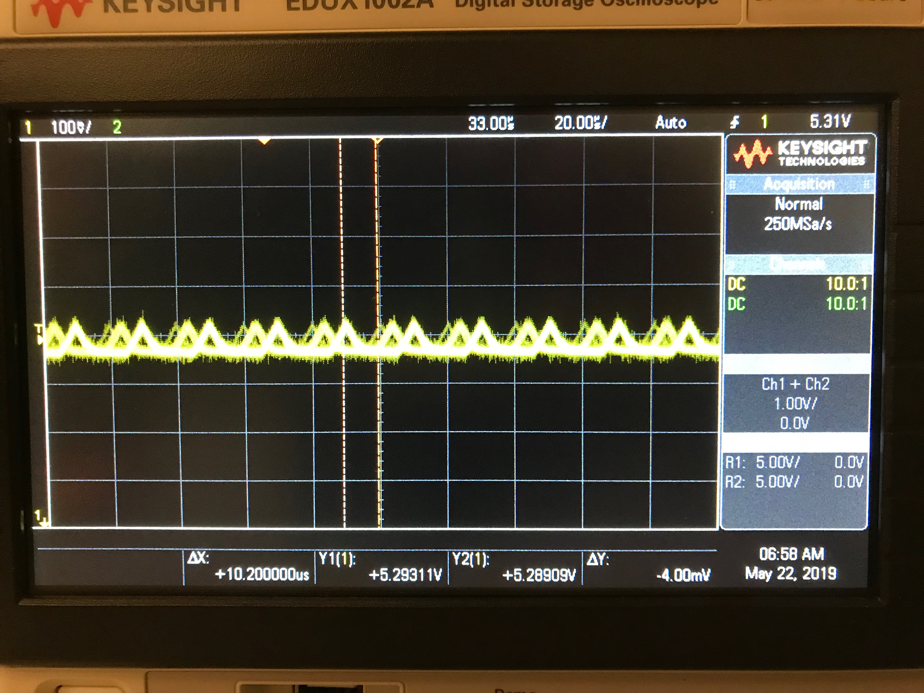

***Figure 4.17*** *- Oscilloscope output voltage reading. Note termination of scope is 10-M $Ω$*

Our +5V board must have is a very low output voltage ripple of less than **5% the nominal output voltage**. The nominal output voltage of our converter is projected to be **5.25-V**. The maximum drive voltage of the LCD is **5.5-V** according to its datasheet. All other sensors as well as the radio can handle voltages up to **5.8-V or 6-V**.

The maximum output voltage value as read by the scope is **5.326-V** and the minimum value is **5.282-V**. This gives us an output voltage ripple of **44-mV** which is approximately **0.8%** of the nominal output voltage. We were very happy with these results as they fall under our design constraints we laid out before building this PCB.

Referring to **Appendix F**, we calculated the efficiency of both the +9V and +5.25V DC-DC boards we used to power all parallel loads. These efficiency ratings came out to be 88% and 86% respectively at their respective input voltages, output voltages, and load currents. We were able to calculate roughly how long the device’s battery life would be using the following equation:

**Battery Life = $\frac{Battery Capacity ⋅ +9V Regulator Efficiency ⋅ +5.25V Regulator Efficiency}{I_{high}+I_{low}}$** / 24 hours

**Battery Life =** 12.79 days ≈ **13 days**

We received the TPS22918 switch towards the latter half of the quarter. Since this is a 6-pin SOT-223 SMD package with dimensions of approximately 3.0 mm x 1.75 mm, we cannot simply plug this IC into a breadboard. We tried solder wires to each pin and plug those wires into the breadboard to test. This ultimately failed because the pins are very frail such that soldering wires to them forced the pins to fall off the package.

The only way to test these IC’s to see if they work is to solder them to a PCB. To save both copper and time, we chose to try a different and hopefully simpler method to implement a load switching method.

This other method was using a BJT switch controlled by the Arduino. The BJT we chose was the TIP120 Darlington NPN transistor, a configuration commonly used for switching purposes. This transistor has a high DC current gain (hfe) of **2500 at a collector current of 4 Adc**. The transistor can be seen in **Figure 4.18**.

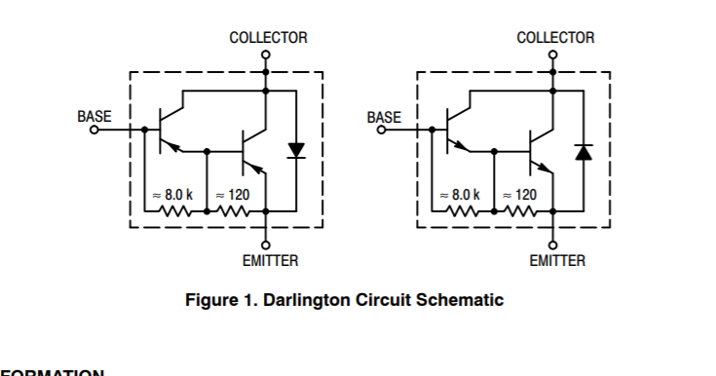

***Figure 4.18*** *- TIP122 Darlington transistor[14]*

This BJT has a low collector-emitter saturation voltage which is **2.0V at 3.0 Adc**. The schematic of how we planned to drive the sensor and radio loads with the transistor setup can be seen in **Figure 4.19**.

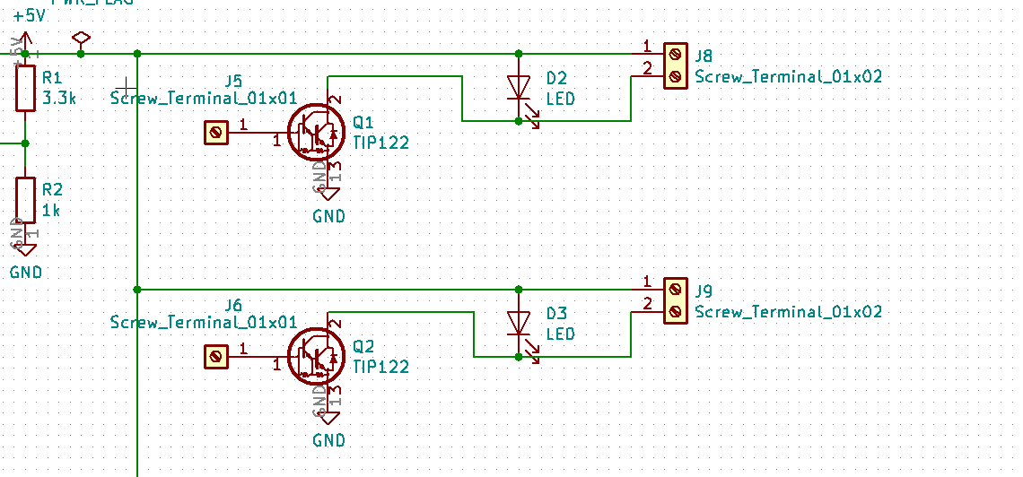

***Figure 4.19*** *- Schematic of the TIP122 transistor switch configuration with the DC-DC converter*

To the left (where the +5V arrow is seen) is the output of the LM2575 buck converter. This 5V will drive the positive end of a screw terminal. The negative end of the screw terminal is connected to the collector of the TIP122. A low power LED is placed before the screw terminal to indicate when the switch is on and off. The base is driven by a digital output pin of the arduino mega. A resistor may be placed between the arduino pin and the base to limit the current driving the BJT and protect the entire IC however, an Arduino digital pin outputs **5V at a limited 40 mA**. The datasheet for the TIP122 states the maximum base current is **160 mA**. There will be no need for a limiting resistor. Finally the emitter is driven to ground to complete the circuit.

Ideally, when the base is driven by the Arduino, it will become saturated allowing the BJT switch to close and current to flow from the collector to the emitter. When a current flows from the Arduino pin to the base, a current flow proportional to the base current in the output will flow from the collector to the emitter.

We wired this simple setup on a breadboard with just the LED to easily see if the switch is closed or open. We ran a simple program on the Arduino that turns the switch on and off in 3 second intervals. Upon probing the voltage between the +5V rail and the collector pin of the TIP122 IC, we expect to see approximately **+5.25 V** with minimal voltage droop. Instead, we got a value of about **3.1 V** at this node. The main contribution for change in voltage is the relatively high collector-emitter voltage of the BJT which was **2 V according to the datasheet**. We needed to find a switch with a significantly less dropout voltage.

Upon printing the TPS22918 switch PCB it was time to solder all of the components and test to assure the device turns on and off when instructed. We made sure to check for any loose connections on the board as well as any undesired shorts before testing. Once this was all good, we drove the input pin of the IC with a clean **+5V** from the power supply while making sure to limit the current on the supply **1.0A** (note the maximum current rating of the package is 2.0A).

We ran a simple program for the Arduino to turn on and off one of its digital pins every 3 seconds. The code can be seen in **Figure 4.20**.

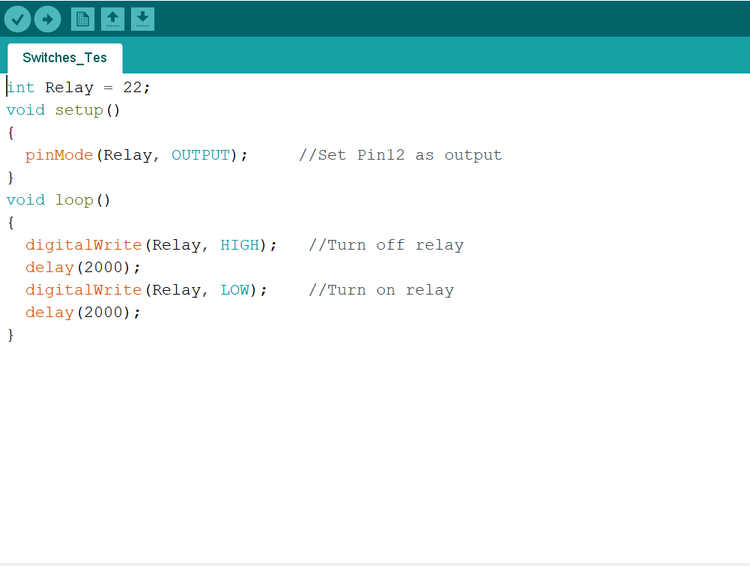

***Figure 4.20*** *- Simple Arduino program for testing the switching capabilities of the IC*

The digital pin of the Arduino is capable of driving and output for **+5V with 40 mA supply current**. This will be used to drive the “ON” pin of the load switch IC which, according to the datasheet, can handle voltages up to **+6V**. There were no resistive or capacitive load attached to the output of the IC.

What we expected to see in the multimeter was the voltage value to fluctuate between approximately +5V and 0V. When testing, it appears the IC was not switching at all. We probed the voltage at the input of the IC and confirmed that it was indeed getting a solid +5V input. We also probed the voltage at the digital pin of the Arduino to assure it was producing +5V and it was changing every 3 seconds as well.

Upon doing more research I believe the solution to the switching problem is that I needed to include a pull-down resistor between the “ON” pin trace and ground. This resistor value would be anywhere from **1-kΩ to 10-kΩ**. This would have required us to print another prototype board for the final product and doing this would set us behind schedule for our end of the quarter deliverables. We needed to find a quicker solution to finding a device that will act as a load switch. This solution came as the 5V relay switch that it seen in **section 4.2**.

## 

## 4.3 Future Work

Future implementation of this system includes detecting harmful VOCs emitted by composting facilities; which are mostly outdoors

This system would thus be placed outdoors where we could take advantage of the sun’s UV rays to power the system rather than relying on replaceable batteries. We designed the concept for a solar charged power system which can be detailed in **Figure 4.21**.

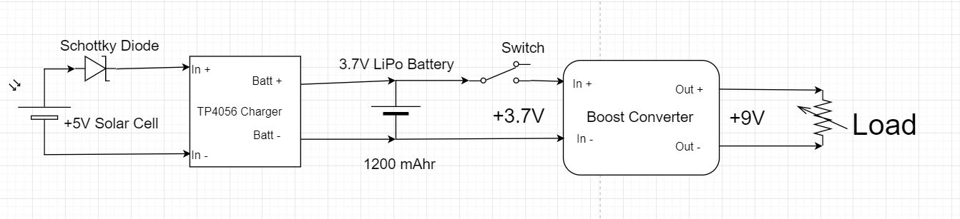

***Figure 4.21*** *- Solar Powered Battery circuit Schematic*

To the left of the schematic is a +5V solar cell driving a TP4056 charger breakout board. A diode is placed between the positive terminal of the solar cell and the charger to protect against any reverse polarity. This charging circuit charges a 3.7V LiPo battery which will be boosted up to +5V by the boost converter described previously. A toggle switch turns the device on and off at the will of the user. The TP4056 charger board can be seen in **Figure 4.22**.

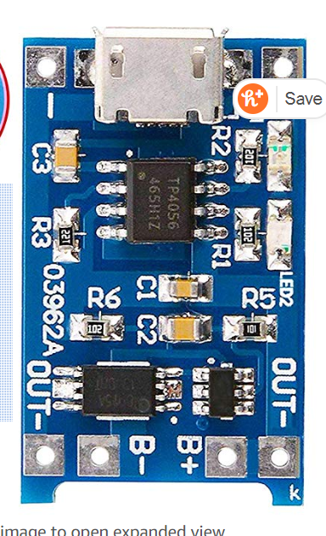

***Figure 4.22*** *- TP4056 Charger board*

This is a micro USB Lithium-Ion or LiPo battery charging board with a built in TP4056 chip. This board also contains battery over-charge, over-discharge, and over-current protection circuitry. The input DC voltage is 5V, which will come from the solar cell and the charging cutoff voltage is approximately 4.2V with a 1% error margin. The maximum charging current of the board is 1.0A and the solar cell which we ordered is rated for a maximum output current much less than this. Furthermore, the cell itself is approximately 5.1” x 5.9” so the housing will need to be designed big enough to incorporate this cell on top.

The most common LiPo batteries come with the standard **3.7V and 1200 mA $⋅$ hr** configuration. The battery needs to be charged enough to last in periods with no sunlight or in the winter months. This will take further calculations and is a goal for next years team if this project were to continue.

Future work also includes the implementation of the valves we chose. These are ½’’ valves that can be powered off **6-V, needing only about 160-mA of supply current**. These valves can be easily interfaced with the Arduino UNO microcontroller which was a big tradeoff on why we decided to purchase these. These valves were also cheaper than most mechanical valves that can be found, and operate at much lower supply voltages than most others.

These valves are *normally closed* meaning they need a **constant** supply current to keep them open. These valves also contain gasket arrangements inside so there is a minimum pressure requirement of **3 PSI** to operate nominally. Finally liquid can flow in **one** direction.

Our test circuit to check if the valve opens and closes in its respective intake and outtake states can be seen in **Figure 4.23**.

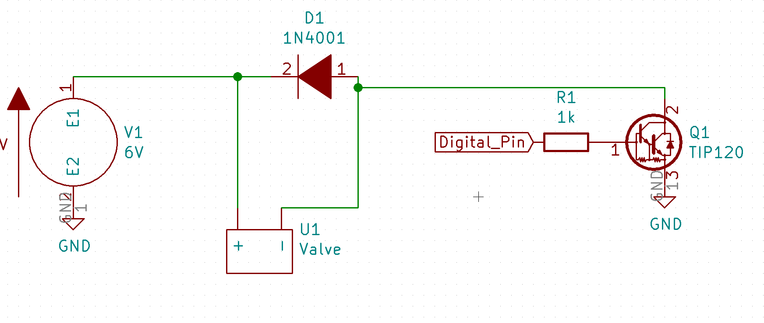

***Figure 4.23*** *- Valve Test Circuit*

The valves need *at least* 6 V and 160 mA of current when open. Since a solenoid is an inductive load, a snubber diode across the contacts must be placed to eliminate any transient voltages when a magnetic coil suddenly loses power. This transient voltage spike can damage other elements of the circuit. It is placed from the negative to the positive side of the coil. The low side of the solenoid will be used as a switch to turn on and off the valve.

Switching on the low side means that the circuit will be interrupted between negative and ground rather than power and the solenoid. We do this because switching on the power side is more difficult with the BJT when the power voltage is higher than the 5V logic voltage of the digital pins from the Arduino.

The TIP120 Darlington Transistor was picked since the current draw of the solenoid is higher than most transistors can handle. A 1k resistor is placed at the base to limit current going into the base of the BJT. A digital pin of our choice on the Arduino is designated for switching purposes and driven through the base of the transistor. The collector side gets connected to the negative terminal of the solenoid and the emitter gets tied to ground.

A standard test was to open and close the valve every three seconds and its code can be seen in **Appendix C**. Uploading this code to the board, we see that the valves successfully opened and closed every 3 seconds. This was verified by looking at the 6V power supply and seeing the current draw change every 3 seconds to 47 mA (which is the current draw of the Arduino), to 253 mA. The current would return back to 47 mA when closed again. While our delivered design does not employ these valve, they can be easily onboarded for future iterations.

## 4.4 Conclusions

The power subsystem of this device is considered one of the most crucial ones. A well designed power system will protect all components while effectively supplying load currents and voltage where needed. The portability of this device would have otherwise failed to be realized without designing a proper compact and effective power distribution system.

We were successfully able to deliver our client, Peter Weiss a battery powered device that is portable enough to move between different labs and offices. He will always be informed about the battery state and will be prompted to change out the replaceable batteries before he can do any other testing. Effective ways of protecting the in-house batteries as well as all series circuitry was implemented in the unlikely scenario an anomaly with the batteries occur The use of switching regulators rather than linear regulators provides for a much more efficient way of stepping up and down the voltages of for both the +9V and +5.25V rails. Our system utilizes switch methods to help conserve the battery life by shutting down the power to the sensors board when they are not taking in a sample.

# Chapter 5 - RF

## 5.1 Design Considerations

Wireless capabilities of our device were vital to the system since it makes implementation and ease of use seamless and manageable. As noted above, our device is battery powered for the purpose of remote operation, allowing the user to place the node in a hard to reach place near an exhaust pipe, and removing the need to wire the device to an outlet. It follows that with this portable design feature, data needs to be communicated over radio frequencies. Removing the need for cords and cables allows the device to be implemented in vastly more locations, removing reasons for pushback from wineries themselves.

Our goal of implementing our device in wineries to measure their ethanol emission relied on the premise that said facilities would be scrubbing their ethanol. This requires data to be collected pre- and post-scrubber to monitor gross and net emission values, respectively. Each scrubber has two nodes; data from those nodes is then relayed to a central hub to be collected and stored onto a microSD card. The topology for a network like this follows a star pattern, however, there was thought of using a small short range transmitter between the two nodes, packetting those values together, and sending them on a long range (LoRa) transmitter to the central hub (**Figure 5.1**). A topology for a hybrid network would have the frame of a star network, but additional appendages at each point of the star for the pre-scrubber. Though there is a cost benefit of using a short-range radio over LoRa, you must take intended application into consideration.

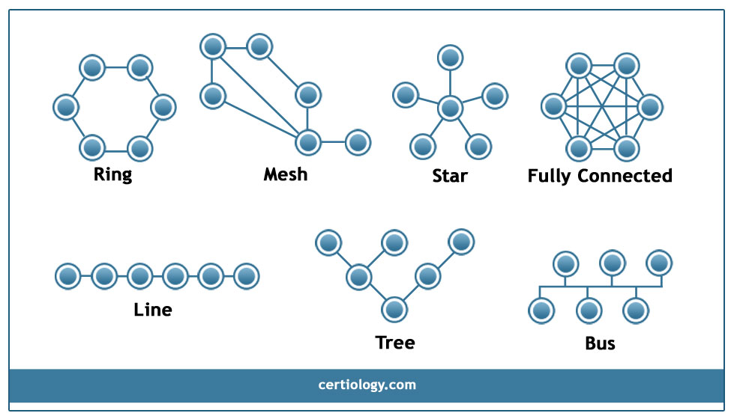

***Figure 5.1*** *- Examples of common topology networks*

Our end goal is to implement our device in large industrial wineries, where the size of the plant and warehouses is comparable to gas refineries, larger than the size of city blocks, hundreds of thousands of square feet in size. Sutter Home, a commercial winery whose fermentation plant is located in Lodi, CA, has an aging facility 2800’x2000’, roughly 5,600,000 square feet. On a site like this, hundreds of large silo-like vats form towering rows on the property. With separate offices adjacent to these vats, transmitted data would have to go through many obstacles before reaching an amiable location on the other end of a campus. The farthest propagation distance would then be 3650’ on such a location, obstructed by metal containers and through multiple walls. While wineries like this are our target, starting small allows us to get our foot in the door as a baby step, rather than tackling a giant.

Our focus shifts from large scale locations to smaller sized local breweries and wineries in Santa Cruz County. With locations like this, our range for data to be transmitted drops considerably. For example, a propagation report of a local canning and brewing company, Bottleneck Solution, reveals a shorter distance of, at most, 300ft. Talking with a former employee, the warehouse contains 10-30 barrel fermenting tanks, burners, kettles, grinders, and other large machinery. An office inside is partitioned off by drywall, making for an ideal location to store a central hub to collect data. These are the kinds of facilities we have in mind for initial implementation, talking with other roasters and brewers like Verve and Humble Sea. Local wineries in mind include Hallcrest in Felton and Bargetto in Soquel. Considering potential participants, a link budget was necessary to determine what radio would work best for our applications (see Testing and Validation).

Changing scope from large industry to small mom-and-pop locations alter our decision making and tradeoffs for the radio of choice. Instead of having two different radios, for short and long range, and writing code that would packet those values together to be sent off from the LoRa, it makes more sense to use the same radio across the board. The radio chosen needed to be able to have an address, communicate within a range of 100-300m, and operate on the available ISM band (902-928MHz). Looking at the commercially available radios on the market, and comparing some popular ones, **Table 5.1** shows useful comparisons.

|  |  |  |  |  |  |
| --- | --- | --- | --- | --- | --- |
| **Table 5.1** - Radio Comparisons | | | | | |
|  | Needed | Adafruit RFM69HCW | Adafruit RFM9x | XBee XB24CZ7UIT | Nordic NRF24L01 |
| Frequency | ISM Band | 915MHz | 900 MHz | 2.4GHz | 2.4 - 2.5 GHz |
| Voltage | Lowest | min 1.8V | 3.3-5.5V | 2.1-3.6V | 1.9-3.6V |
| Range  (Indoor) | 100m | 100m | 400m | 60-90m | 3-15m |
| Range  (Line of Sight) | 500m | 500m | 2-20km | 1200-3200m | 17-66m |
| Cost | Cheapest | $9.95 | $19.95 | $17.50 | $5.59 |
| Data Rate | TBD | Up to 300kbps | Up to  1.2 kbps | Up to  250 kbps | Up to 2000kbps |
| Packet Size | TBD | 66 bytes | 252 bytes | -- | 32 bytes |
| Temperature Range(०C) | Withstand >65०C | -40º C to +85º C | -40º C to +85º C | -40º C to +85º C | -40º C to +85º C |
| Power Output Capability |  | +20 dBm - 100 mW | +20 dBm - 100 mW | +5dBm -  3.1mW | +4dBm -  60mW |
| Dimensions | Smallest | 16x16mm | 16x16mm | 24x27mm | 33x15mm |

Wifi was ruled out to avoid interference, but more importantly the packets we were sending were considerably small (~30 ASCII Characters, so around 210 bits). Since wifi operates at such high bitrate, it is excessive to use considering what was needed. Thus, considering cost, bitrate, frequency, and availability, the RFM69HCW was initially chosen. Looking to the tests below, the data showed that while it was useful in addressing, encrypting, and sending data a short range, for our intended need and seeing as the next option up was double the cost, the RFM95 was finally chosen. Using the same amount of power (20dbm), and sending at a lower bitrate, but larger packet sizes, the radio was able to communicate roughly 150 ft indoors through multiple walls.

With this upgrade came the tradeoff of addressing capabilities and encryption. This issue was met with simple code that addressed each node with a specific packet of data (see Github), and if the packet matched with the node “address”, data would be relayed back to the hub. This all required an order of operations to be figured out on how the hub would ping for data from multiple sensors. The hub would begin by first starting up and connecting to all the nodes on the network, as determined by user input on a push button on the hub, indicating the number of nodes by LEDs. Once the number of nodes was determined on the network, the hub would connect to each one individually, working through the list, and once all were established, the hub would move on to pinging each node on a specified interval. **Figure 5.2** shows the states the hub goes through to retrieve data.

Error states from initialization are written to the SD card, or indicated by the LEDs flashing if the SD card is the error. The limits of this design arise when the user wants more that four nodes on their network, but considering the scope of our project and intended clients, this allows for clients with two scrubbers on their facility. The interval is also predetermined, to be ten minutes, but this can be altered by editing and upload customized code. This allows for over 5000 data points over the two weeks of a fermentation cycle.

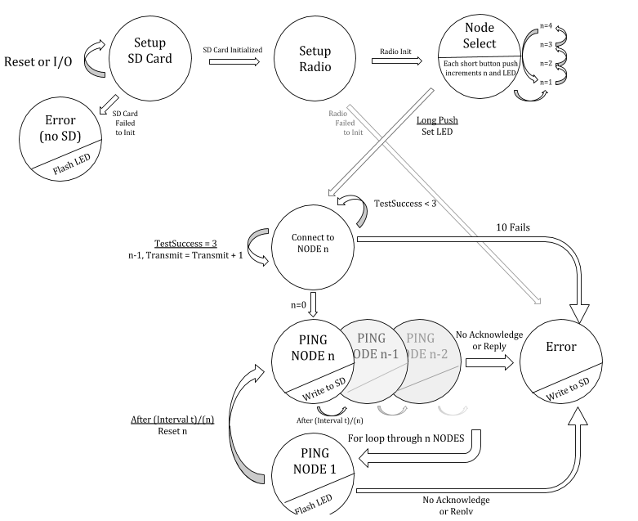

***Figure 5.2 -*** *Hub protocol upon start up for connecting to each node.*

## 5.2 Testing and Validation

To begin testing, the RFM69HCWs were initially purchased, and later upgraded to the RFM95s. Data for both is shown below to comparatively see what influenced our design decisions. Originally using an Arduino UNO board, the radios were breadboarded and the sample code given was used as a cornerstone for the code now on board the microcontrollers used currently (see code in Appendix C for HUB). The wiring for the Adafruit RFM69HCW uses SPI on the Arduinos for input and output functionality, that is, it uses MISO (Master Input Slave Output), MOSI (Master Output Slave Input), and SCK (System Clock). This is a common serial data protocol, similar to USB. Additionally, each module that has these ports on their board also has either a SS or CS pin. This pin, known as the chip select, lets you determine which module or device is being written to or read from. If CS is low on the radio, the data comes in and out, whereas if it’s low on our microSD card reader, it opens the gate for data to be written and read to and from.

Wiring the 69s (see **Appendix B**), a link was established and code written to ensure a connection. A wire antenna was used initially, before an SMA connector and commercial antenna. The code is of course commented, but the way it works is by first sending out test packets from the transmission node to wait for a reply back from the receiver. Once three successful test packets have been received, out of ten chances to do so in 1 second intervals, the node is considered connected and an output message is displayed to the LCD. Having this connection established with a receiver and transmitter, distance tests were conducted, with results in **Table 5.2**.

|  |  |
| --- | --- |
| **Table 5.2** - RSSI testing between RFM69HCW over multiple distances and using different antennas | |
| Condition | RSSI (dbm) |
| Uploaded Code, connected 3 feet apart | -77 |
| 15ft apart, line of sight | -90 |
| 10ft apart, through a door and then a wall | -87 |
| Attached old antennas 3ft apart | -64 |
| Tested without wire antenna and just commercial | Connection lost |
| Resoldered wire antenna, 3ft apart | (-66)-(-72) |

As seen, these values are not ideal, nor what was promised by the company who sells these chips. Don’t believe everything you read when choosing a radio for the device. Hence, for double the cost, we upgraded to the RFM95, with results shown in **Table 5.3**.

|  |  |
| --- | --- |
| **Table 5.3** - RSSI testing between RFM95x over multiple distance | |
| Condition | RSSI |
| 15ft apart, line of sight | -42 |
| 3ft apart, line of sight | -30 |
| ~150ft apart, room 310 to 389, through ~6 walls | -85 |
| Further testing [Spring 2019] |  |

Looking at a link budget, the expected values for a radio operating at 915 MHz are in **Table 5.4**.

|  |  |
| --- | --- |
| **Table 5.4** - Link budget for radio operating at 915 MHz under assumed conditions | |
| * Transmitter output power | +20dBm |
| * Attenuation in the transmitter’s antenna cabling, including any impedance matching network | unknown |
| * Transmitter antenna gain in the direction of the receiver | +3dBi |
| * Propagation loss in free space = $20log(d)+20log(f)-27.55, d=100m, λ=915MHz$ | -71.67dB |
| * Attenuation due to the absorption in atmospheric gases | N/A <22GHz |
| * Margin for attenuation due to rain | N/A <11GHz |
| * Margin for attenuation in tree foliage | Variable and dependent upon location |
| * Margin for signal fading |  |
| * Receiver antenna gain in the direction of the transmitter | +3dBi |
| * Attenuation in the receiver’s antenna cabling, including any impedance matching network | unknown |
| = Signal strength at the receiver input terminals, to be compared with the minimum necessary signal strength (must be >-90dB) | -45.67dB |

Comparing the first test results to the expected value show experimental values are of course not in line with the ideal theoretical. Nonetheless, the limits of the radio were tested to see what extent they could communicate and under what conditions we could confidently implement the device in.

Further testing with the RFM95 showed promising results. The RSSI vs distance graphs in **Figure 5.3** and **Figure 5.4** were taken with wire antennas attached to the modules, producing far more exceptional results that initially expected. Tests were conducted outside line of sight on a clear day on the third floor of J. Baskin Engineering 1, and inside the facility as well at the location specified on the map in **Figure 5.5**. I set up both radio to send messages on the interval of 5 seconds, moving roughly 10-15ft between each interval, and tracking the RSSI at each location as I moved the receiver away from the transmitter.

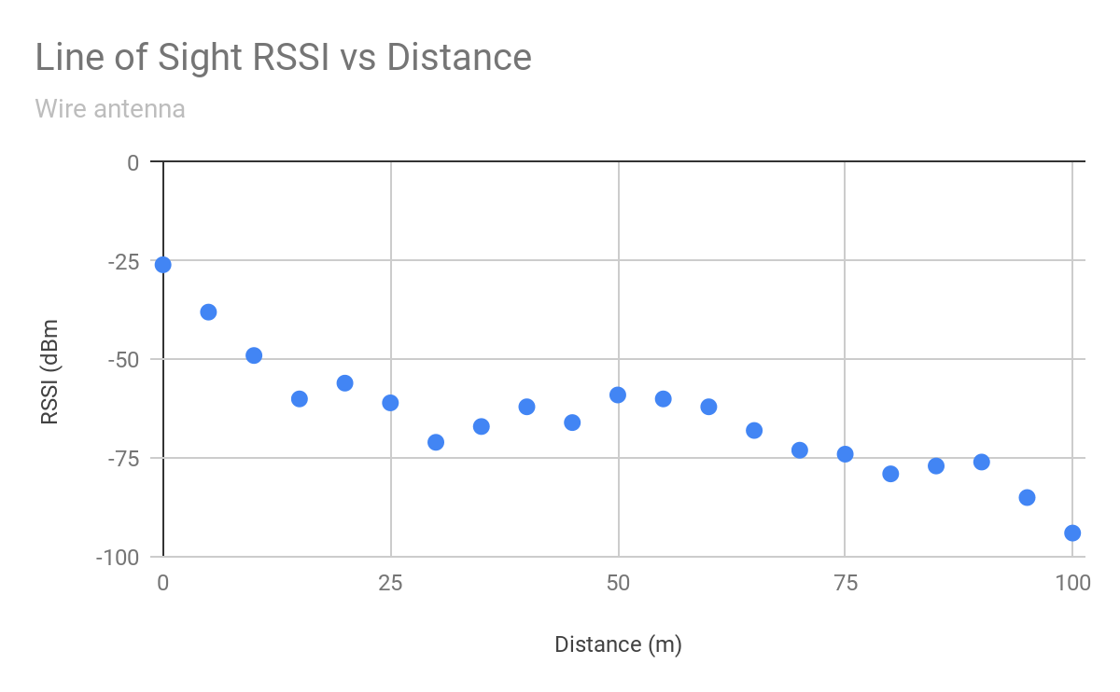

***Figure 5.3 -*** *Line of Sight RSSI vs Distance test with wire antenna*

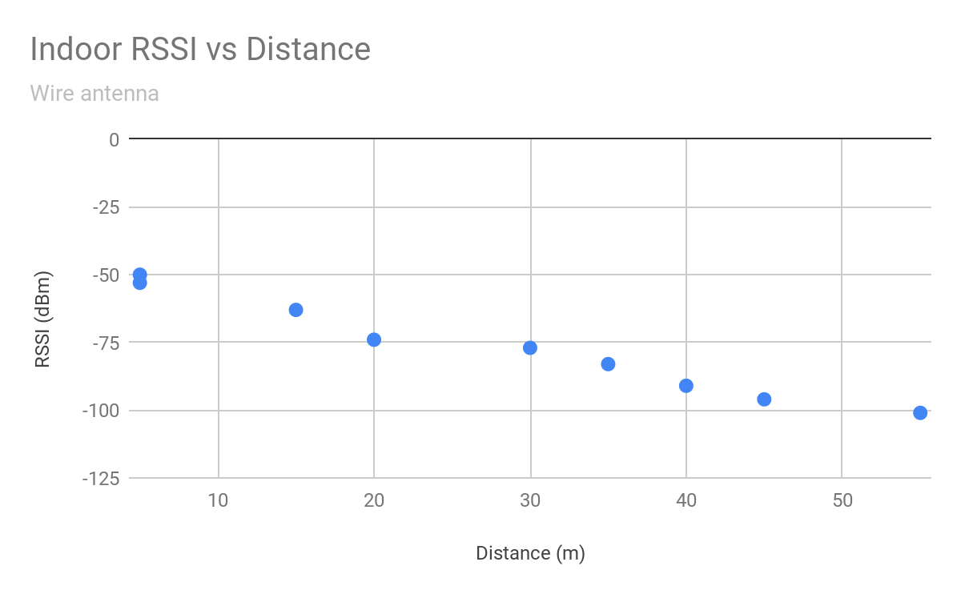

***Figure 5.4 -*** *Line of Sight RSSI vs Distance test with wire antenna*

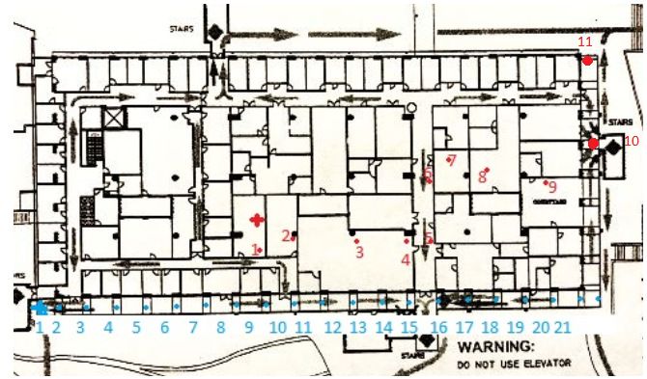

***Figure 5.5 -*** *Locations of tests conducted for RSSI vs Distance*

Concluding that the wire antennas worked for the RFM95, uFL SMA connectors were purchased to use commercial antennas. These sleek black 8.3cm plastic antennas looked professional, and work well, but through iterative use, they weren’t always reliable when even testing code and not just signal strength. Tests below show multiple tests with one commercial antenna on the exterior of the hub, with a wire antenna left on the interior of the node. Although weaker, the commercial antenna was used for the hub because of its durability and professional aesthetic.

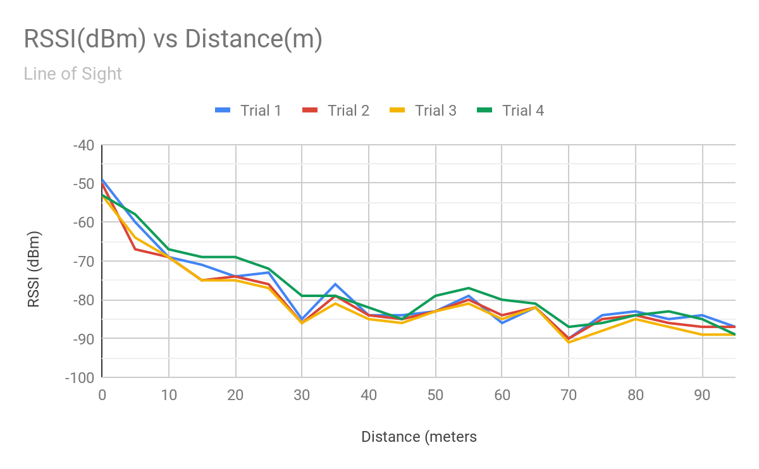

***Figure 5.6*** *- Line of sight RSSI vs Distance testing with both commercial and wire antenna*

The line of sight testing was conducted under the same conditions and locations as the previous wire tests (**Figure 5.6**). Oddly enough, with the single commercial antenna the starting RSSI averages to about -51dBm in immediate range, and its final value averages to -88dBm, maxing at -90dBm at 100m. It can be observed that while initial values are weaker, at the further distances on both tests, the antenna type doesn’t matter. While the tests could have gone further, the criteria of 100m line of sight was met, and tests until failure were not carried out.

Conducting indoor testing, with the same conditions as the first test with only wire antennas, the graph was as follows seen in **Figure 5.7.** In this test, however, at further distances the signal does deplete. Starting at an average of -58dBm in immediate range, values reached on average up to -123dBm, with a maximum at -126dBm. At this distance, messages were not always sent, corroborating our suggestion to stay within -90dBm. An error message is written to the SD card when the radio is past this signal strength value.

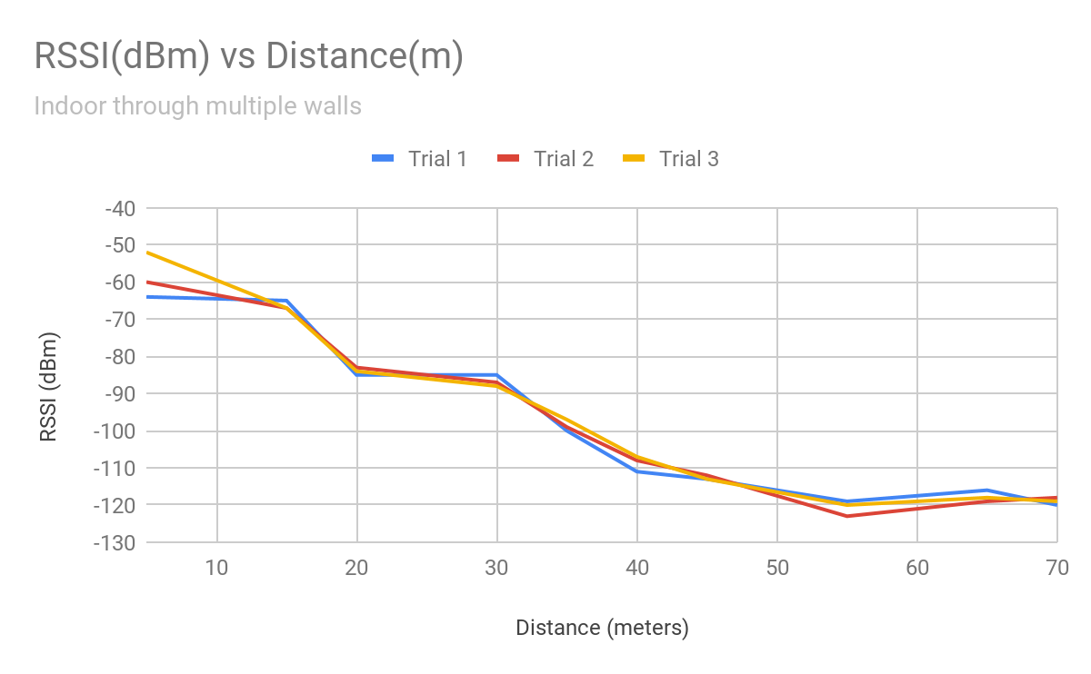

***Figure 5.7*** *- Line of Sight RSSI vs Distance test with wire and commercial antenna*

While the commercial antenna offers a sleek design, for initial implementation it may be best for the user to use solely wire antennas, since they provide a stronger signal strength. This is easily achieved by soldering a 8.3cm wire to the radio module (refer to data sheet in **Appendix A).**

Validating the data was not corrupted was done internally by the radios checksum feature, as well as a checksum implemented in earlier version of the node code. This was later removed since the radio will not accept data unless the checksum matches. Packet formatting is in the form of a 8 symbol preamble, header CRC, 4 octets header (TO, FROM, ID, FLAGS), the the 0-251 octets of data, then another CRC (checksum handled internally by the radio). Using GFSK, the 1.2kbps baud rate sends over data packets that for our client will look like [Data, Error Status, TimeStamp] seen below.



***Figure 5.8 -*** *Data format as seen on the Serial Monitor*

## 5.4 Conclusions

The decision making and implementation of a radio system was easily accomplished by assessing the needs of our client and the constraints of the device and environment it would be placed in. Ultimately, our choice to go with a long range 915MHz radio packet from Adafruit was concluded, but different options on the market turned out to work better when considering their features. A tradeoff was made by choosing to use the RFM95x over the RFM69HCW, sacrificing automatic addressing and encryption for the longer distance and lower RSSI of the RFM95x. With the radio, we are able to achieve a range of distance to communicate data from our devices reliably and with low power. The cost is also kept low since each module is only $20, which will make the overall price of the system cheaper without loss of quality.

The furthest distance achieved with the radios indoors with obstructions was roughly 70 m with a received signal strength of -120dBm, but reliably 40m with a RSSI of -95dBm . Line of sight testing showed the maximum to be -90dBm at 100m. While these values are within the desired range of most warehouses, signal strength and propagation distance can be improved upon with further work. Lowering the baud rate of the radios from 1.2kbps to about half that at around 600 bps would contribute to a farther connection. Additional focus on yagi or directional antennas can achieve the same benefits, but also tack on additional work for the user. Modifying the design of the HUB can also make modular upgrades easier for the client if they wish to replace the current radio with a more powerful one.

# Chapter 6 - Mechanical

## 6.1 Design Considerations

The needs and requests from our client, Peter Weiss, as well as the wineries that may implement our device in the future greatly influenced our decisions when designing the mechanical housing for the both the sampling chamber and the external hub of the device. From the clients’ perspective, the device needed to be portable, lightweight, user friendly, and able to withstand various environmental elements including ethanol gas, maximum temperature of 150℉, pressure rating between 1 psi and 3 psi, and high humidity levels that create condensation.

Using our clients’ requests, our preliminary idea for the mechanical structure of the 13.6cm x 12.8cm x 12.3cm sampling chamber housing featured a cylindrical shaped chamber with a revolved base on the bottom and a headspace that would hold all of our electrical components, including a front facing LCD screen and button. After careful consideration of various condensation control techniques (see **Table 6.1**), we decided a revolved base would funnel the condensation and allow it to drain out of the outtake pipe located on the bottom of the chamber. The headspace, located in the top 7.8cm of the chamber, holds the necessary components on an inner, double-layer, detachable plate, and protrudes a 20x4 character LCD screen and push-button switch on the front face (see **Figure 6.1**). A battery box extends into the headspace and features a battery cover lid that the user can remove to replace the batteries.

|  |  |  |
| --- | --- | --- |
| **Table 6.1** - Trade-off Analysis of Condensation Control Methods | | |
| **Method** | **Advantages** | **Disadvantages** |
| Desiccants | Easy to construct,  Inexpensive ~30.82/ton | Interaction with ethanol,  Replacement every 4-12 months |
| Insulation | Withstands high temperatures,  Inexpensive ~0.64-$1.19/sq.ft. | Difficult chamber construction |
| Ventilation | Quick,  Efficient | Not airtight,  Added power consumption |
| Drainage | Inexpensive,  Uses valves we already have |  |

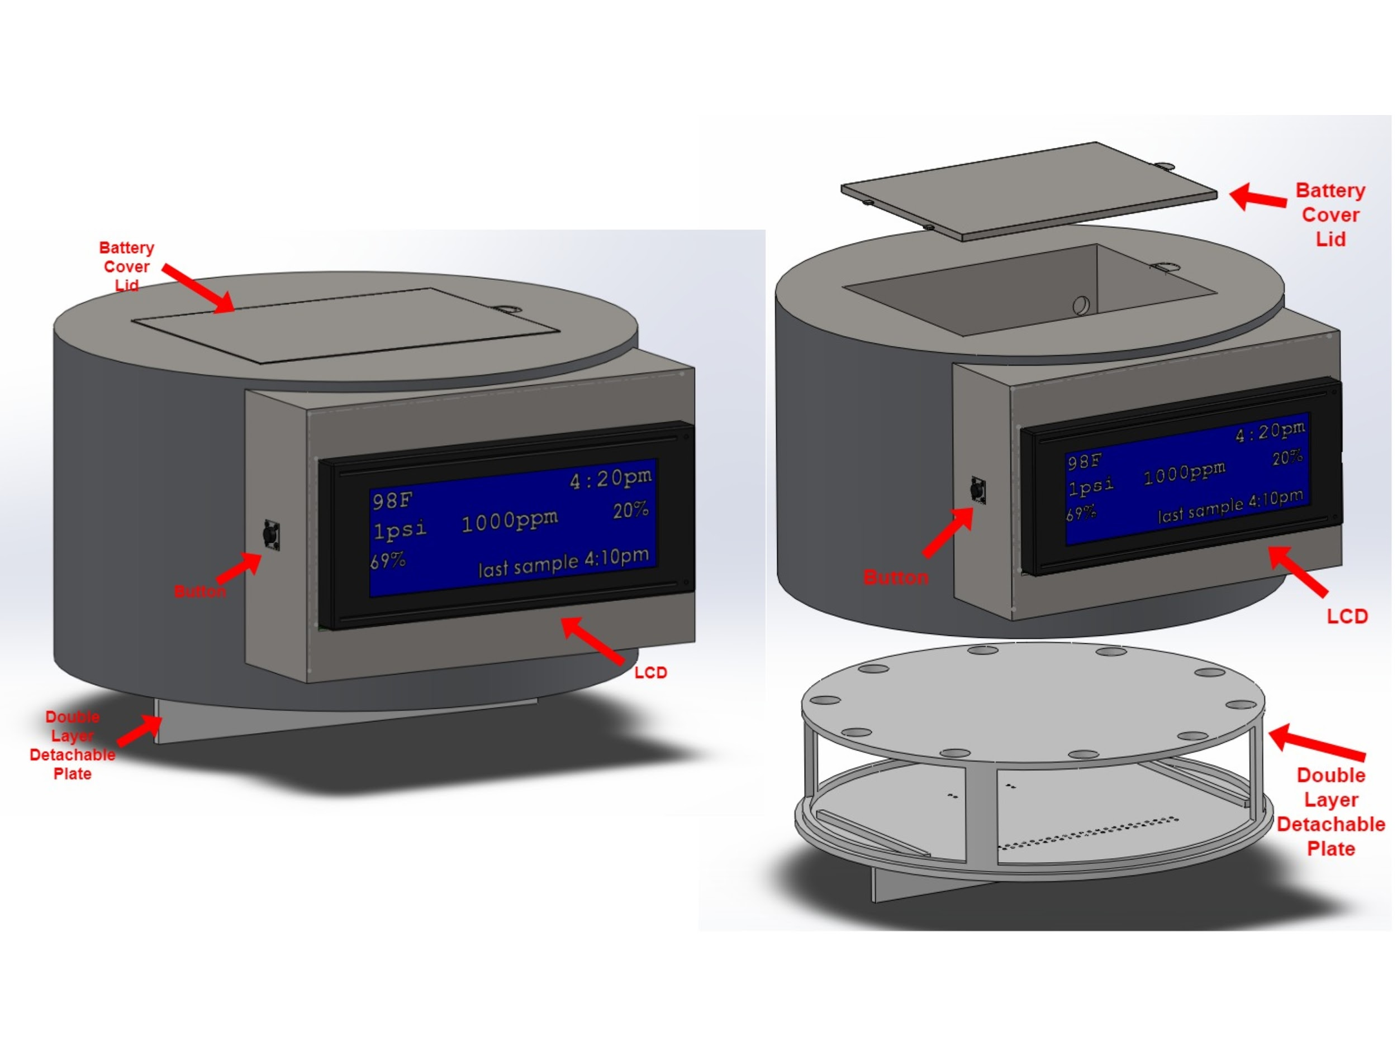

***Figure 6.1*** *- Headspace, battery cover lid, and detachable component holder plate combined (left) and separated to show features (right)*

Our preliminary idea for the external hub also considered the portability aspect requested by our client. We designed it as a 14.6cm x 10.6cm x3.6cm box that could house the Arduino Mega, microSD card breakout board, RF chip, and PCBs. The external hub features a MicroSD card slot and LED on the front face, antenna on the right face, and port on the back face for a DC wall adapter (see **Figure 6.2**).

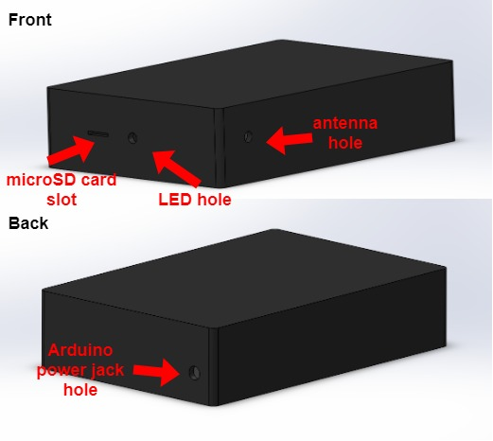

***Figure 6.2*** *- External hub design viewed from the front (top) and back (bottom).*

The scrubber outputs ethanol vapor at a pressure between 1 and 3 psi, and temperatures up to 150℉. The material of the sampling chamber needed to withstand these conditions, as well as not have any reactions with the ethanol vapor present in the pre- and post- scrubber pipelines. The device is mounted against pipelines so the material chosen for the device needed to be relatively lightweight and easily mountable. After careful consideration of various material types (see **Table 6.2**), we decided on stainless steel as the material for the sampling chamber. The external hub is a desktop device that did not have an environmental factors to take into consideration, so we 3D printed the hub using poly-lactic acid (PLA) since it was readily available and cheap.

|  |  |  |
| --- | --- | --- |
| **Table 6.2** - Trade-off Analysis of Material Types for Sampling Chamber | | |
| **Material** | **Advantages** | **Disadvantages** |
| Stainless Steel | Corrosion resistant interaction with ethanol,  Broad range of strength and hardness,  Relatively inexpensive ~$1.40/lb,  Does not soften or lose strength until 800-1000℉,  High pressure ratings | High costs for custom size,  Heavy material ~7.9g/cm3 |
| Aluminum | Corrosion resistant material,  Withstands temperatures up to 1215℉ without melting,  High pressure ratings,  Inexpensive ~$0.84/lb  Lightweight ~2.7g/cm3 | High cost for custom size,  Reacts with ethanol |
| Copper | High pressure ratings,  Can withstand temperatures up to 1100℉ | Corrodes slowly with presence of ethanol  Heavy material ~8.9g/cm3 |
| Noryl (high-temperature plastic) | Can withstand temperatures up to 309℉ without melting,  No known reactions with ethanol,  High pressure ratings,  Lightweight ~0.95g/cm3 | Reactions to ethanol have not been thoroughly tested and/or researched,  High cost ~$3.88/lb - higher cost to get custom size |

The ZnO sensor is most efficient when operating with the UV LED angled at 30°. Using the length of the IDE (1cm) and a little trigonometry, the ideal distance between the UV LED and the ZnO sensor is 1.8cm. To avoid UV LED interaction with the environmental sensors, a small separation wall was needed to separate the ZnO sensor - UV LED duo with the temperature, humidity, and pressure sensors. **Figure 6.3** shows the detachable, double-layer plate described above and its use of a 2mm thick wall to separate these components.

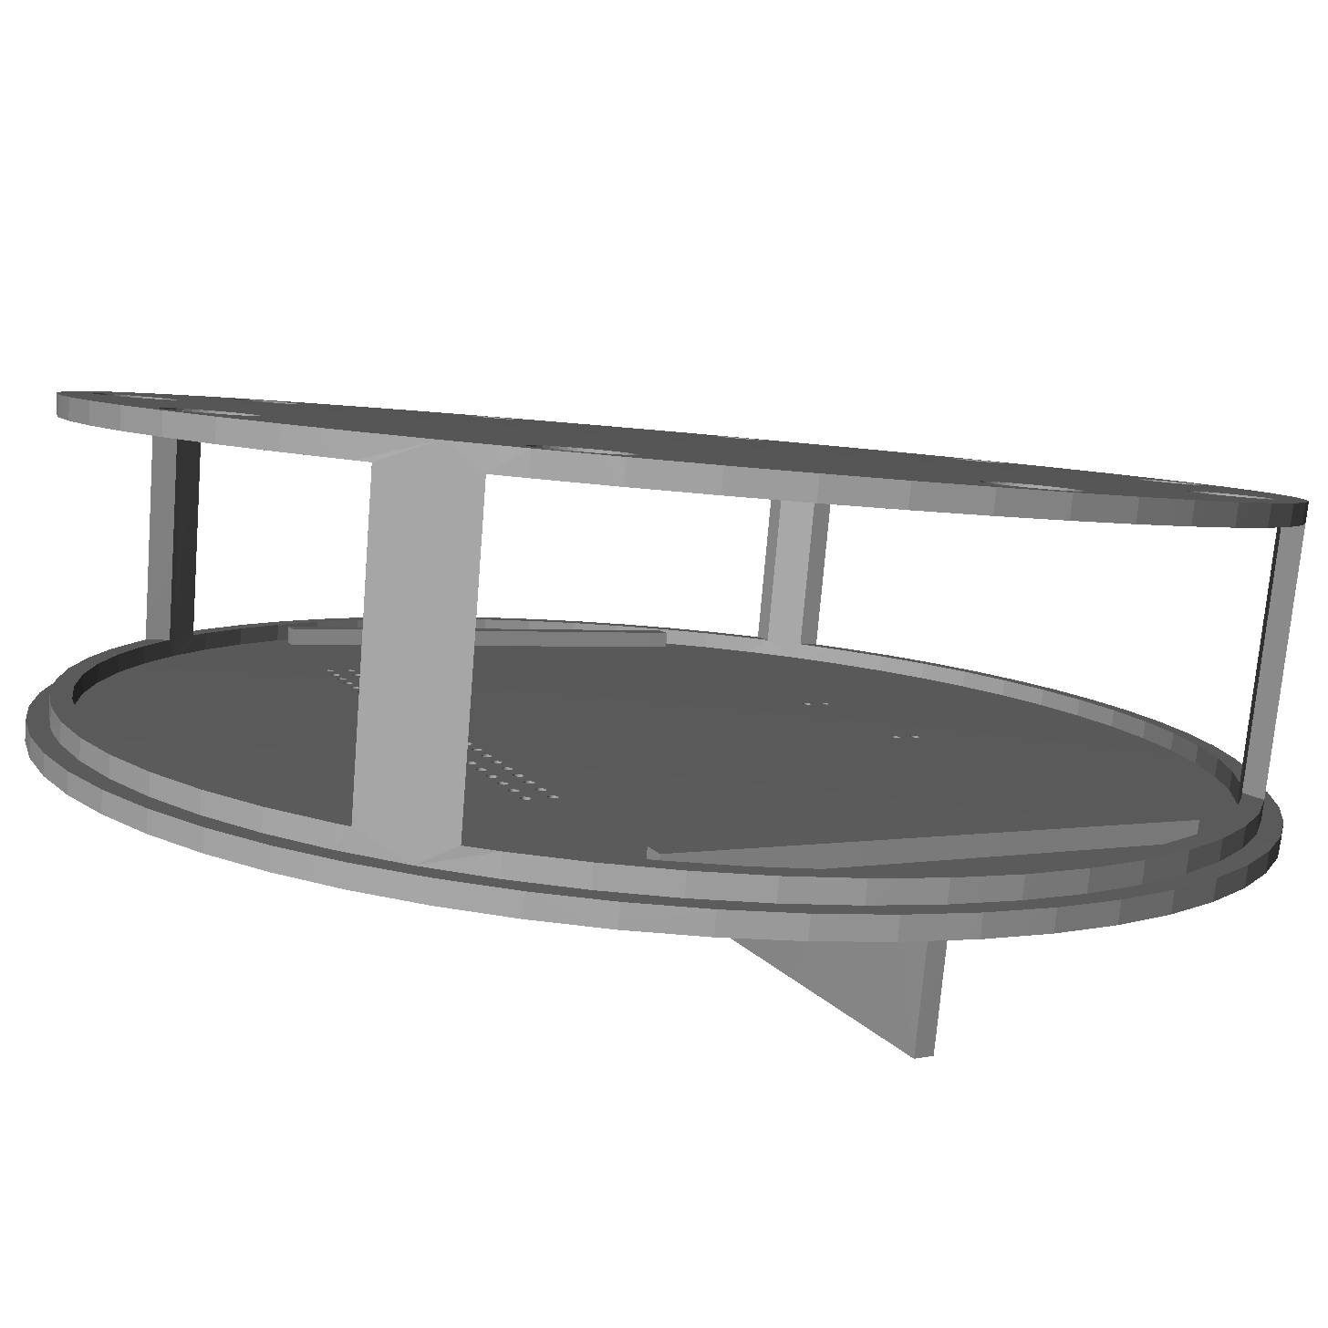

***Figure 6.3*** *- Double-layer component plate with separation wall used to obstruct the UV LED light from reaching the environmental sensors.*

After our first round of testing our prototype (see **6.2 Testing and Validation**), our client informed us that we would no longer be required to have a sampling chamber that would intake and outtake the air and ethanol standard, as he would be providing us with a 7.5in x 4.3in x 2.2in lexan box to be used as the new sampling chamber. The new housing that hold our components would have to completely enclose this sampling chamber, while still making it accessible to the user. Accessibility would allow for ease of replacing the sensors inside of the chamber.

## 6.2 Testing and Validation

Based on the design speculations from both the clients’ and engineers’ perspective, the sampling chamber and external hub were designed in a Computer Aided Design (CAD) software, namely Solidworks. To test the dimensions of the design and its ability to house all the required components, the Solidworks files were converted to STL files suitable for 3D printing, and submitted to BELs. The 3D printer at BELs required the prints to be smaller than the 14.5cm x 14.5cm x 17.5cm printing requirements. Our prints and dimensions are listed in **Table 6.3**. BELs offered free printing for our Senior Design Project team and the 3D prints of both the sampling chamber and the external hub were available for pick-up 3-4 days after submission. Links to the Solidworks and STL files are in **Appendix E**.

|  |  |
| --- | --- |
| **Table 6.3** - 3D Prints and Dimensions | |
| **Print Name** | **Dimension** |
| Sampling Chamber Base | 5.8cm x 12.3cm x 12.3cm |
| Sampling Chamber Headspace | 7.8cm x 12.8cm x 12.3cm |
| Sampling Chamber Component Plate | 4.7cm x 12.6cm x 12.6cm |
| Sampling Chamber Battery Cover | 8.6cm x 0.2cm x 6cm |
| External Hub | 15.6cm x 10.6cm x 3.6cm |
| External Hub Baseplate | 15cm x 0.3cm x 10cm |

Once we received the 3D prints the components, namely the Arduino Mega, sensors, LCD, battery, PCBs, and communication components, we attempted to place them in the 3D printed sampling chamber, but soon came to the conclusion that all the components would not fit. The rounded sides of the headspace made it hard to mount flat PCBs. Additionally, the Arduino Mega with all of its corresponding wires took up more space that we would have liked. The model was printed using PLA, and came printed with supports that we had to cut off and sand down. We did not get a choice of material since we printed through BELs. This material turned out to be brittle and our pieces snapped easily, especially when sanding the printed supports. The 2mm walls of the chamber were also designed too thin and easily broke as we were attempting to place the electronics. The components required for the external hub, namely the Arduino Uno, radio components, LED(s), and microSD breakout board, however, were placed in the configuration shown in **Figure 6.4**. This configuration proved to be the best placement of components to allow for wiring to easily reach their required locations.

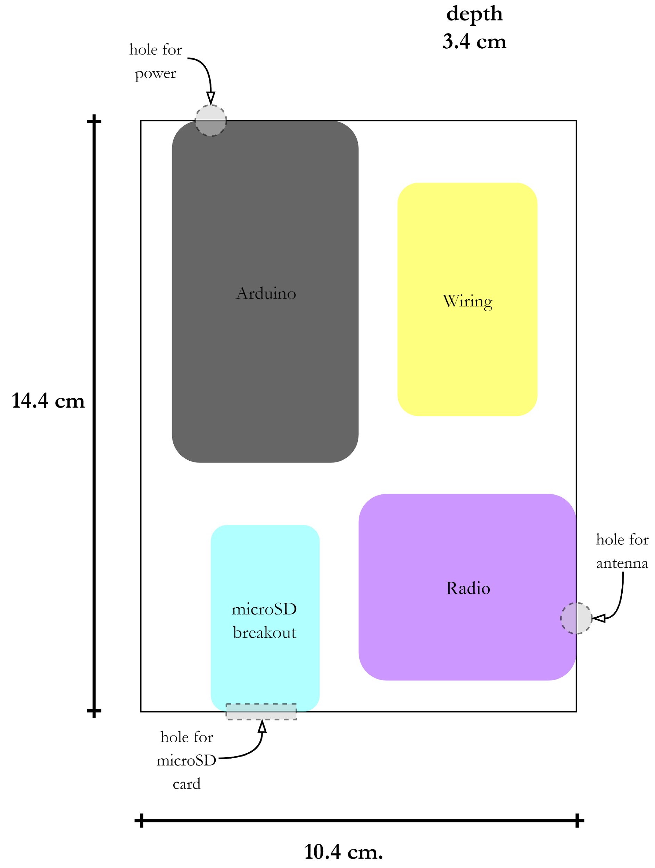

***Figure 6.4*** *- External Hub Component Layout*

After using the 3D printed prototype of the samping chamber to find the appropriate layout and dimensions of the device, we were able redesign a new prototype in Solidworks. The new design would allow for proper fit of all the required components, as well as enclose the sampling chamber given to us by Peter Weiss. The layout of the components in the new headspace design can be seen in **Figure 6.5**. We wanted to allow for an extra inch of space on each side of the components so integration would be easier. With the dimensions of the components and the extra space, the new headspace needed to be at least 8in. x 5in. x 4in. We also increased the size of the walls from 2mm to ¼ in., or 6.35mm.

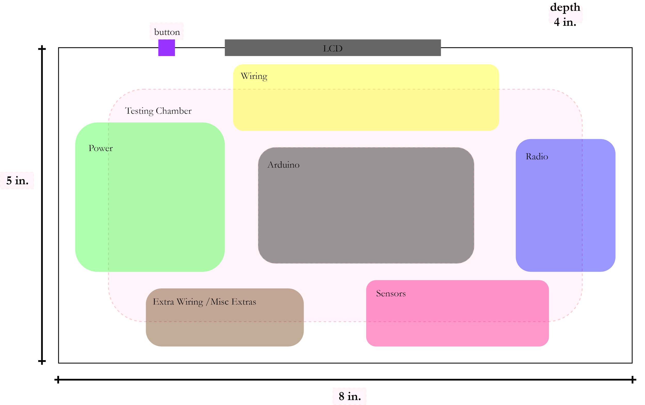

***Figure 6.5*** *- Node Headspace Component Layout*

The final design of the housing for the node is shown open and closed in **Figure 6.6**. This design features a pull out drawer that houses the 7.5in. x 4.3in. x 2.2in. sampling chamber, which makes it easy for the user to change out sensors, if needed, while also enclosing the chamber inside the structure while measurements are being taken. The internal dimension of the headspace is 8.25in. x 5.75in. x 5in. and includes a 3.2in. x 2.3in. x 1in. (internal dimension; does not include ¼ in. wall thickness) box for enclosing the battery pack, along with a tab-and-slot cover that makes it easy for the user to change out the batteries. An 8.25in. x 5.25in. x 0.25in. shelf in the center of the structure is held into the left and right side walls by a tab-and-slot design. The shelf, as seen in **Figure 6.7**, does not touch the front and back walls, but rather has a ¼ in. gap on either side to allow for passage of wires down to the sampling chamber.

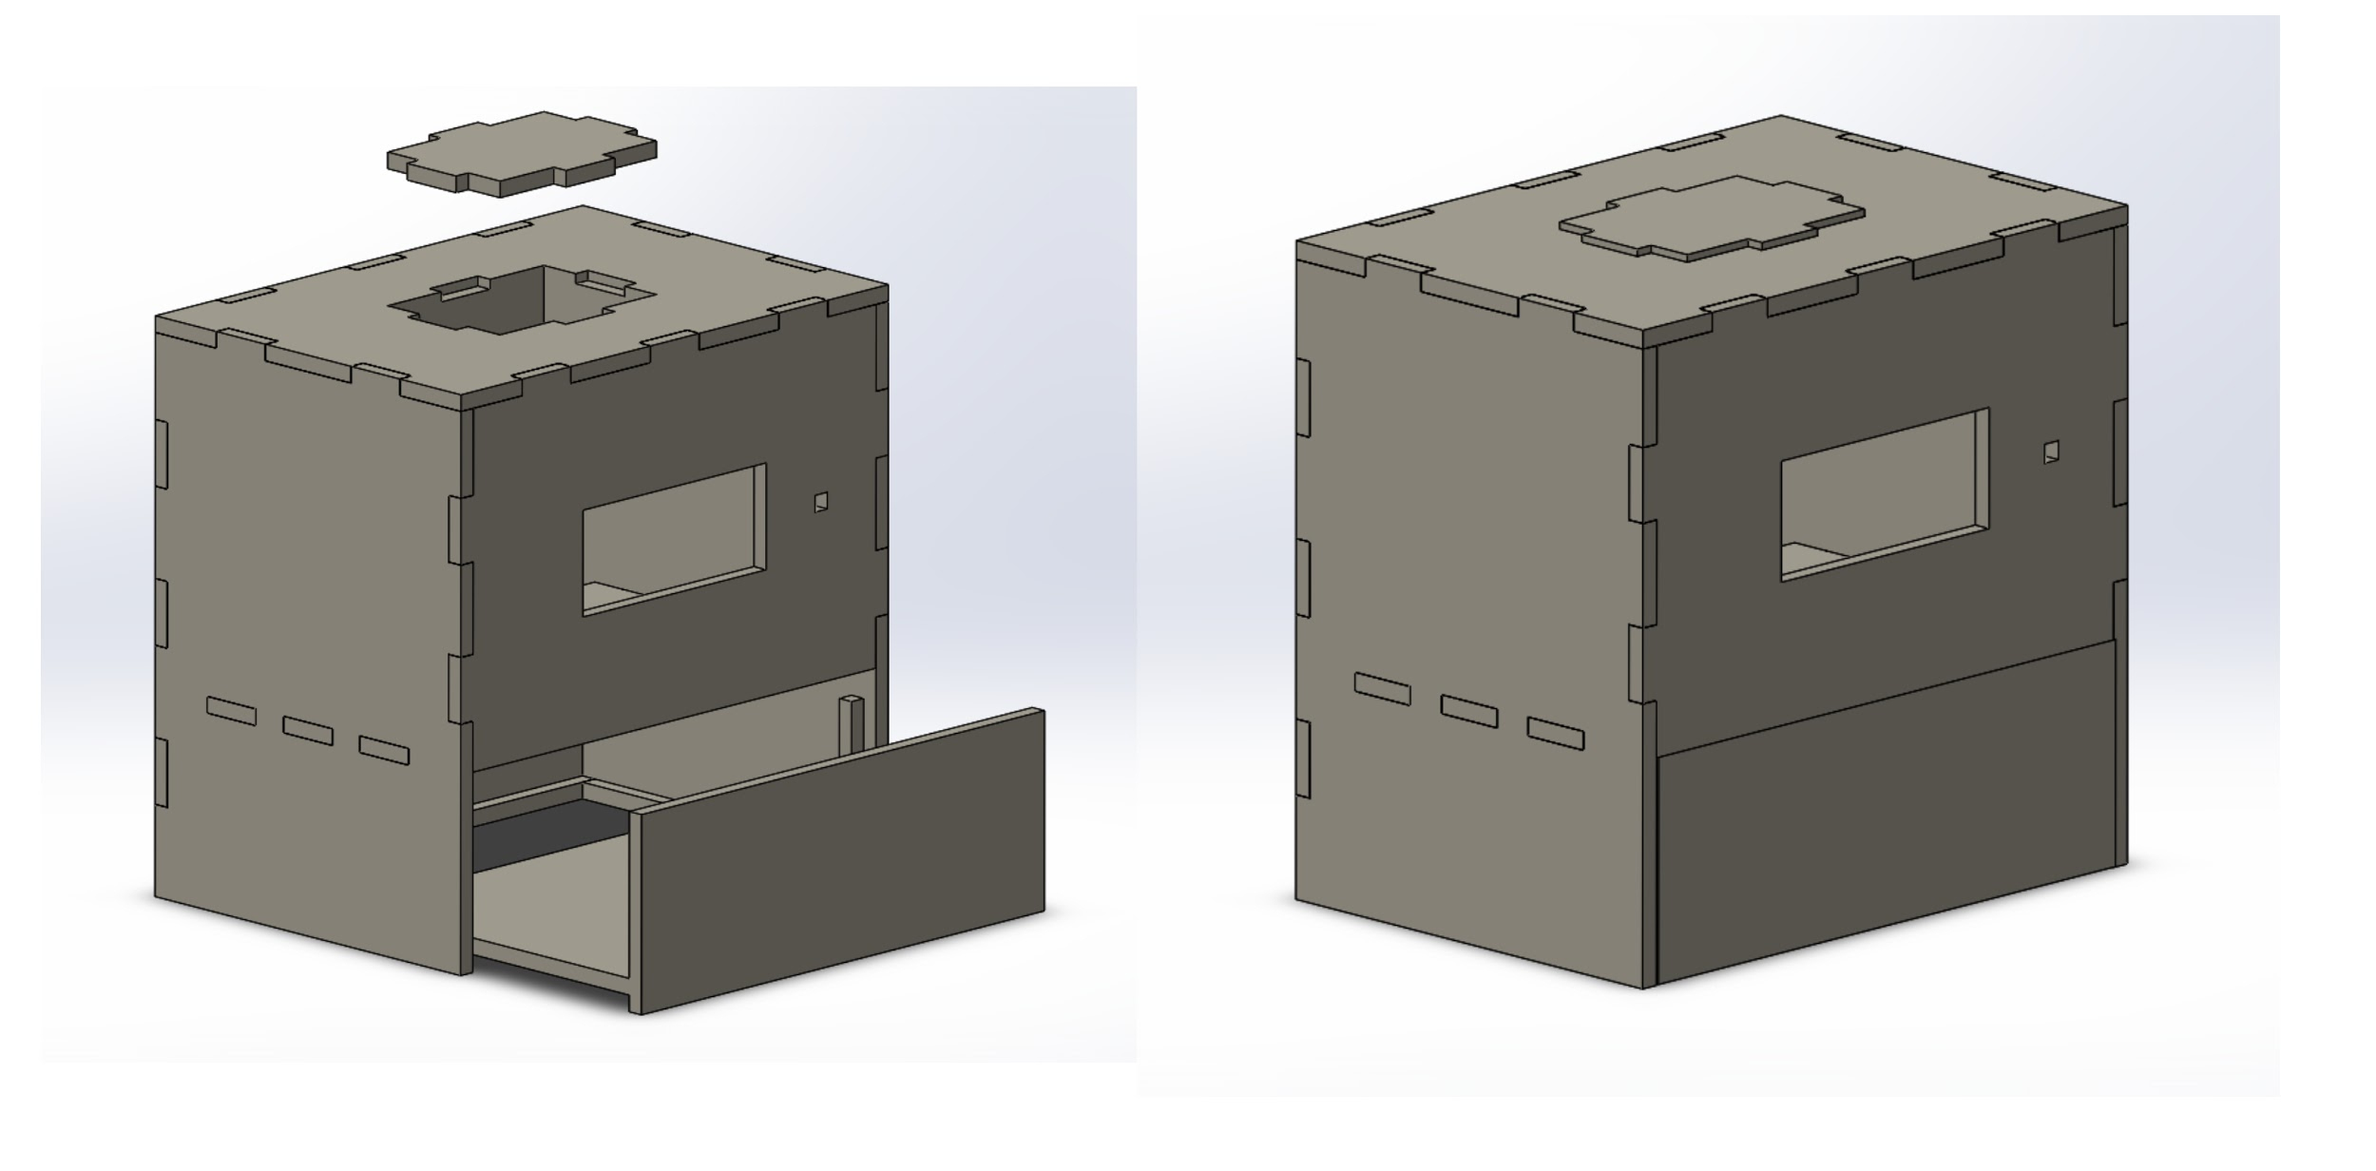

***Figure 6.6*** *- Node designed in Solidworks. The design features a drawer and battery cover that can open (Left) and close (Right).*

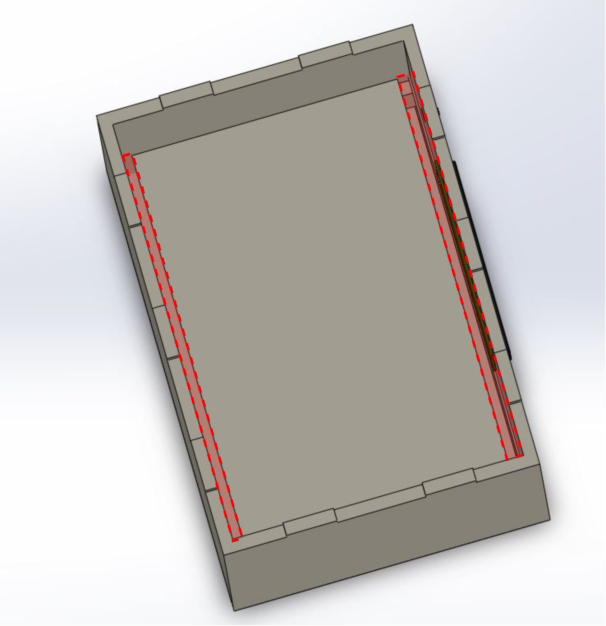

***Figure 6.7*** *- A shelf inside of the structure holds the electrical components. The shelf attaches to the left and right walls with a tab-and-slot design. The shelf sits ¼ in. away (indicated in red) from the front and back walls to allow for passage of wires to the sampling chamber below.*

Since the 3D printers at BELs have the 14.5cm x 14.5cm x 17.5cm size requirements and our structure had an external dimension of 8.75in. x 5.25 in. x 6.25in. (22.2cm x 13.3cm x 15.9cm), which exceeded that limit, we chose to print through Maelia’s dad, Bill Gomez, as he owns a 3D printing company called 3D Sprout. After sending him the finalized STL files, he suggested we print the walls of the structure separately to reduce the cost and time it would take to print. As seen in **Figure 6.8**, each wall is labeled with a letter to allow for easy assembly of the structure. The dimensions of each of the separate parts is listed in **Table 6.4**.

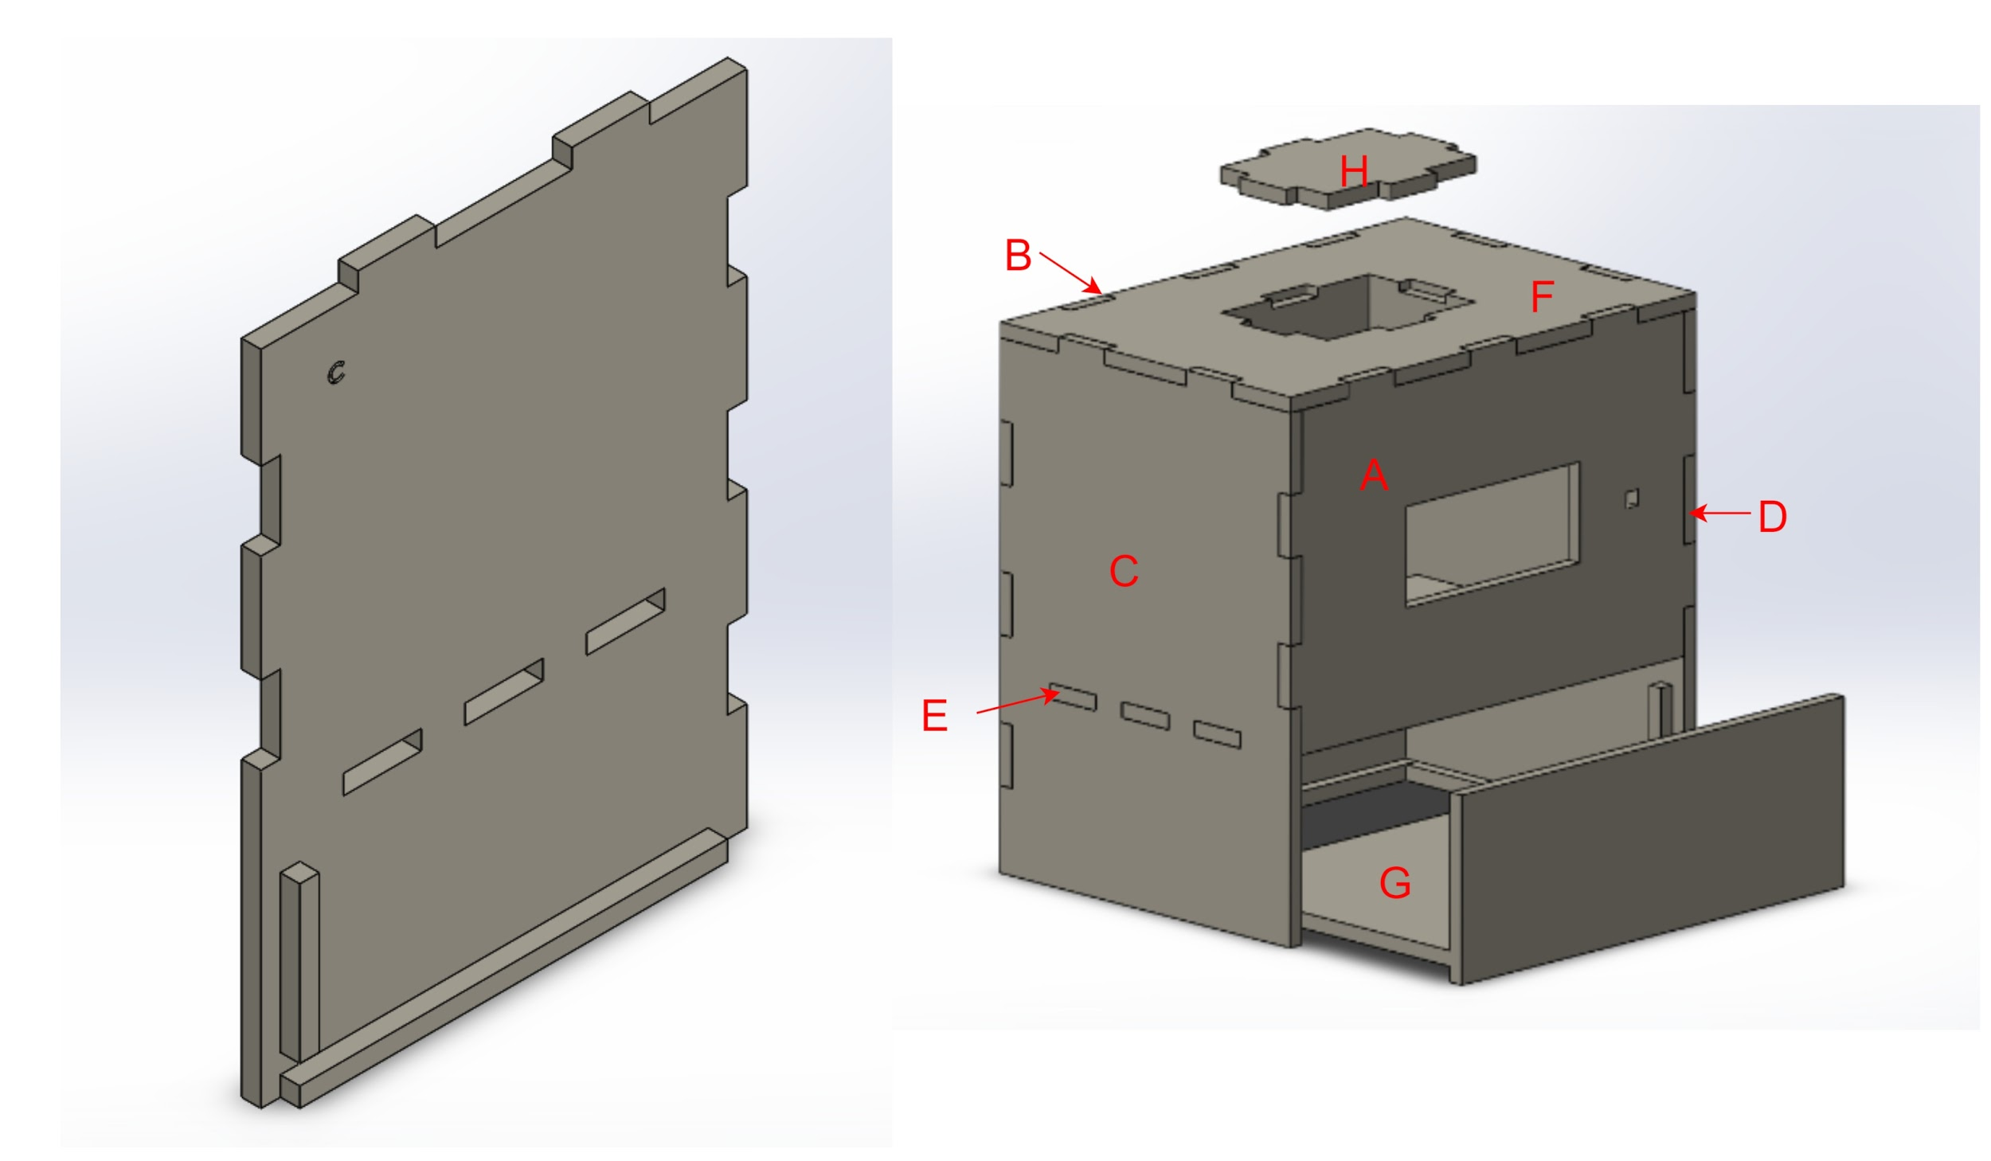

***Figure 6.8*** *- Each of the 8 individual pieces of the housing were engraved with a single letter A-H on the inside portion as to not be seen from the outside of the structure. The picture on the left is the Left wall labeled with a “C” on the inside panel, while the picture on the right shows what letter each piece was labeled with.*

|  |  |
| --- | --- |
| **Table 6.4** - Prototype Version 2, 3D Prints and Dimensions | |
| **Print Name** | **Dimension** |
| A - Front Face | 8.75in. x 5.7in. x 0.25in. |
| B - Back Wall | 8.75in. x 8.7in. x 0.5in. |
| C - Left Wall | 0.5in. x 8.7in. x 6.25in. |
| D - Right Wall | 0.5in. x 8.7in. x 6.25in. |
| E - Component Shelf | 8.75in. x 0.25in. x 5.25in. |
| F - Headspace Lid | 6.25in. x 1.5in. x 8.75in. |
| G - Sampling Chamber Drawer | 6in. x 3in. x 8.25in. |
| H - Battery Cover | 2.8in. x 0.25in. x 3.7in. |

After receiving the housing printed from Mr. Gomez, we began assembling the structure. Since the walls were constructed in a tab-and-slot design and labeled with a letter, the assembly was fairly easy and self explanatory. The walls fit together very well, so we chose not to glue the pieces together. This choice also makes it easier to access the internal components in case we needed to adjust or change the electronic components. Mr. Gomez runs his printer using Acrylonitrile butadiene styrene (ABS) filament, so we once again did not have a choice in choosing the material. However, although the surface is more porous rather than smooth when compared to PLA, ABS is known to be tougher and less likely to break. When put under pressure it tends to bend rather than snap, which made a big difference when placing our components as compared to the PLA prototype we made previously.

Since the deliverable shifted from being ready to implement in wineries, to just being used for sensor testing purposes in Peter Weiss’ lab, we did not have to create a marketable version made from stainless steel. Since the final structure was made from ABS and we were not implementing into wineries, we did not have to undergo environmental testing to ensure the device would be able to withstand up to 150℉, a pressure rating between 1 psi and 3 psi, and high humidity levels that would create condensation.

## 6.3 Conclusions

The mechanical structure of this device was relatively simple to create, as it did not have any complex features - it was simply a hollow, rectangular prism shape with a tab-and-slot construction. Environmental factors including temperature, pressure, and humidity that may or may not produce condensation are important factors to remember when designing the device, however, were not necessary for our final deliverable. These factors can also be considered in the trade-offs between structural shape, material, and layout of components for any future implementation into wineries.

Although this design worked for our required deliverable, additional modifications could be made to decrease the size of the structure, as it may be too large for winery implementation. These modifications may include, but may not be limited to better portability and improved mounting onto winery scrubbers.

# 

# Chapter 7 - User Interface

## 7.1 Design Considerations

Because the purpose of this project was to produce a marketable product, the user interface needed to be clean and simple — easy enough for any non-technical user to be able to understand. The simple interface consists of a 20x4 liquid crystal display (LCD) screen with a single push button for the user to either power on the screen to display the readings or take a measurement outside of the predefined interval period.

In order for the user to make use of the measurements the sensor is taking, we also needed to implement a way for the client or regulations personnel to access the data. The file type we needed to save was a simple text file in tabular form so the sensor readings could be graphed if necessary. The size of a file like this would be very small, a few gigabytes at most. Originally, the team was leaning towards a cloud-based storage, such as MySQL. We also considered a mobile application or local storage, but assumed that online storage was more accessible to most users. However, after looking into the different cloud-based data management systems, it was found that not only was the storage space excessive for the amount of data recorded by the sensors, but it also would require the user to learn how to use the system in order to access the data. Taking into account that our client base may be older, we wanted to avoid the any possibility of a steep learning curve, as well as the excessive storage space. Because of this, we started looking into local storage. Between a microSD card and a thumb drive, the microSD shield was a smaller module that could more easily fit into the physical casing being designed by the mechanical subteam. Luckily, the costs of these modules are very cheap, so local storage emerged as our best option as of now.

|  |  |  |
| --- | --- | --- |
| **Table 7.1** - *Trade-off analysis table of data management systems* | | |
| **System** | **Advantages** | **Disadvantages** |
| Cloud-based (MySQL, SQLite, etc) | * Easily integrated * Give access only to regulation board * Free | * Excessive storage space * Possibly steep learning curve |
| Mobile application | * Accessible to any user with a phone * Customizable to fit our needs/wants * Could be free | * Difficult to integrate (learning curve for team) * Need separate apps for iOS and Android |
| Local storage (thumb drive, microSD) | * Easily integrated * Well documented * Cheap * Easy to use | * Extra module * Can not monitor who accesses data (wineries vs regulation board) |

After the data management was sorted out, we needed to decide what size LCD screen we wanted to use. Because we had so many sensor readings to display, we opted for a 40x4 character display. However, when the mechanical subteam drafted a design of the housing, the LCD screen was the only module taking up a significant amount of room in the headspace. Because of this size constraint, we looked into smaller LCD screen sizes, and found that a 20x4 LCD still gave us enough screen space to display all the readings, while allowing the headspace to be reduced by half the original size. This meant a more reasonable sized device, as well as cheaper in terms of production costs.

With the front end of the UI sorted out, we worked on integrating the LCD screen and microSD shield with the rest of the parts, meaning all the sensors, radios, and Arduino UNO. When it came to configuring all the pins, we realized that the UNO did not have enough data pins for the microSD shield or the LCD screen. This forced us to shift to using the Arduino MEGA, which allowed us more pins, enough for all of our modules.

## 7.2 Testing and Validation

Though the LCD screen and microSD card scripts were written separately from the scripts for say, the sensors and radio, when all modules were integrated together, minor changes were made to display state machine measurements, and to configure the sensor data to the LCD screen according to the design, outlines in **Figure 7.1**.

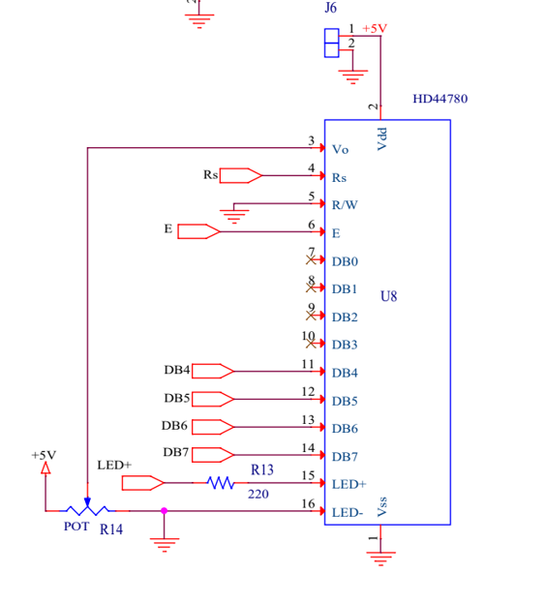

***Figure 7.1*** *- LCD Screen Display Layout*

## 7.3 Conclusions

Creating the UI had a steep learning curve because the team was not comprised of any computer science majors, nor engineers with particularly strong programming experience in relation to UI design, but the team was able complete the deliverables on time. Luckily, the simplicity of the UI design for the user translated to a simple UI on the back-end. The LCD and microSD are both well-documented, providing the team with adequate resources to learn and implement the design in mind.

Although the UI met our specifications for this version of the project, there are modifications and improvements that could be made to the original design. For instance, the use of the microSD card does not offer the security necessary for regulation advisory boards to monitor ethanol emissions without the potential of winery owners to fabricate data.

# 

# 

# 

# 

# 

# 

# 

# 

# 

# 

# 

# 

# 

# 

# 

# 

# 

# Chapter 8 - Implementation and Integration

## 8.1 State Machine Integration

Automation of remote sensor monitoring and wireless communication necessitates the implementation of a state machine (SM). The function of the device is governed by conditions specified for the state machine by various sensors and wireless communication acknowledgements. Figure 8.1 below displays a general overview of the sampling process and the conditions necessary to transition to different states. The initial state for this process is “SLEEP.”

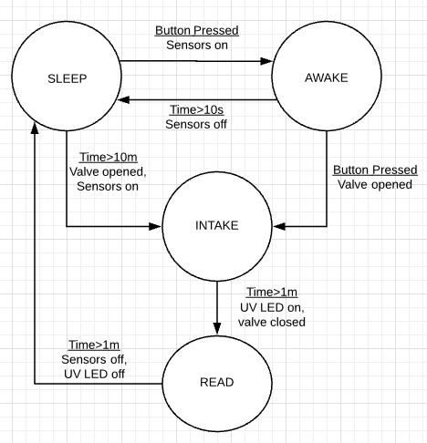

*Figure 8.1: Sampling process general overview*

The SM controls the zinc oxide sensor sampling process. The sampling rate was defined by our client as every ten minutes. As explained earlier in the sensor section, the resistance across the IDE changes with respect to the intensity of the UV light incident on its surface. On average, ten minutes is the minimum amount of time required for the ethanol sensor to return to its nominal resistance. Therefore, a sleep mode was necessary to ensure that the resistance returns to its initial value before new samples are performed. Also, the battery life of our system benefits from this state because each component is idle during sleep.

For the sake of our client, the wait time in between each sample can be interrupted by pressing the onboard button that will instantaneously perform a measurement. While in the sleep state, pressing the button once will turn on the node LCD to display the current environmental sensor information. The ethanol sampling process is instantiated if the button is pressed again within ten seconds of the first press. If not, the LCD turns off and the device goes back to sleep mode. This process of retrieving data by pressing the onboard button was designed for the convenience of the customer and/or individuals interested with a quick status update regarding the conditions inside of the chamber. This feature can only be accessed in sleep mode, therefore the button loses functionality once the sampling process begins.

The valves, discussed earlier in the *Power Chapter*, connected to the node open up as soon as the sleep mode wait time is over or once the user begins a sample through the button. The chamber intakes ethanol for ten seconds before the valve closes. Once the valve closes, the UV LED turns on and the resistance across the ZnO sensor is recorded. The UV LED eventually turns off after an appropriate amount of data is collected and this data is stored in memory until further notice by the hub. Data is transmitted via an RF transceiver once the node receives a data retrieval signal from the hub. The status of this signal is checked continuously to ensure that the customer receives data upon request. The receiver not only checks for a signal to send data to the hub, but also checks for an instantaneous sampling signal. The status of this signal is checked in the background of the state machine but behaves similar to the button that was mentioned earlier. This signal has no effect on any ongoing sampling processes and is not acknowledged until the SM returns to sleep mode.

Figure 8.1 only displays the sampling process and does not take into account the possible errors. Various hardware components are handled by this SM and since systems are rarely ideal, corner cases are always bound to happen thus affecting the flow. Figure 8.2 below depicts the complete state machine for our system that takes these issues into account.

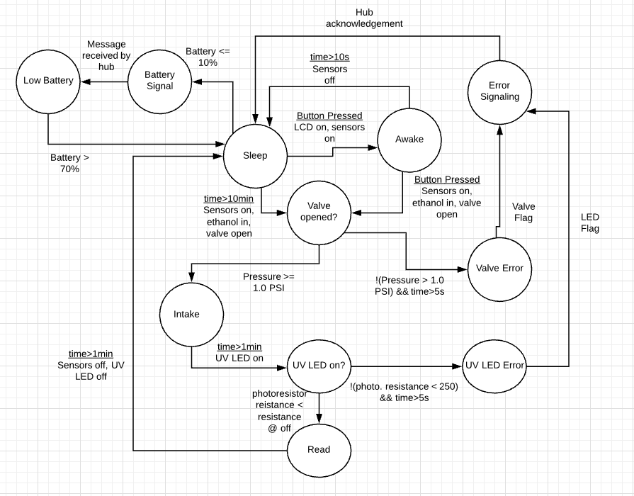

*Figure 8.2: State Machine diagram- Initial state is “Sleep”*

The errors that are monitored by the SM in figure 8.2 are valve, UV LED, and battery percentage errors. Valve functionality was addressed by utilizing a pressure sensor to compare the pressure when the valves are open and closed. For example, the pressure reading when the valve is closed is 0.8 psi and this value was used to determine whether the valve opened when needed. If the pressure recorded when the valve is supposed to be open is not significantly greater than 0.8, then this indicates that the valve did not work properly. Progression onto the next stage of the sampling process will only occur if the recorded pressure is significantly greater than the known pressure when the valves are closed. If this is not the case, a valve error message is sent to the hub and the system goes back to sleep.

Another error that is addressed is the functionality of the UV LED. The light intensity sensor was used to address this issue by using a similar concept in the valve error handling. The resistance of the photoresistor decreases as the intensity of the light incident on its surface increases. The resistance range when the UV LED is turned on is 250 to 260 Ohms. This range was monitored and if the recorded reading is not in this range, then this indicates a UV LED malfunction. Similar to the valve error, the state machine will only progress if the recorded light intensity is in .the expected range when the UV LED is on. If not, an error message is sent to the hub and the system goes back to sleep.

The SM is also able to notify the user if the battery percentage is too low. The node is powered by three 1.5 Volt batteries placed in series creating a combined nominal voltage of 4.5 Volts. Each battery has a discharge voltage of 0.9 Volts therefore, the discharge voltage for this configuration is 2.7 Volts. The voltage supplied by the batteries is measured using the analog pins on the Arduino and this value is compared to the discharge voltage. The recorded voltage ranges from 4.5 to 7 Volts and this range is mapped from 0 to 100 percent. For further information regarding these calculations, refer to the **Power** chapter. If the battery percentage is at or below 10 percent, the low battery state is triggered and the user is notified via the transceive. Once this low battery state is entered, the state machine remains idle until it detects that the batteries were replaced. The battery percentage is sampled every 2 seconds in this state and will return to sleep once the battery percentage is measured to be 70 percent or more.

In order to combat battery drainage, switch regulators are used to control the current draw by the four environmental sensors. The switch is open during sleep mode and error states and closed in all the other states. With this power-saving implementation, the sensors are only powered for roughly 1-2 minutes per sample as opposed to having a 100% duty cycle. More information regarding the switch regulators and the impact on battery life can be found in the **Power** chapter.

The system state machine was influenced by the manual sampling process that our client, Peter Weiss, was performing. It was needed to remotely monitor the sampling process, hardware, and data logging. The SM checks off the deliverables that were agreed upon by the team and Peter Weiss but further work can be implemented as the development of zinc oxide sensor proceeds. Recording the resistance of the zinc oxide sensor with a microcontroller has been a difficult practice since this value extends over a huge range and spans into the mega Ohms. The analog-to-digital converter onboard the Arduino has trouble reading resistances in the mega Ohm range because it practically resembles an open circuit at that point. Therefore, a more reliable data logging method must be implemented in the future.

# 

# Chapter 9 - Conclusion

The features of our prototype device realize the goals that we sought to achieve -- It lays the foundation for the future development of the device as an air quality measurement tool for use in large-scale wineries. The humidity, temperature, pressure, and light intensity environmental sensors ensure that workable conditions are maintained within the device to ensure its proper function through hot, wet, and other nonideal conditions. The housing we fabricated is both sturdy and spacious, leaving sufficient room for different sized chambers in its sliding drawer and can easily be modified to house many different additional components like UV LED drivers or other valve components (See **Future Work**). The RF system can ping up to four nodes on a star network, collecting the data on a specified interval or instantly, and storing the data to a microSD card up to 50 meters away indoors. Power system was designed such that it could run on simple AA batteries, facilitating testing by increasing portability and versatility compared to conventional stationary machine measurement systems.

This project utilized all types of expertise needed to become a successful and useable product. The development of the Zinc-Oxide sensor was the main focus of our project and we were able to make significant progress towards having a fully-fabricated sensor capable of producing repeatable ethanol reading results. This would not have been possible without both the financial assistance and education consultation from our faculty advisor, Peter Weiss. James Doan and Maelia-Uy Gomez efforts in fabricating, and testing the ZnO sensor as well as documenting all characteristics and test results have made the progress we achieved in this project possible.

Not only has the development and fabrication of the ZnO sensor been crucial in the success of this project, but also the electrical and mechanical aspects of the housing device. An array of environmental sensors to check the humidity, pressure, and temperature inside the chamber, as well as the output power of the UV LED inside the chamber is necessary to provide our client with the necessary information about the conditions of the test chamber. Both Jorge and Jacob have done a great job choosing and optimizing a set of sensors that are accurate and power saving. Both the LCD to display all sensor values and a functional state machine that governs the process at which our device measures a sample would not have been possible without Jorge’s embedded programming skills.

A proper RF system had to be implemented so that multiple nodes can relay all information to a designated hub that a client can easily access the information of the device without needing to go inside of the wineries fermentation room. David’s previous RF knowledge and skills made this feature possible on the device. Furthermore, a mechanical housing that was both sturdy to survive the temperature conditions inside the winery while also being light and compact was necessary to the success of this project. Thanks to Bridgette’s previous SolidWorks experience, this goal was possible to achieve.

Finally, a power system that is both efficient compact enough to fit inside of the small housing was necessary to keep the form factor of the device intact while effectively powering the microcontroller, sensors, LCD, and RF communication chip. John’s experience in power systems made this possible with working closely with all other subteams in the project to assure each team got the proper supply current and voltage to power their device while mainiting over 85% efficiency in all power distribution circuits. John also successfully designed a battery power system that was both safe to use and convenient for the potential client.

This device’s purpose is the reside within any wineries indoor fermentation room and be completely autonomous with the exception that the user may need to change the batteries every couple weeks. This device is also versatile to be used the detect the emission of harmful VOCs from breweries which is what makes it a marketable device for the environmental protection industry. Future work for this design includes additional features like valves, the fully incorporated zinc oxide sensor, and radio additions that we have left details for in the next section, if a future senior design team were interested in completing the work that we did not.

# 

# Chapter 10 - Future Work

There were numerous stretch goals that we were not able to get achieve during the six months devoted to the design and implementation of our Ethanol Vapor Detection System allocated by the SDP timeline. The following section outlines and expands upon these goals. Some of these significant events include on-site testing at wineries, full integration of the final ZnO IDE, and an air-flow/valve system to control the flow of spiked and clean air.

A goal that we hoped to achieve early in the project was to implement a version of the design at a winery to test the durability, functionality, and ease of use with our prototype. We realized this was out of the scope of our project for multiple reasons. First, finding contacts that were willing to help was difficult. The nature of this project would impose an expense to wineries, because our product gives power to the regulatory agencies to enforce policy onto them. As students, we do not have the regulatory power to pose a threat unto the winery in the same way agencies might. However, finding contacts was not simple, and the few that we were able to coordinate with over the course of the project were dead-ends. This was not a problem since we do not have a marketable product to test with them anyway. It would be advantageous to pursue these avenues once a replicable model is produced.

Once there are concrete IV characteristics of the ethanol sensor determined, it will be necessary to measure the resistance across the IDE. The simplest method to measure the resistance across the ZnO channel is to use a multimeter. Measurements are taken by applying a current across the channel and finding the voltage, and consequently the resistance using Ohm’s law. The team determined early on that this was likely the best and most straightforward method for obtaining the resistance. Using a transfer function, a linear relationship could be determined between resistance and parts per million. This requires a great deal of testing using a potentiostat, which applies a known current or voltage across the ZnO channel. Furthermore, this given value would need to be considered with the multimeter internal resistance and measurement strategy in mind.

The potentiostat testing strategies would need to be made such that a known constant current or voltage is applied which takes into consideration the contribution of current or voltage by the multimeter used for testing. One resistance strategies that the team tried was a Wheatstone Bridge circuit. This circuit was not useful because it did not provide a linear resistance across a wide enough range of values for use in the project. A Wheatstone Bridge circuit should only be considered if the critical resistance of the IDE only varies by 100-ᘯ to 1-k൨.

Additional implementation of an air pump system and flowmeter integration is needed. Whether an always open or always closed system is used, the characteristics and longevity of the IDE need to be tested. Based on durability, the lifespan of the IDE determines whether one could have air flow only during testing, or a continuous flow. Sealing air within the chamber seems to be the most controlled option, and should likely be used in the final product.

Further, a hose connection system will need to be setup to connect the proper air-type (either spiked or zero air) to the input of the chamber. The hose connection must work in coordination with the valve system.

Then, the air pump and valve system we implemented could use our valves to control the flow of air entering and exiting the chamber following this sequence of events, or other similar process:

1) Test pressure to make sure both valves are closed

2) Open input-valve to allow flow of spiked air within chamber

3) Take pressure to ensure open input-valve

4) Close after specified amount of time to ensure chamber is completely filled

a. If a digital flowmeter is also integrated, its digital output could be connected to microcontroller to calculate the amount of time that the input valve needs to be open for to completely fill the chamber. This time would then control the input-valve within the state machine.

5) Once specified time has elapsed, close the input-valve and test pressure again to ensure proper valve closeage

6) Initiate testing protocol by exciting UV LED for specified time, read the resistance, and convert it to ppm (or use different method as mentioned earlier in the ZnO testing section).

7) Open input/output valves to flush out spiked air with zero air

8) Once sufficient time has elapsed (to be determined by more ZnO sensor testing calibration), close input/output valves to isolate chamber until next testing cycle.

The radio in place currently works well for small local wineries and clients, but upon implementation into industrial wineries, the radio will need to be upgraded, which may include a redesign of the power budget, schematics, and design or the hub and node. As it stands now, sampling is taken on a predetermined interval of 10 minutes. Redesigning the hub to allow customizable time intervals on the outside of the device, on some sort of UI, would make the device more versatile. Also, continuous sampling would provide smoothing curves and data plots, but would require more memory storage.

With clear vision of what can be done, and motivation to see wineries and other facilities emit VOCs within a environmentally conscience standard, one could carry this project to fruition. Though these stretch goals were further off than we thought, what was accomplished can be used as a foundation to build upon, and bring forth these ideas, and others, to see regulation enforced, and change enacted in the systems we see today.

# 

# 

# 

# Acknowledgements

Thanks to the contributions, efforts, hours, and hard work from many, the team was able to achieve our goal. The team would like to give a big “thank you” to those listed below, and the other who helped in ways unseen and unknown.

Peter Weiss

Mauricio Andrade-Rojas

Humble Sea Brewery

Launchpad Grant

Richard Stedman from Monterey Air Resource Board (MARB)

Marco Rolandi

John Selberg

Bill Gomez from 3D Sprout

Ad Verkuylen from NoMoVo

Alexandra Stambaugh and Emily Enlow

Stephen Petersen and Tela Favaloro

Steve Harvey

Thank you,

The Ethanol Vapor Sensor Team

# 

# 

# References

Hullavarad, Shiva & Hullavarad, Nilma (2010). *Zinc-oxide materials and their alloys redefine*

*UV sensing.* Retrieved 2019-03-20, from https://www.laserfocusworld.com/ar

ticles/2010/06/uv-detectors-zinc-oxide-materials-and-their-alloys-redefine-uv-

Sensing.html

National Center for Biotechnology Information. PubChem Database. Tin(IV) oxide, CID=29011,

https://pubchem.ncbi.nlm.nih.gov/compound/Tin_IV_-oxide (accessed on June 8, 2019)

Nelson,Kimberly (2016) Dirty Air Monitors: *Are they telling us the whole truth?* Retrieved on

2019-03-20, from https://www.abc4.com/news/local-news/dirty-air-monitors-

are-they-telling-us-the-whole-truth/382744964

PurpleAir (2019) *An Internet of Things (IOT) device, PurpleAir sensors are part of an exciting new generation of connected smart sensors.* Retrieved on 2019-03-20, from https://www.purpleair.com/technology

Stedman, Richard (2019) *Concerning the Regulation of Ethanol Emissions.* Santa Cruz: Monterey Bay Air Resources District and University of California, Santa Cruz.

United States Environmental Protection Agency (EPA). (2018) *List of Designated Reference and Equivalent Methods.* Retrieved on 2019-03-20, from https://www.epa.gov/sites/produ

ction/files/2018-12/documents/amtic_list_dec_2018_update_1.pdf

Weiss, Peter. "Ethanol Gas Sensing." *Grant Proposal to University of California, Santa Cruz* (2018): pp. 0-7.

Williams, Lynn A, and Rodger Boulton. “Modeling and Prediction of Evaporative Ethanol Loss During Wine Fermentations .” *Modeling and Prediction of Evaporative Ethanol Loss During Wine Fermentations* , vol. 34, no. 4, 1983, pp. 234–242.

Zheng, Z.Q. & Yao, J.D. & Wang B. & Yang, G.W. (2015). *Light-controlling, flexible and transparent ethanol gas sensor based on ZnO nanoparticles for wearable devices.*  Retrieved on 018-11-15, from https://www.nature.com/articles/srep11070

Zhu, L., & Zeng, W., & Ye,H. & Li,.YQ.(2018). *Volatile organic compound sensing based on coral rock-like ZnO*. Retrieved 2018-11-15, from

http://apps.webofknowledge.com/full_record.

do?product=WOS&search_mode=GeneralSe

arch&qid=1&SID=8ABoSmitI5gbJQPj3BO&page=1&doc=1

# 

# Appendix A: Datasheets and Parts

LM2575HVN: <http://www.ti.com/lit/ds/symlink/lm2575-n.pdf>

Arduino MEGA: <http://www.mantech.co.za/datasheets/products/A000047.pdf>

TPS6104x: <http://www.ti.com/lit/ds/symlink/tps61041.pdf>

RFM95x: <https://cdn-shop.adafruit.com/product-files/3076/RFM69HCW-V1.1.pdf>

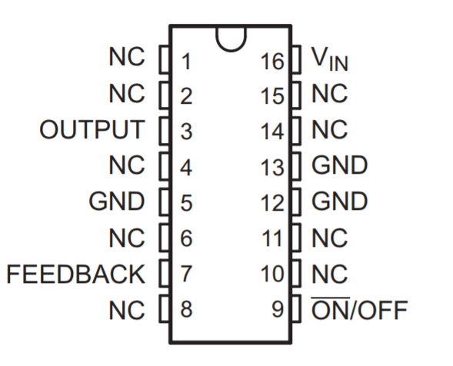

*LM2575 DIP Package*

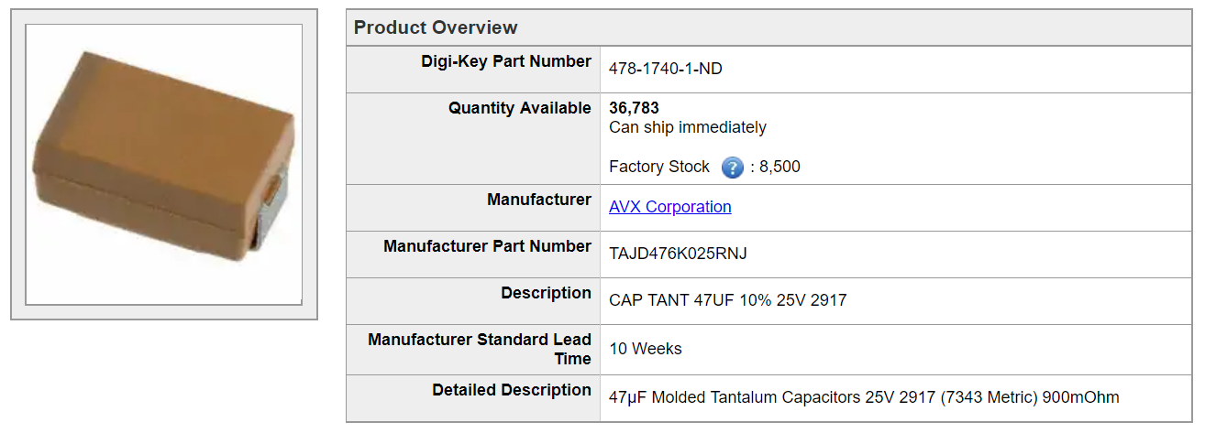

*+9V board output tantalum capacitor*

# 

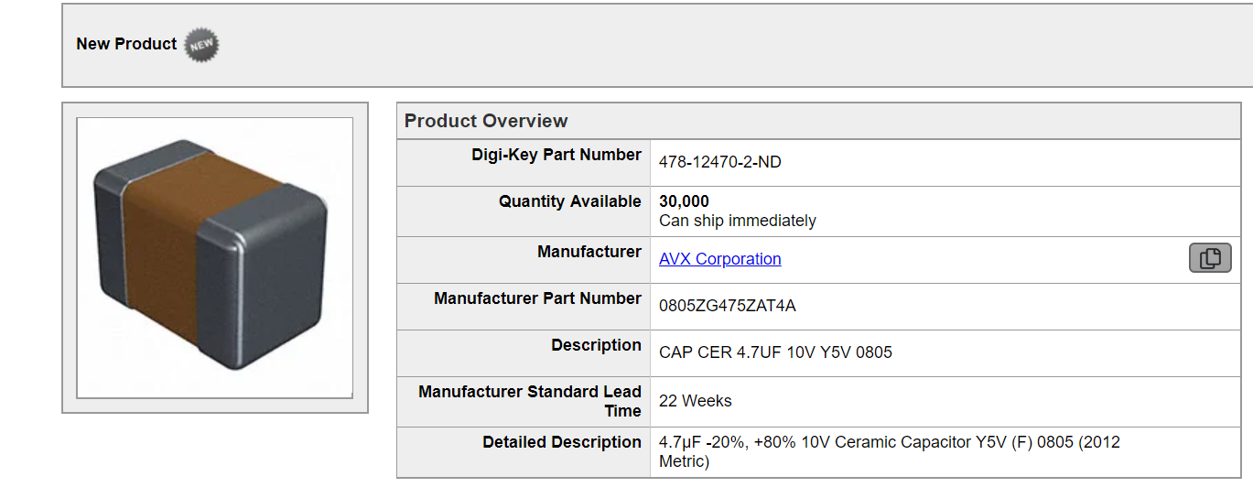

# *+9V Input capacitor*

# 

# 

# *+9V board Schottky diode*

# Appendix B: Schematics and PCBs

The following images will be our entire system schematic broken into its modular parts:

Power:

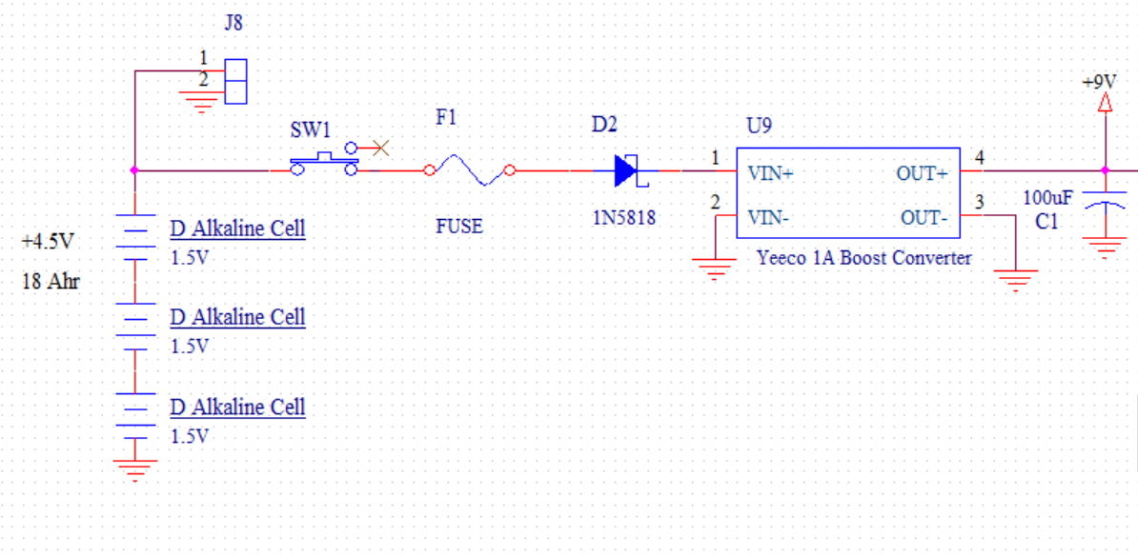

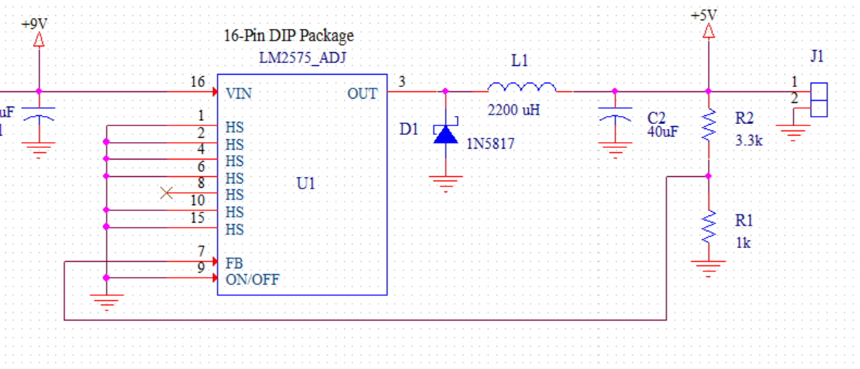

*Buck Converter Schematic*

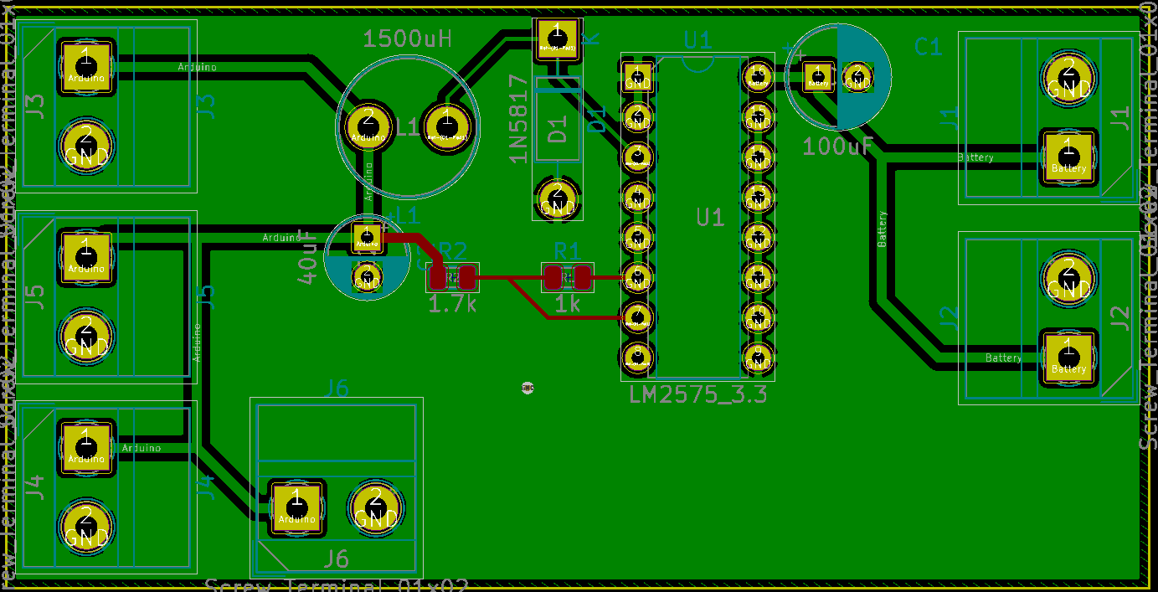

*Buck Board*

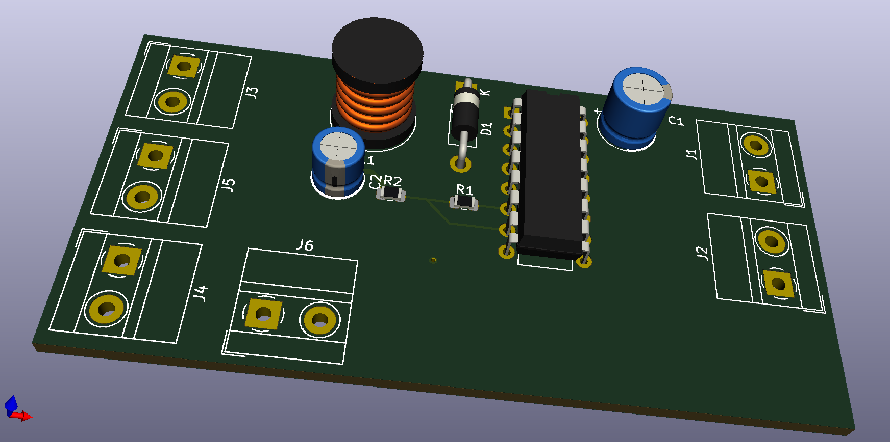

*Buck 3D model*

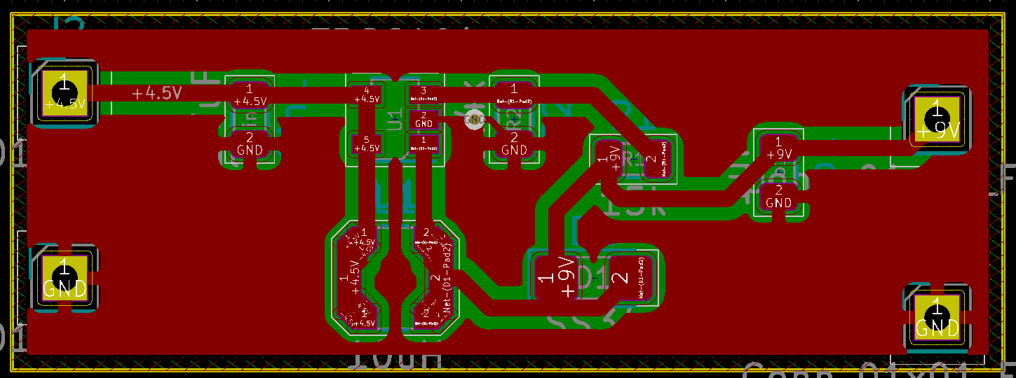

*+9V board layout*

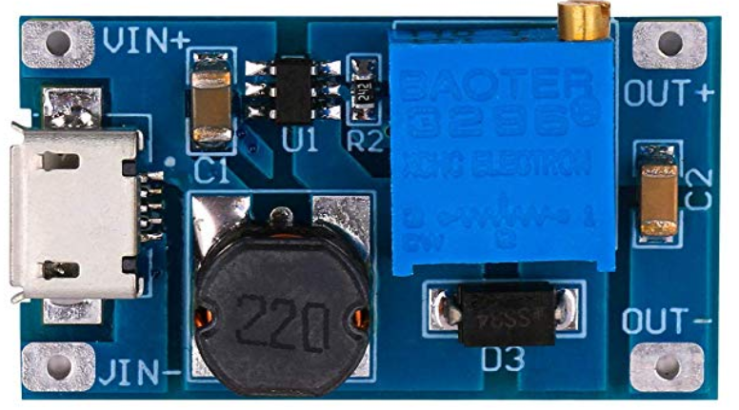

+9V board

Microcontroller:

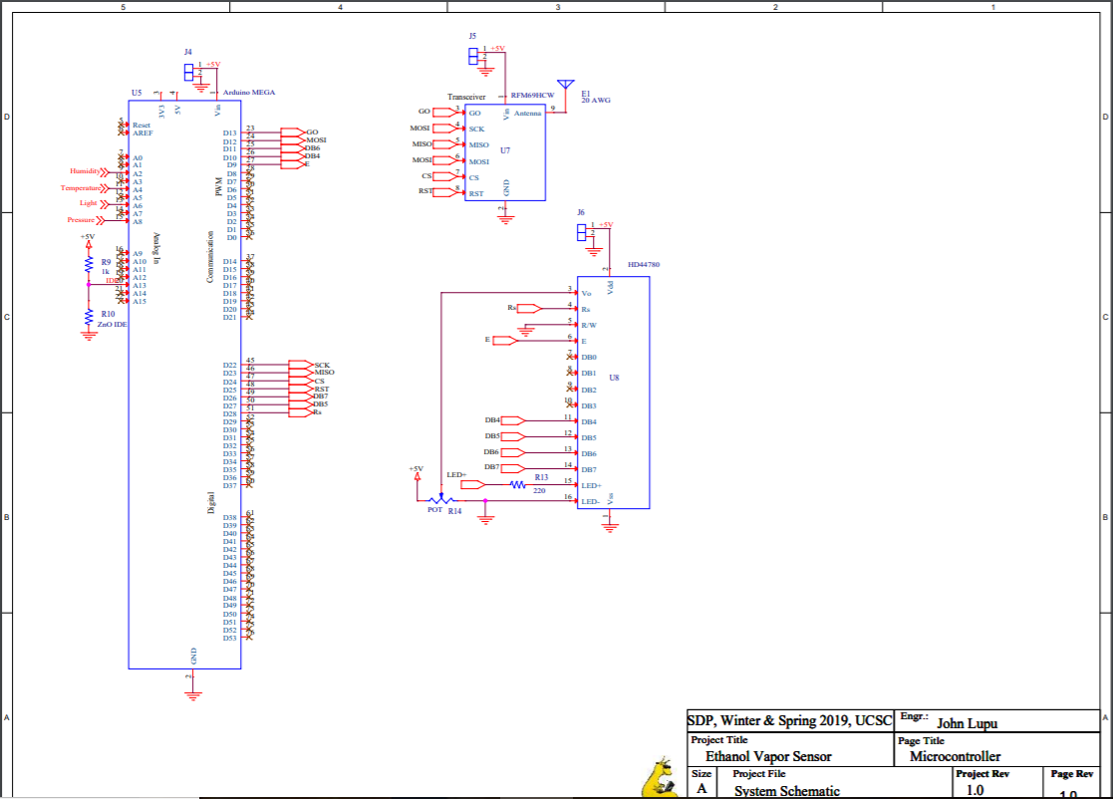

Sensors:

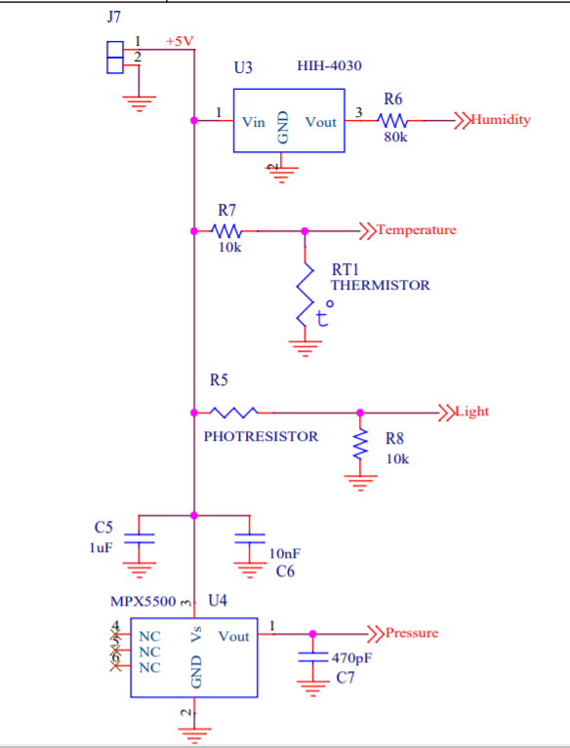

Node Schematic:

Hub Schematic:

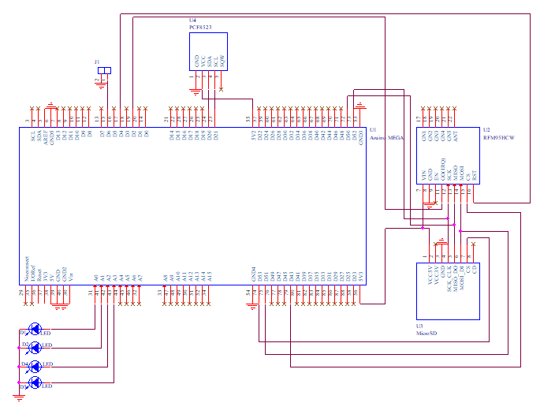

Hub PCB Schematic:

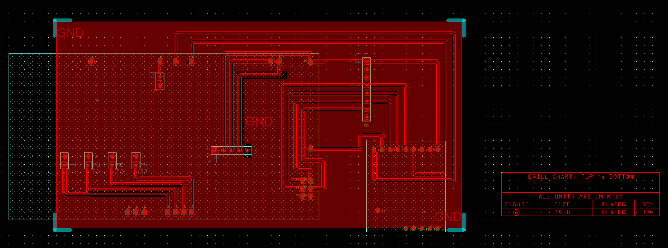

Initial Arduino wiring for testing:

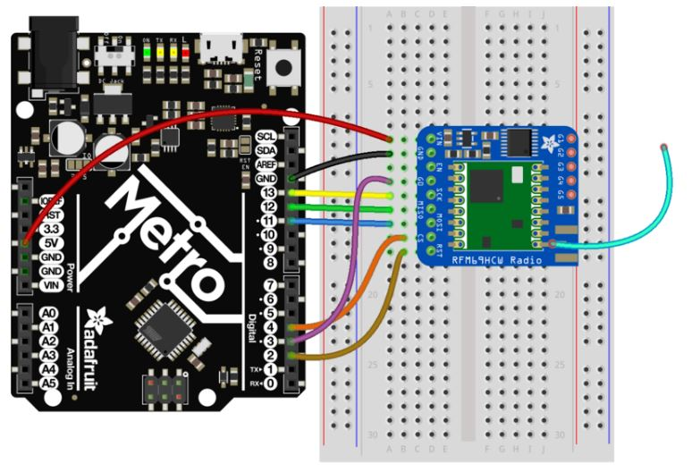

Final Hub in printed and in housing

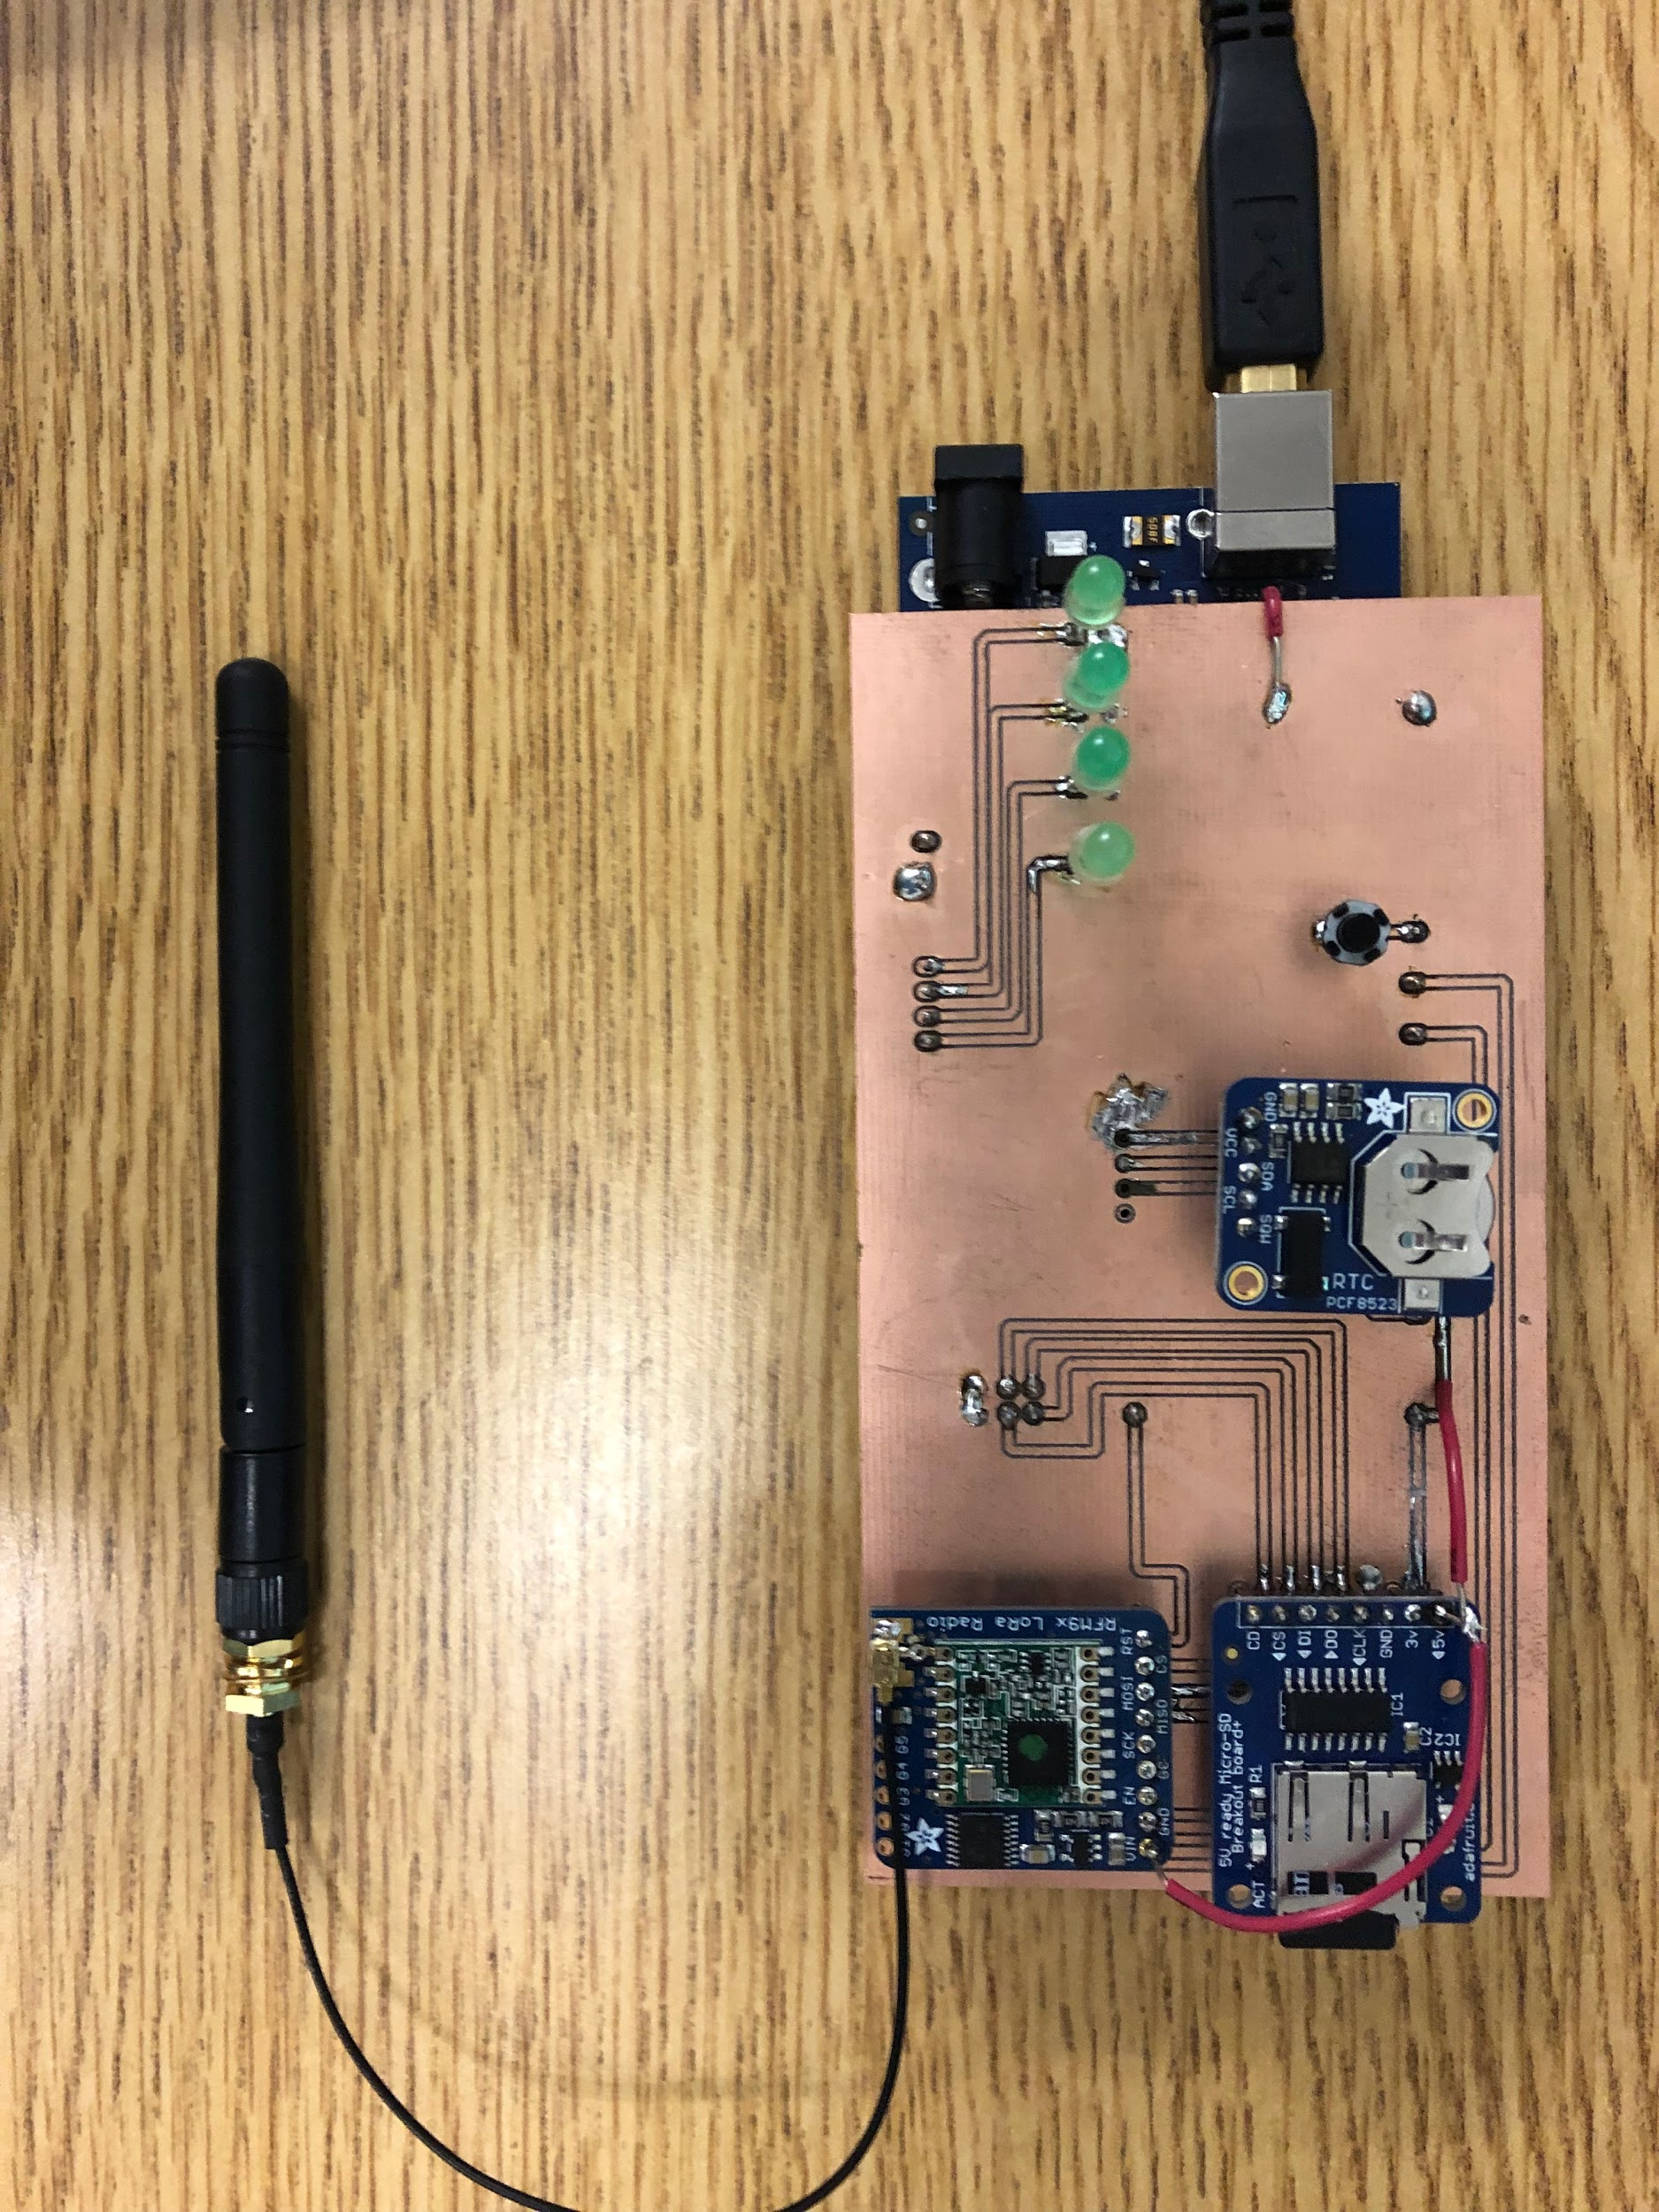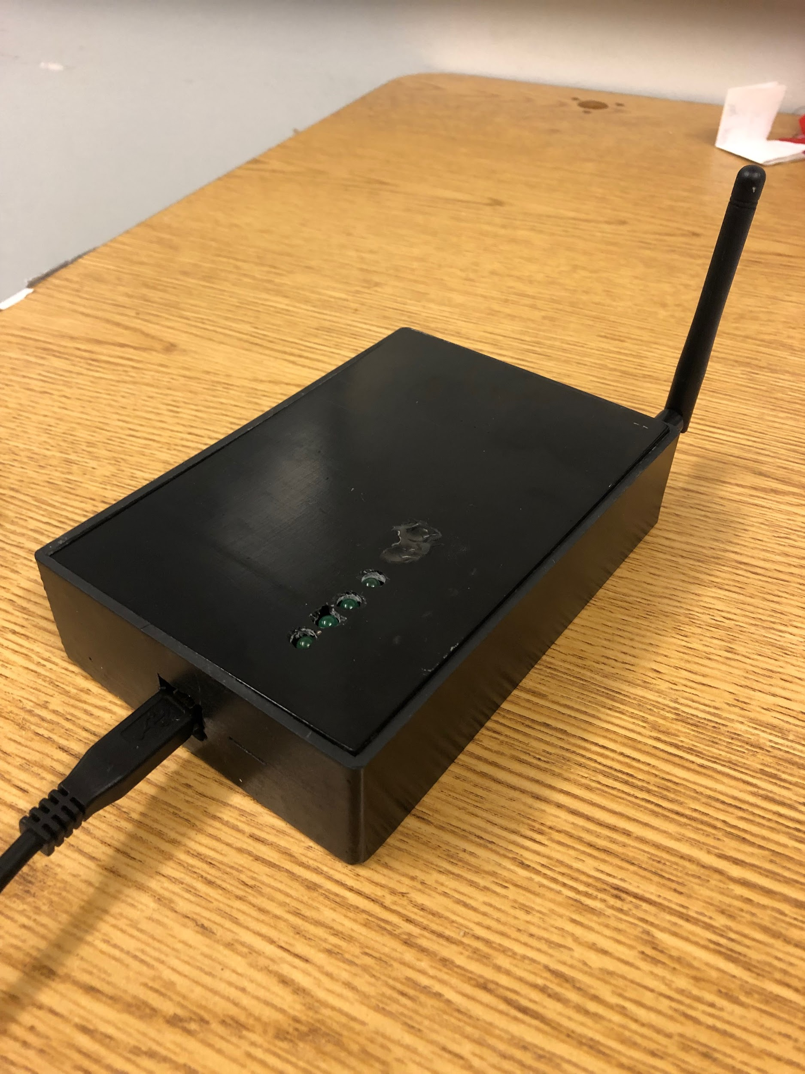

PCB schematic for the sensor array:

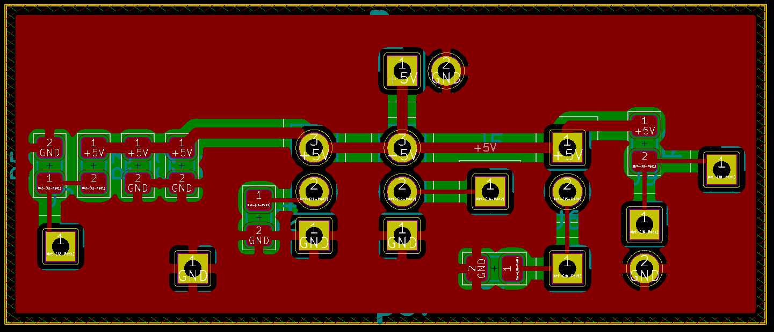

# 

# Appendix C: Code

Code for the Hub:

<https://github.com/daviddurkins/EthanolVaporSensorHub>

Sensors and state machine:

<https://github.com/jorgealegria1/EVS>

Code for testing the valves, reference 4.7

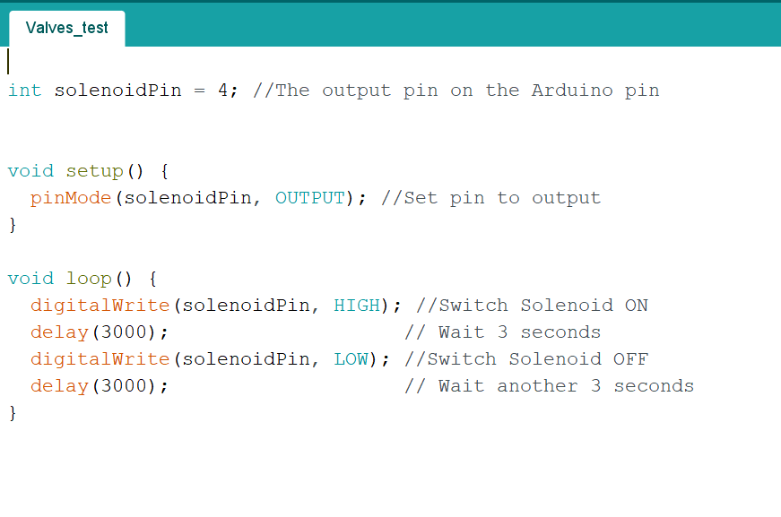

# Appendix D: Standard Operating Procedures (SOPs)

|  |  |  |
| --- | --- | --- |
| |  | | --- | | Standard Operating Procedures for ITO glass and Micrux IDE: | | <https://drive.google.com/drive/u/2/folders/1QkMCOOotaUtPmWmZkfym_NjDR1eUNJwT> | |

# 

# Appendix E: Mechanical Specifications

Note: You must login with a UCSC email to download these files

|  |  |  |
| --- | --- | --- |
| **CAD Files** | | |
| **File Name** | **File Type** | **Link** |
| Battery Cover | Solidworks Part | <https://drive.google.com/open?id=1-lwZNvQfWF5HKsRE9wh3Tu_64Tn26D-h> |
| Battery Cover Print | STL | <https://drive.google.com/open?id=14EiZKXGCAj5NyLMly1cF1Z6wkuVF43d1> |
| External Hub | Solidworks Part | <https://drive.google.com/open?id=18ZzCYGxap81fghvGuahYSY-vzNX7muhP> |
| External Hub Assembly | Solidworks Assembly | <https://drive.google.com/open?id=1wX7iLIt9Hn00fYsCXZ0kMHLbcsXrdczF> |
| External Hub Print | STL | <https://drive.google.com/open?id=1p6X9-HunPkwedevHmJZLJNOFud8TdR2x> |
| Intake Pipe | Solidworks Part | <https://drive.google.com/open?id=19WbyInxHd2QFik0yVfvShv2OZOwjOnXv> |
| External Hub Base | Solidworks Part | <https://drive.google.com/open?id=1lAYgiWhNjmTX4lMvRCGPc4wBttgRO0ov> |
| External Hub Base Print | STL | <https://drive.google.com/open?id=1LCdDzcIrol_7W_gb7saXOglpruAMt2bw> |
| Sampling Chamber Assembly | Solidworks Assembly | <https://drive.google.com/open?id=1WVfZiMX-IFGNQV58tEDr5z19CWQyEHrm> |
| Outtake Pipe | Solidworks Part | <https://drive.google.com/open?id=1eMRdgJR-_trdIw-zXQot5p3g7njC2kb9> |
| Sampling Chamber Base | Solidworks Part | <https://drive.google.com/open?id=11tLCKwyIZ1l8S5LyPOi5ZhfyIWXwkQJt> |
| Sampling Chamber Base Print | STL | <https://drive.google.com/open?id=1o5KbiyDXqWeDXDzZAAfo9qFDHm6uJ2Yn> |
| Sampling Chamber Component Plate | Solidworks Part | <https://drive.google.com/open?id=1QadCo_2VaMH3HzpirzxBfy2z-VCYN2cF> |
| Sampling Chamber Component Plate Print | STL | <https://drive.google.com/open?id=1PwkwGxAvUMeArzaZx5P5Ti9WP3nktzwu> |
| Sampling Chamber Headspace | Solidworks Part | <https://drive.google.com/open?id=1-3iaFpHI7XgutcTo05q_iiWsGAZG1-je> |
| Sampling Chamber Headspace Print | STL | <https://drive.google.com/open?id=1qHA85W2y7NJ7Gzx9h0mxJ8gzrayR-99D> |
| Wall A (front face) | Solidworks Part | <https://drive.google.com/open?id=10iacAqPX0Dqi9I2PmTbGn9iBy2EEj8ij> |
| Wall B (back panel) | Solidworks Part | <https://drive.google.com/open?id=1BIGQ48xpoLcl-OoHU9R3nuYh_29uZmAA> |
| Wall C (left wall | Solidworks Part | <https://drive.google.com/open?id=1AQ7WDoTwoKVxgpR9HDhtg3jRSh0SX7AM> |
| Wall D (right wall) | Solidworks Part | <https://drive.google.com/open?id=1PlNhLVHJEWa5nRiWJEmV7_IYjwnCH6Kg> |
| Wall E (shelf) | Solidworks Part | <https://drive.google.com/open?id=1upOnNKdMSccPYfmLcmGyCsSl1AvAz1kG> |
| Wall F (lid) | Solidworks Part | <https://drive.google.com/open?id=1KezCWp2JPQIvdIJipVj9IDWdpdX4XjjN> |
| Wall G (drawer) | Solidworks Part | <https://drive.google.com/open?id=1mmRHND4pweexFrP6684XPoMSCqH932Vk> |
| Wall H (battery cover) | Solidworks Part | <https://drive.google.com/open?id=1zKs34TqVKFBLtnBXwJQ5xLCCiPOSXFFv> |
| Device Assembly | Solidworks Assembly | <https://drive.google.com/open?id=17ss6-GZ6rsOpN3gM3n1Ld62JmaGqXMW4> |

# 

# Appendix F: Testing Results

*+9V converter efficiency versus input voltage test* (with Arduino MEGA and +5V loads):

|  |  |  |  |  |
| --- | --- | --- | --- | --- |
| Vin (V) | Iin (mA) | Vout (V) | Iout (mA) | Efficiency (%) |
| 4.97 | 140.00 | 8.95 | 68.50 | 88.11 |
| 5.47 | 125.50 | 8.96 | 68.50 | 89.34 |
| 5.98 | 114.00 | 8.98 | 68.50 | 90.31 |
| 6.48 | 105.30 | 9.01 | 68.50 | 90.43 |
| 6.98 | 97.30 | 9.01 | 68.50 | 90.85 |
| 7.48 | 90.00 | 9.00 | 68.50 | 91.61 |
| 7.98 | 84.00 | 9.00 | 68.50 | 91.97 |
| 8.48 | 78.00 | 9.01 | 68.50 | 93.25 |
| 8.98 | 73.00 | 9.01 | 68.50 | 94.15 |

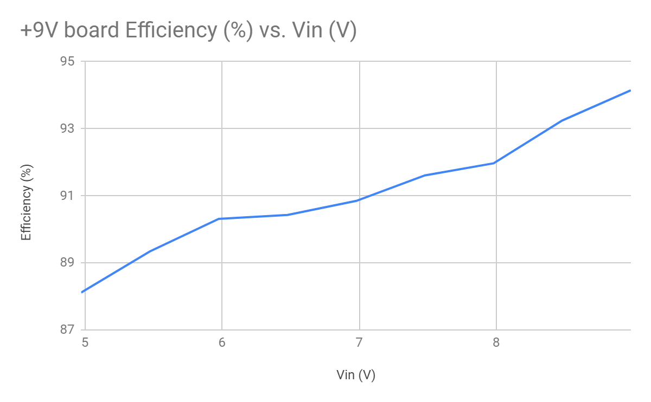

*+5.25V converter efficiency versus input voltage test* (with sensors, LCD, and radio loads):

|  |  |  |  |  |
| --- | --- | --- | --- | --- |
| Vin (V) | Iin (mA) | Vout (V) | Iout (mA) | Efficiency (%) |
| 7.99 | 25.03 | 5.28 | 30.10 | 79.47 |
| 8.53 | 22.38 | 5.27 | 30.10 | 83.09 |
| 9.02 | 20.66 | 5.30 | 30.10 | 85.61 |
| 9.48 | 19.21 | 5.26 | 30.10 | 86.94 |
| 9.97 | 18.49 | 5.25 | 30.10 | 85.72 |
| 10.53 | 18.13 | 5.26 | 30.10 | 82.93 |
| 11.00 | 17.75 | 5.31 | 30.10 | 81.86 |
| 11.47 | 17.52 | 5.24 | 30.10 | 78.49 |
| 11.98 | 17.39 | 5.27 | 30.10 | 76.14 |

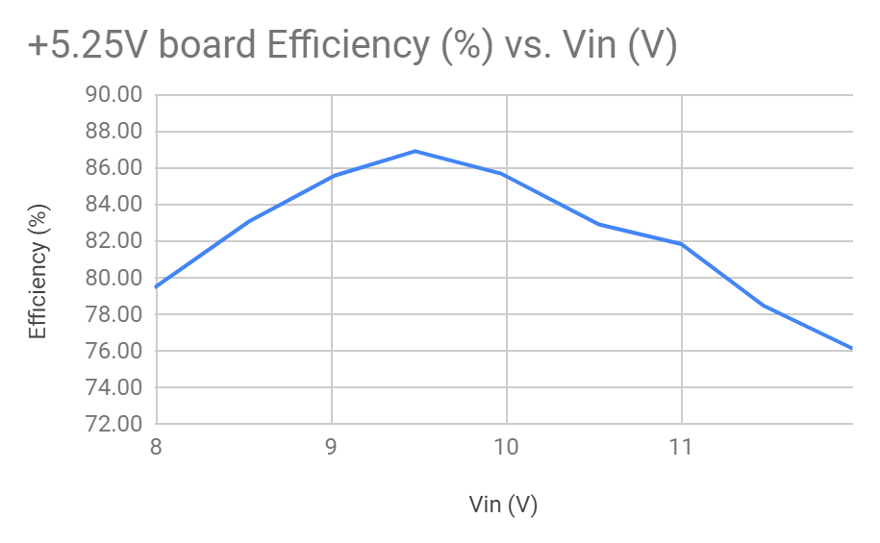

+5V board oscilloscope output voltage oscilloscope readings (fully loaded)



1. Jancou, Pierre. “Fermentation and Wine Making.” *Morethanorganic.com*, 2019, www.morethanorganic.com/fermentation.
2. Hunsaker, Larry. “FOOD & AGRICULTURE WINE FERMENTATION.” *Estimation Methodology: 2005*, Mar. 2005, www.arb.ca.gov/ei/areasrc/fullpdf/full5-1.pdf.
3. Kraus, Ed. “Wine Fermentation 101.” *ECKraus*, 2019, eckraus.com/wine-making-101/.3
4. Diodes Incorporated. DS23001 Rev 8-2. *1N5817 - 1N5819: 1.0A Schottky Barrier Rectifier*. https://www.diodes.com/assets/Datasheets/ds23001.pdf
5. Savini Hemachandra. *SWITCHING CONVERTERS - Buck and Boost Converters*. Medium. 2018. https://medium.com/@savinihemachandra/switching-circuits-buck-and-boost-converters-d03afcc1e786
6. Texas Instruments. LM1575/LM2575/LM2575HV SIMPLE SWITCHER® 1A Step-Down Voltage Regulator. SNVS106E. 1999. http://www.ti.com/lit/ds/symlink/lm2575-n.pdf
7. Texas Instruments. LM1575/LM2575/LM2575HV SIMPLE SWITCHER® 1A Step-Down Voltage Regulator. SNVS106E. 1999. http://www.ti.com/lit/ds/symlink/lm2575-n.pdf
8. Prof. Michele Menniti. *Feeding power to Arduino: the ultimate guide*. OPENELECTRONICS. 2015. https://www.open-electronics.org/the-power-of-arduino-this-unknown/
9. Same as previous
10. Texas Instruments. *TPS6104x Low-Power DC-DC Boost Converter in SOT-23 and WSON Packages*. 2016.http://www.ti.com/lit/ds/symlink/tps61041.pdf
11. Texas Instruments. *TPS6104x Low-Power DC-DC Boost Converter in SOT-23 and WSON Packages*. 2016.http://www.ti.com/lit/ds/symlink/tps61041.pdf
12. Texas Instruments. *TPS22918 5.5-V, 2-A, 52-mΩ On-Resistance Load Switch*. 2017 Revision. http://www.ti.com/lit/ds/symlink/tps22918.pdf
13. Texas Instruments. *TPS22918 5.5-V, 2-A, 52-mΩ On-Resistance Load Switch*. 2017 Revision. http://www.ti.com/lit/ds/symlink/tps22918.pdf
14. ON Semiconductor. *TIP120, TIP121, TIP122 (NPN); TIP125, TIP126, TIP127 (PNP): Plastic Medium-Power Complementary Silicon Transistors*. Rev 9. 2014. https://www.onsemi.com/pub/Collateral/TIP120-D.PDF